Sort data alphabetically
Let Word sort a text list for you, either from A to Z or Z to A.
- Select the text in a one-level bulleted or numbered list.
- On the Home tab, click Sort. (In Outlook: On the Format Text tab, click Sort.)
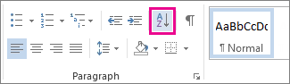
- In the Sort Text box, set Sort by to Paragraphs and Text.
- Click either Ascending (A to Z) or Descending (Z to A).
- Click OK.

