TIER5 LLC
3C or TM SMS Dashboard Design wise Feature Description

Version: 0.01

Tier5

Abbreviation 3
USER WISE FUNCTIONALITY 3
Super-Admin:- 3
Common Login Panel (Super Admin/Admin/Agents):- 4
Profile:- 5
Twilio Accounts: 6
Admin Section: 7
Agent Section:- 9
Department Section:- 11
Widget Section:- 13
Chat Section:- 16
Contact List Section:- 17
Admin:- 18
Common Login Panel (Super Admin/Admin/Agents):- 19
Admin Registration Panel:- 20
Profile:- 21
Agent Section:- 22
Department Section:- 23
Widget Section:- 25
Chat Section:- 28
Contact List Section:- 30
Agent:- 31
Common Login Panel (Super Admin/Admin/Agents):- 32
Profile:- 33
Message log(Pending):- 34
Chat Notification(Pending):- 35
Contact List Section(Pending):- 36
Front-End User/ Client:- 36
Chat Panel:- 37
Special Feature (Pending):- 38

Abbreviation
Sr. No | abbreviation | Full Form
1
2

Dev link: http://138.197.215.68

USER WISE FUNCTIONALITY
Following user’s functionalities are discussed in this doc
- Super-Admin
- Admin
- Agent/User
- Front-End User/Client

Super-Admin:-
Super-Admin will be that type of user who will have the top most access permission of this system. Super Admin can access any functionalities of this system. Even System Admin can create/edit and access the other user’s information also.
The following menus and functionalities will be available for Super Admin user:-

Common Login Panel (Super Admin/Admin/Agents):-
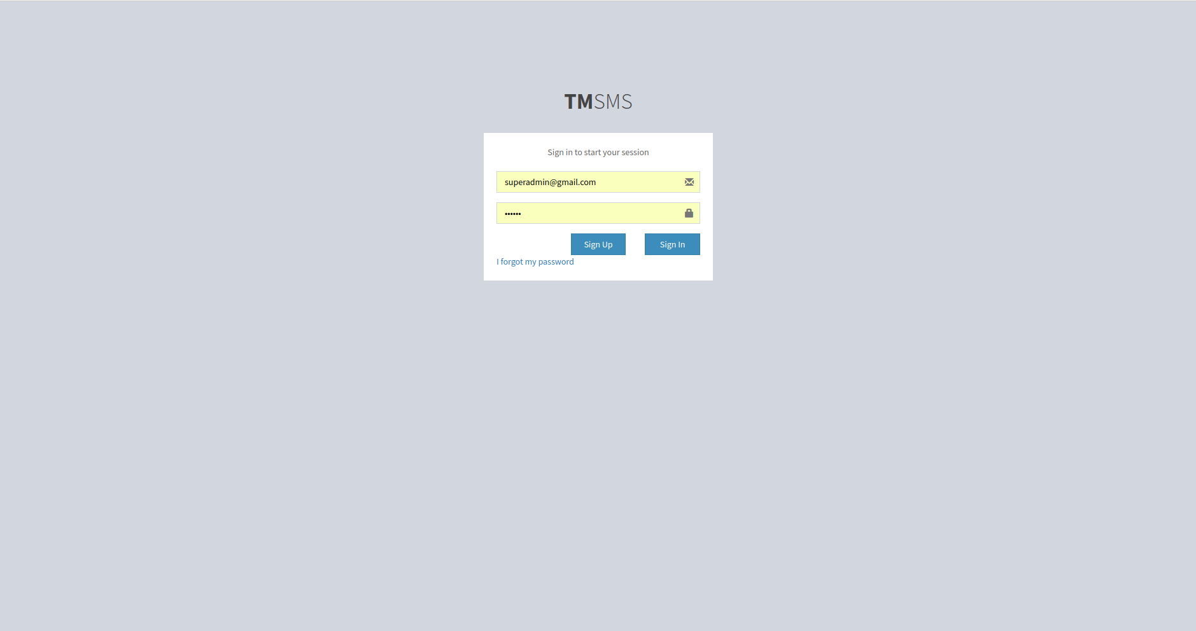

Above picture is for the common login panel for all kind of user.
Login panel should contain with this following fields:
A. User Name:- It is the field where user will give their registered e-mail id as username.
B. Password:- It is the field where user will give the password. Minimum number of character of password will be 6.
C. Forgot Password Link:- After clicking on this link, system will send a reset password link to the user email, which redirect to a page where the user could reset his password
D. Sign Up button:- After clicking on this button, user redirect to the register page.
E. Sign In button:- After clicking on this button, user login to this system and redirect to the dashboard.
If error will occur, then error message will come.

Profile:-
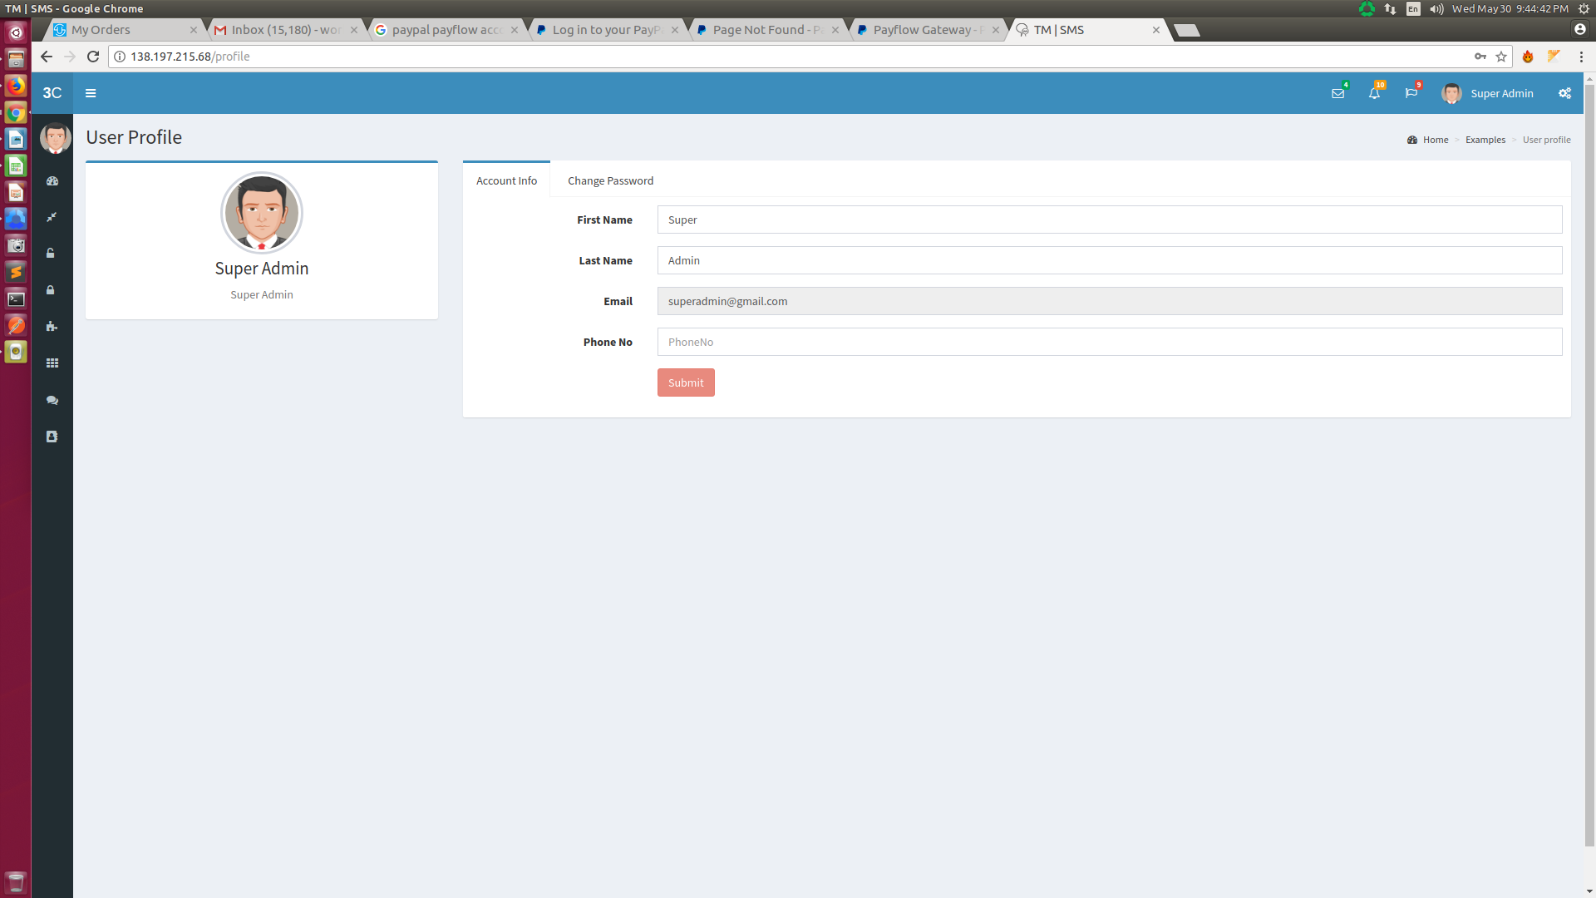
Above picture is for the common Profile panel for all kind of user.
User’s can see his profile information and also can update the information by this section.
Profile panel containing two tab: 1. Account Info & 2. Change Password
Account Info tab should contain with this following fields:
- First Name:- It is the field where user can see and update their first name.
- Last Name:- It is the field where user can see and update their last name.
- Email*:- It is the field where user only can see their registered email id. This field is not updatable.
- Phone:- It is the field where user can see and update their phone number.
Change Password tab should contain with this following fields:
- Password:- It is the field where user can give their password to update.
- Change Password:- It is the field where user can repeat their password to update.
For update the profile informations, users have to click on “Submit” button.
* Email Id Should Be unique and cannot be changeable in update sections.
# For Super Admin One Default User was Supposed to be Seeded in the Table.

Twilio Accounts:
This section will be accessible by only Super Admin.
There will be two part of this section:- A. Create, & B. List.
- Create:
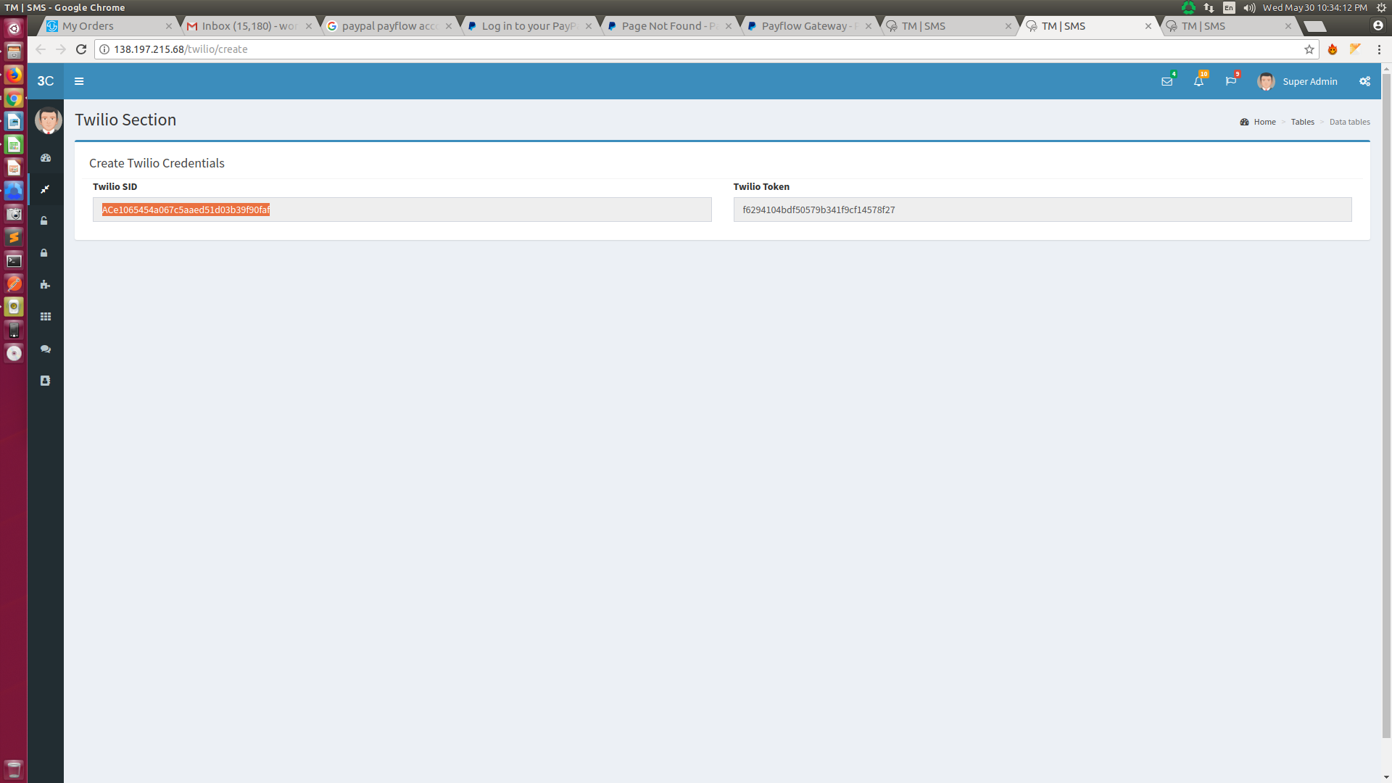
In this section, for the first time Super Admin can add the Twilio credentials into the page with fields as follows:
- ACCOUNT SID :- It is the field where Super Admin can add the Twilio account SID.
- AUTH TOKEN :- It is the field where Super Admin can add the Twilio auth TOKEN.
- List:

In this section, Super Admin Can view all his sub account (Whenever an Admin will register an automatic sub-account in Twilio will be created under Super-Admin Twilio account) and registered admin details in table view.
* The twilio credentials (for main account and sub accounts) should Be unique and cannot be editable.
# For the first time Super Admin can add the twilio credentials and can validate the credentials by this section.

Admin Section:
This section will be accessible by only Super Admin.
There will be two part of this section:- A. Create, & B. List.
- Create:
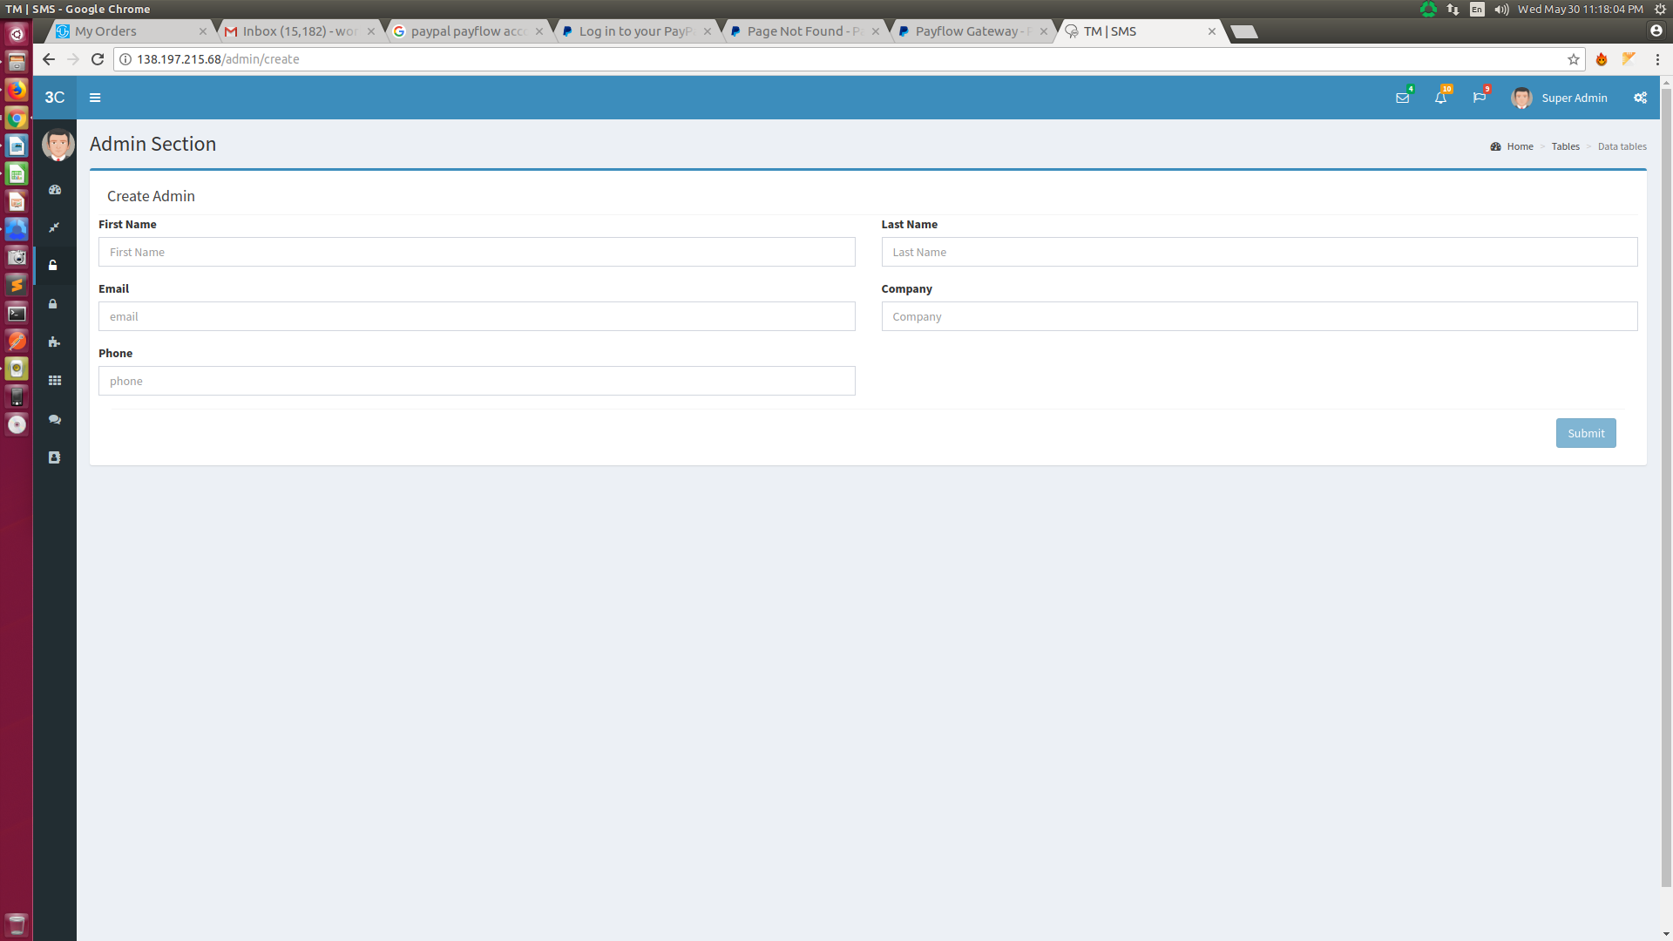
In this section, Super Admin can create and update the Admin accounts with the fields as follows:
- First Name:- It is the field where Super Admin can add and update Admin’s first name.
- Last Name:- It is the field where Super Admin can add and update Admin’s last name.
- Email*:- It is the field where Super Admin can add Admin’s email id, which should be unique and uneditable.
- Company:- It is the field where Super Admin can add and update Admin’s company.
- Phone:- It is the field where Super Admin can add and update Admin’s phone number.
* Email Id Should Be unique and cannot be editable in update sections
# Whenever an Admin will be registered an automatic sub-account in Twilio will be created under Super-Admin Twilio account

- List:
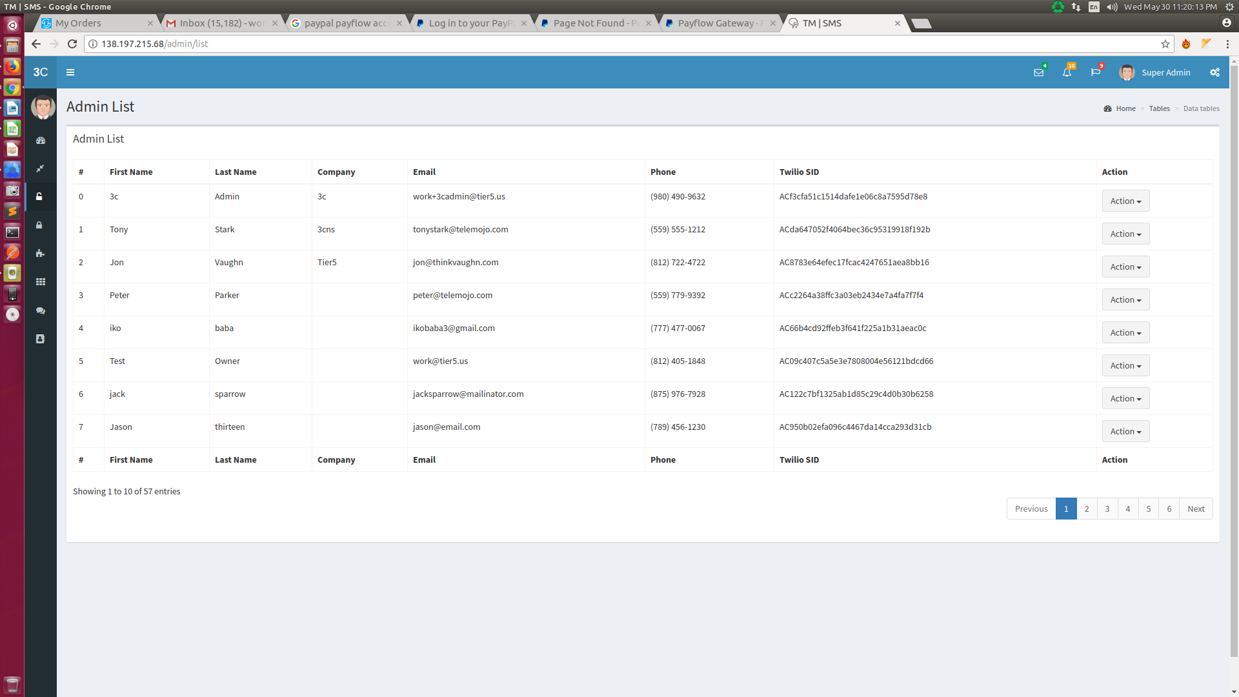
In this section, Super Admin Can view all the Admin’s details list in table view. Super Admin also can edit them and block any Admin account too. In this process of blocking an account, Twilio sub account attached with that admin account will also be suspended or blocked which can again revive on removing the block.
#Super Admin can Emulate as an Admin into his profile and can access everything as like Admin do.

Agent Section:-
There will be two part of this section:- A. Create, & B. List.
- Create:-
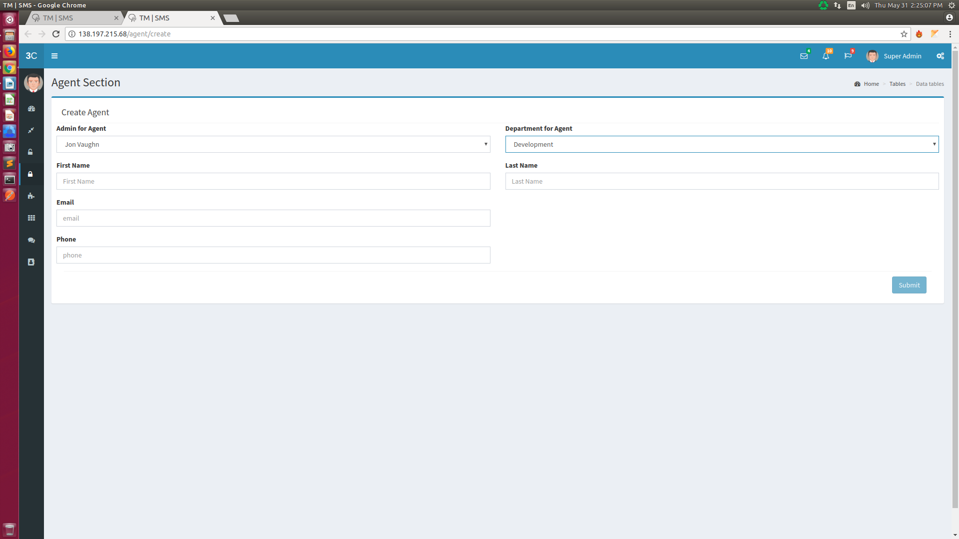
In this section, Super Admin can create and update the Agent accounts with the fields as follows:
- Admin for Agent:- It is mainly a dropdown box, there all the Admin’s name will appear and Super Admin can select a Admin name to create the agent under that Admin
- Department for Agent:- After selecting the Admin Name, this drop down box will come. Here also all the department name will appear (the departments associated with the selected Admin).
- First Name:- It is the field where Super Admin can add and update Agent’s first name.
- Last Name:- It is the field where Super Admin can add and update Agent’s last name.
- Email*:- It is the field where Super Admin can add Agent’s email id, which should be unique and uneditable.
* Email Id Should Be unique and cannot be editable in update sections
# Whenever an Super Admin will register an Agent, that time an automatic email will shoot to that agent’s email id, containing his login password.

- List:-
In this section, Super Admin Can view all the Agent’s details list in table view. Super Admin also can edit them and block any Agent account too.
#Super Admin can Emulate as an Agent into his profile and can access everything as like Agent do.

Department Section:-
There will be two part of this section:- A. Create, & B. List.
- Create:-
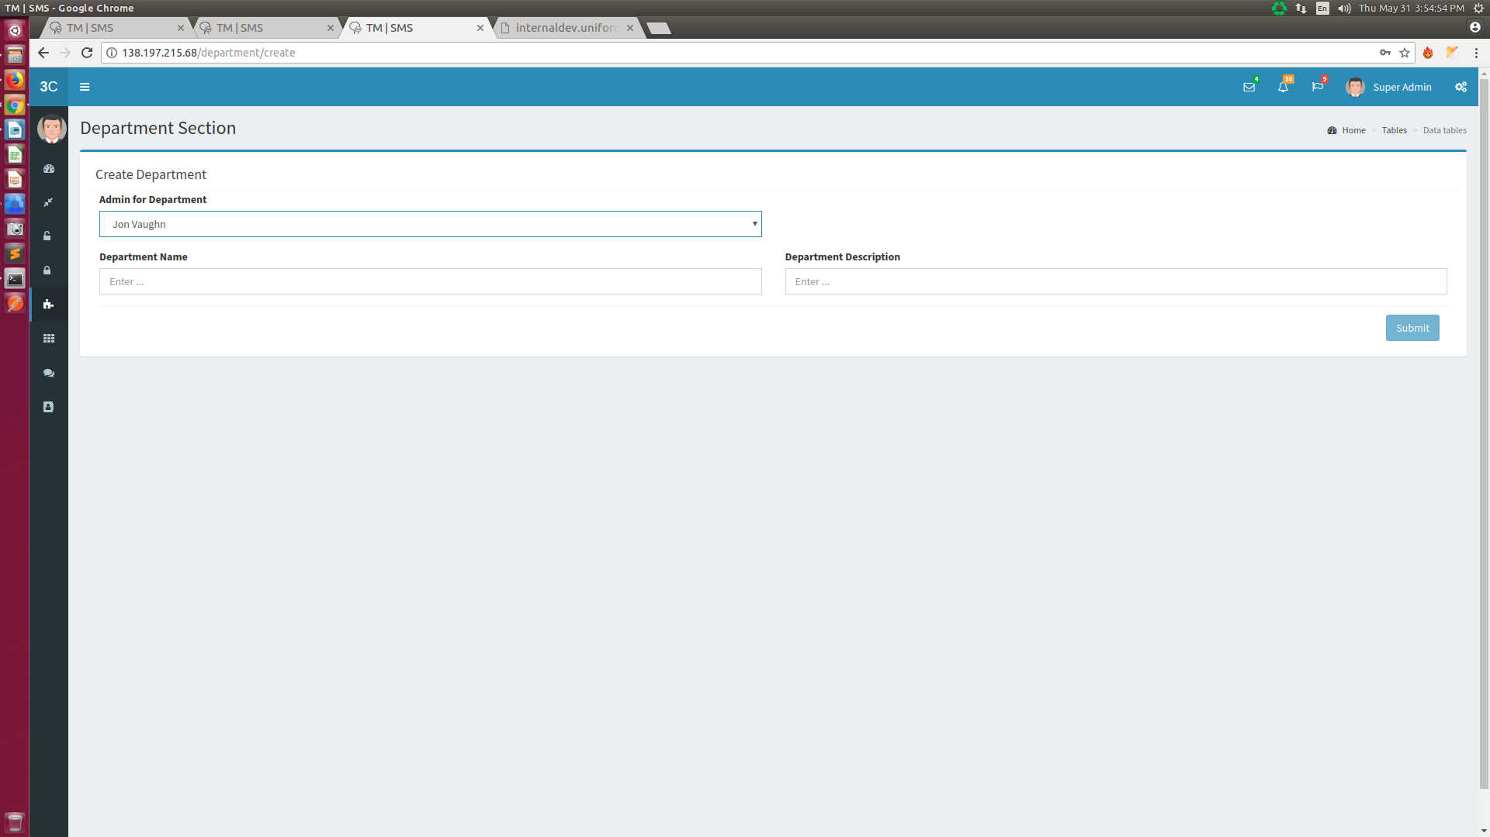
In this section, Super Admin can create and update the Admin’s department with the fields as follows:
- Admin for Department:- It is mainly a dropdown box, there all the Admin’s name will appear and Super Admin can select a Admin name to create the department under that Admin.
- Department Name:- It is the field where Super Admin can put the department name.
- Department Description:- It is the field where Super Admin can add the department description

- List:
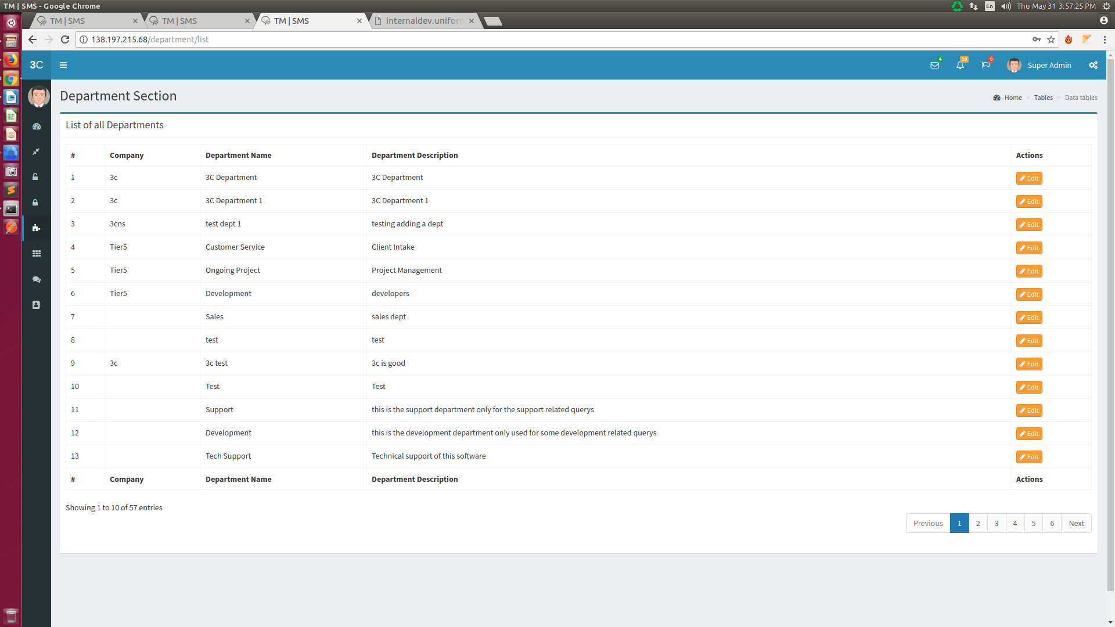
In this section, Super Admin Can view all the department details ( Company Name, Department Name, Department Description, Created Date, Number of Agents Associated) respect the admin in a table view. Super Admin also can edit them.

Widget Section:-
There will be two part of this section:- A. Create, & B. List.
- Create:-
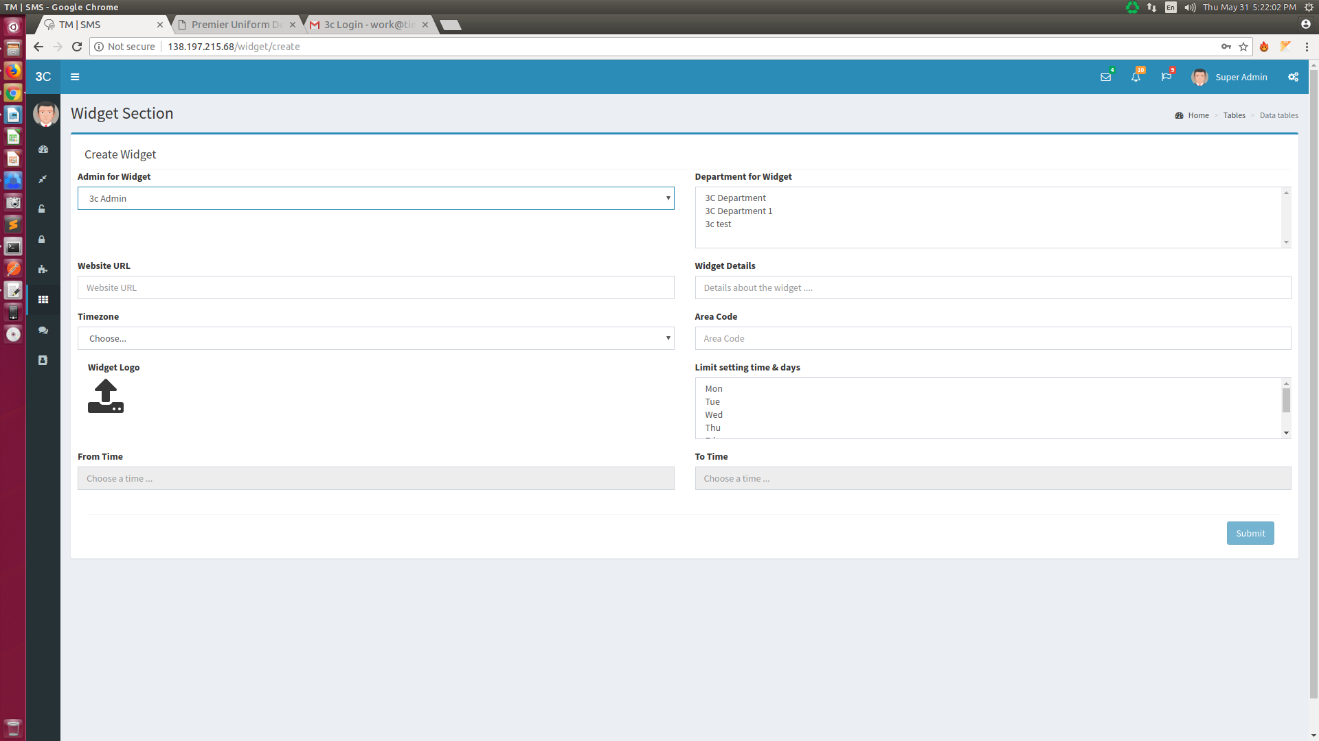
In this section, Super Admin can create and update the widget under any Admin with the fields as follows:
- Admin for Widget:- It is mainly a dropdown box, there all the Admin’s name will appear and Super Admin can select a Admin name to create the widget under that Admin.
- Department for Widget:- After selecting the Admin Name, this drop down box will come. Here also all the department name will appear (the departments associated with the selected Admin). Super Admin have to select the department, which will show in that widget.
- Website URL:- It is the field where Super Admin will give the website name, on which the widget will be placed.
- Widget Details:- It is the field, where Super Admin will add any description regarding that widget.
- Time Zone:- It is mainly a dropdown box, where all the time zone in USA will be stored and displayed. Super Admin can easily select the single timezone based on which the widget functionality will be active.
- Area Code:- It is the field, where super admin can give the area code, and based on that area code, one number from twilio will be automatically assigned to the widget. When any conversation or notification will go through that widget, all will be throw by that number.
- Widget Logo:- It is mainly upload section, by which Super Admin can easily upload the logo which will be shown in the widget.
- Limit setting days:- It is the section, where super admin can select the days, on which the widget will work.
- From Time:- It is mainly a time picker, by which Super Admin can easily set the time, from which the widget will work.
- To Time:- It is mainly a time picker, by which Super Admin can easily set the time, to which the widget will work.

- List:-

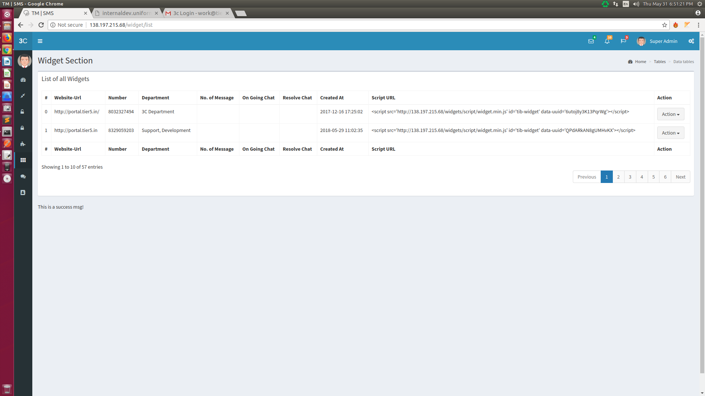
In this section, Super Admin Can view all the widget details in a table view. Super Admin also can edit them.

Chat Section:-
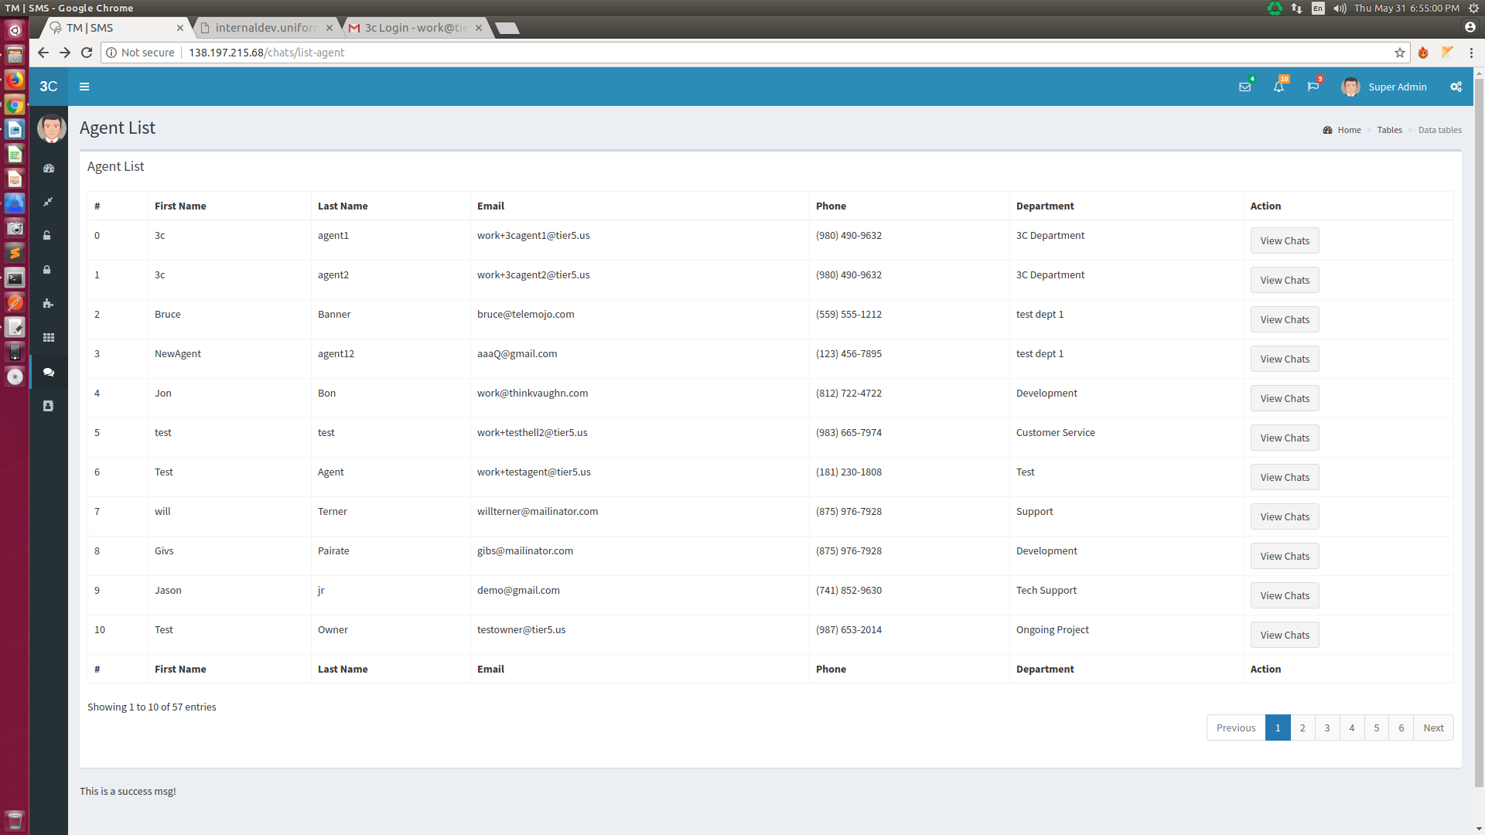
In this section, Super Admin Can view all the Agent’s details list in table view. By selecting any particular Agent, Super Admin will be able to view all the chats history related to that agent.

Contact List Section:-
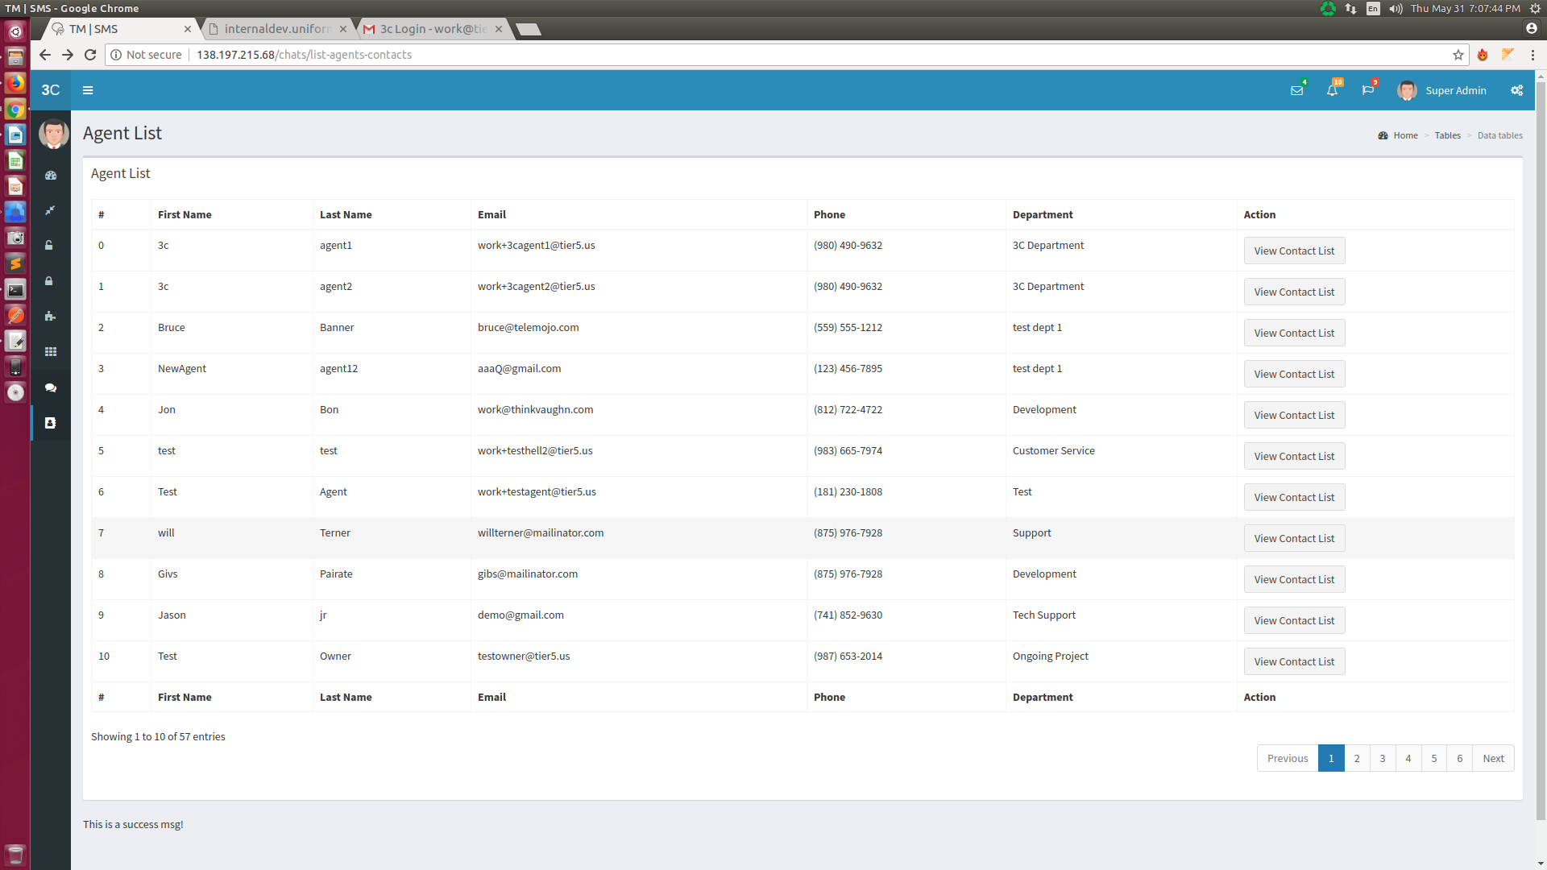
In this section, Super Admin Can view all the Agent’s details list in table view. By selecting any particular Agent, and after clicking on View Contact List button, Super Admin can easily view all the contacts associated with that particular agent.
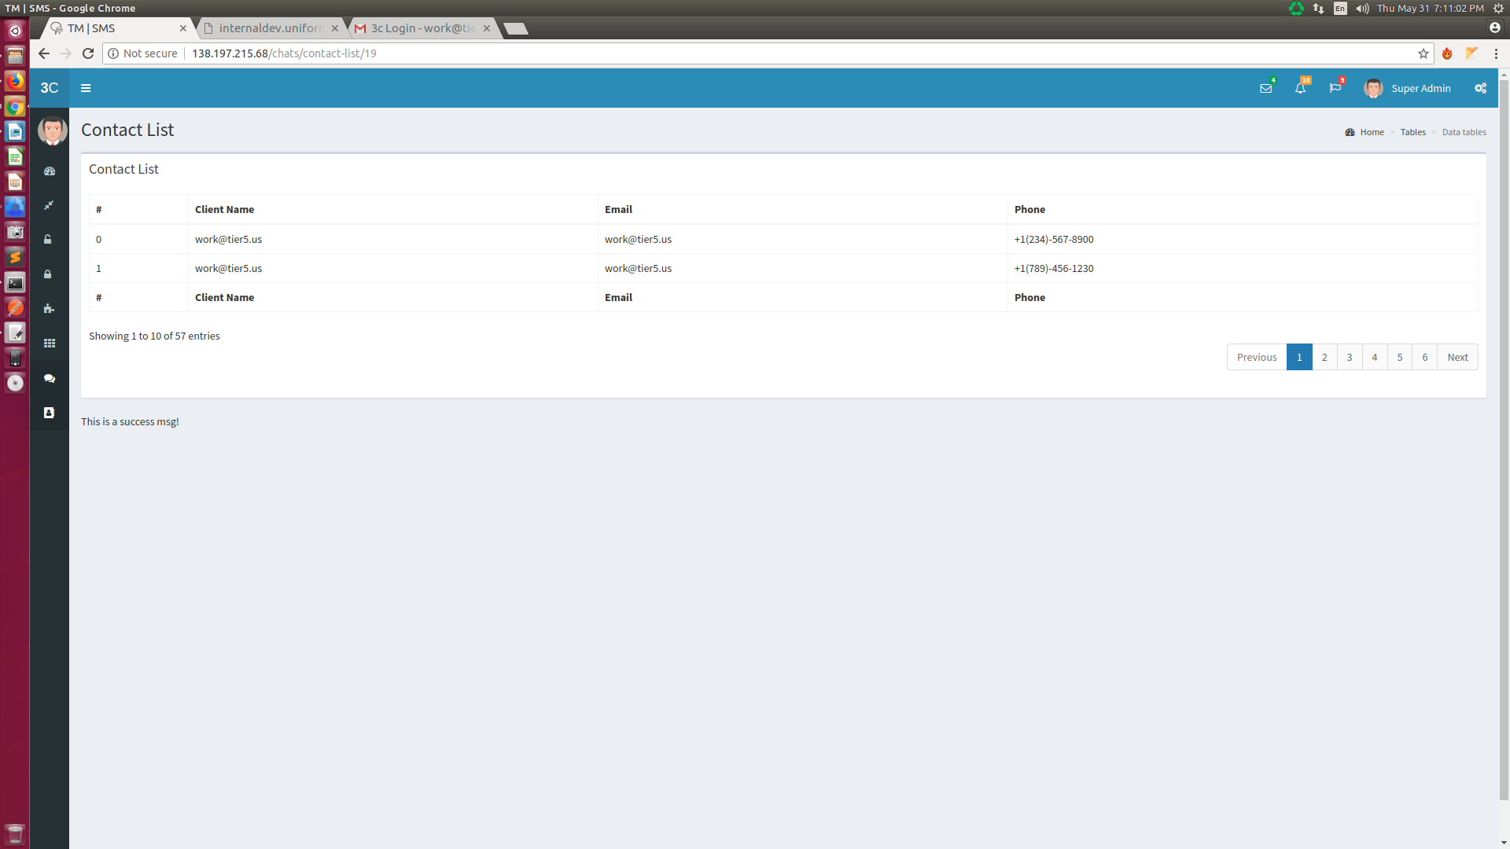
In this Section, Admin can view all the contact and his details information ( the contacts will be associated with a particular agent) in a table view.
#The second screen will appear after clicking on view contact list button.

Admin:-
Admin will be that type of user who will have specific access permission of this system. Admin can access the functionalities which he will get after registering as Admin in this system. The following menus and functionalities will be available for Super Admin user:-

Common Login Panel (Super Admin/Admin/Agents):-

Above picture is for the common login panel for all kind of user.
Login panel should contain with this following fields:
A. User Name:- It is the field where user will give their registered email id as username.
B. Password:- It is the field where user will give the password. Minimum number of character of password will be 6.
C. Forgot Password Link:- After clicking on this link, system will send a reset password link to the user email, which redirect to a page where the user could reset his password
D. Sign Up button:- After clicking on this button, user redirect to the register page.
E. Sign In button:- After clicking on this button, user login to this system and redirect to the dashboard.
If error will occur, then error message will come.

Admin Registration Panel:-

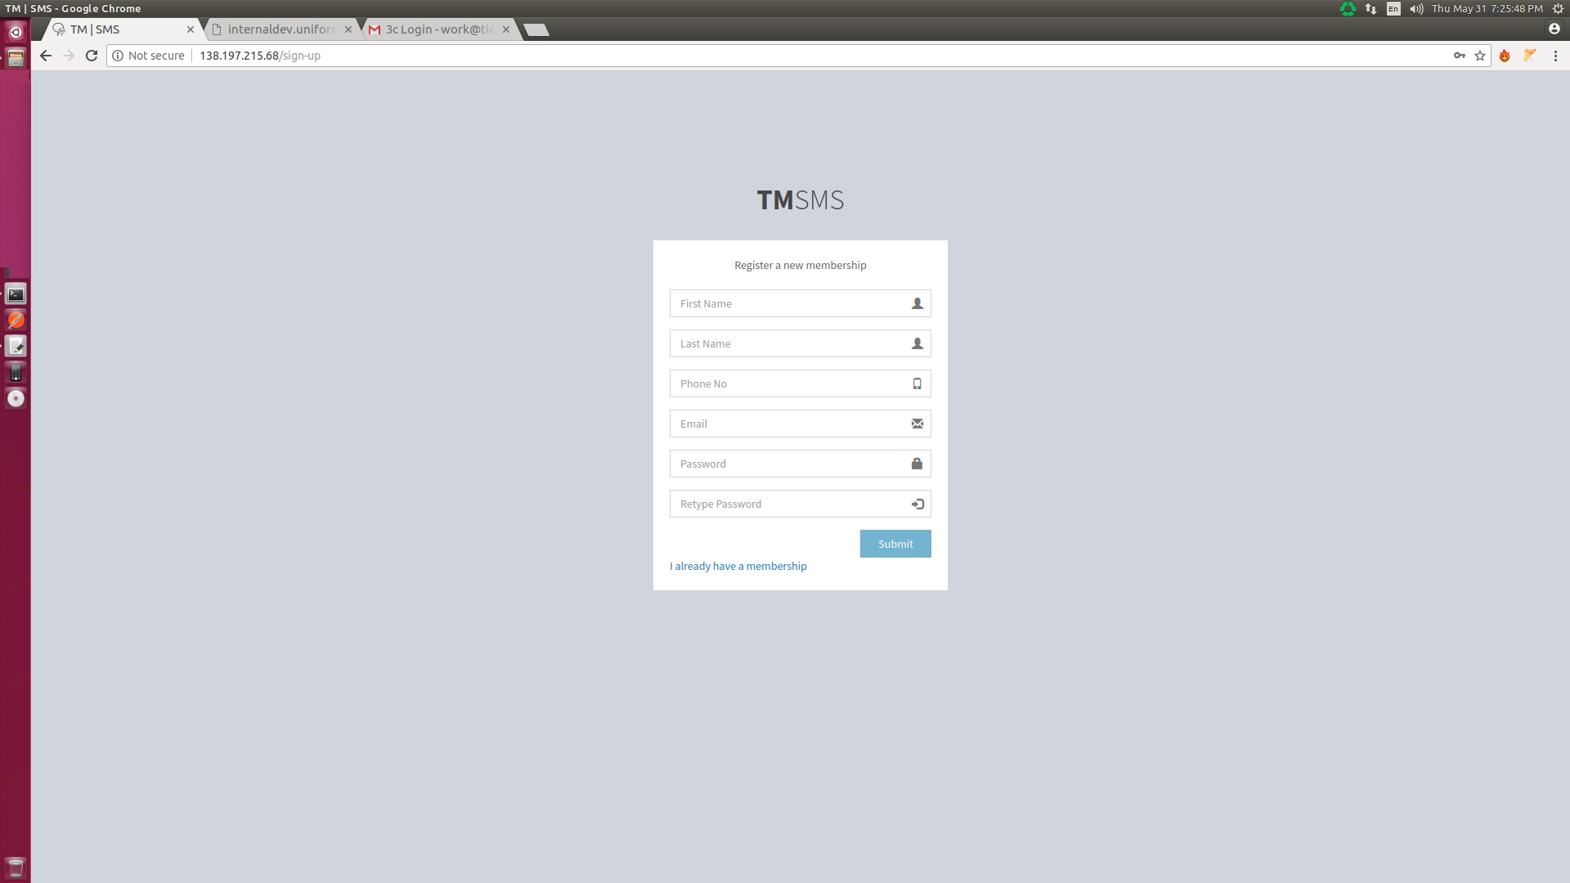
Above picture is for the registration panel for Admin only.
Registration panel should contain with this following fields:
- First Name:- It is the field where Admin can give their first name.
- Last Name:- It is the field where Admin can give their last name.
- Phone:- It is the field where Admin can give their phone number.
- Email*:- It is the field where Admin can give their email id at the time of registration. Which is not updatable.
- Password:- It is the field where Admin will give the password. Minimum number of character of password will be 6.
- Re-type Password:- It is the field where Admin will re-type the password.
- Submit button:- After clicking on this button, Admin registration will be done and Admin will be redirect to the Dashboard. After successful registration, Admin will get one system generated mail to his mail id containing his user id and Password from the system.
- I Already have a membership link:- After clicking on this link, Admin will redirect to the login page of this system.
If error will occur, then error message will come.
* Email Id Should Be unique and cannot be editable in update sections
# Whenever an Admin will be registered an automatic sub-account in Twilio will be created under Super-Admin Twilio account.

Profile:-
Above picture is for the common Profile panel for all kind of user.
Admin can see his profile information and also can update the information by this section.
Profile panel containing two tab: 1. Account Info & 2. Change Password
Account Info tab should contain with this following fields:
- First Name:- It is the field where admin can see and update their first name.
- Last Name:- It is the field where admin can see and update their last name.
- Email*:- It is the field where admin only can view their registered email id. This field is not updatable.
- Phone:- It is the field where admin can see and update their phone number.
Change Password tab should contain with this following fields:
- Password:- It is the field where admin can give their password to update.
- Confirm Password:- It is the field where admin can repeat their password to update.
For update the profile informations, admin have to click on “Submit” button.
* Email Id Should Be unique and cannot be changeable in update sections.

Agent Section:-
There will be two part of this section:- A. Create, & B. List.
- Create:-
In this section, Admin can create and update the Agent accounts with the fields as follows:
- Admin for Agent:- It is the field where the Admin’s name will be shown and it is not editable for Admin.
- Department for Agent:- It is mainly a drop down box. Here all the department name will appear (the departments which created by the Admin).Admin have to select the department name, under which agent will be created.
- First Name:- It is the field where Admin can add and update Agent’s first name.
- Last Name:- It is the field where Admin can add and update Agent’s last name.
- Email*:- It is the field where Admin can add Agent’s email id, which should be unique and uneditable.
* Email Id Should Be unique and cannot be editable in update sections
# Whenever an Admin will register an Agent, that time an automatic email will shoot to that agent’s email id, containing his login password and user id.
- List:-
In this section, Admin can view all the Agent’s details list (First Name, Last Name, Company, Email, Phone) in table view. Admin also can edit them and block any Agent account too.
#Admin can Emulate as an Agent into his profile and can access everything as like Agent do.

Department Section:-
There will be two part of this section:- A. Create, & B. List.
- Create:-
In this section, Admin can create and update the department with the fields as follows:
- Admin for Department:- It is the field where the Admin’s name will be shown and it is not editable for Admin.
- Department Name:- It is the field where Admin can put the department name.
- Department Description:- It is the field where Admin can add the department description

- List:
In this section, Admin Can view all the department details ( Department NAme, Department Description, Created Date, Number of Agents Associated) in a table view. Admin also can edit them and make active/deactive them.

Widget Section:-
There will be two part of this section:- A. Create, & B. List.
- Create:-
In this section, Admin can create and update the widget with the fields as follows:
- Department for Widget:- it is mainly a list field. Here all the department name will appear (the departments created by the Admin).Admin have to select the departments, which will show in that widget.
- Website URL:- It is the field where Admin will give the website name, on which the widget will be placed.
- Widget Details:- It is the field, where Admin will add any description regarding that widget.
- Time Zone:- It is mainly a dropdown box, where all the time zone in USA will be stored and displayed. Admin can easily select the single timezone based on which the widget functionality will be active.
- Area Code:- It is the field, where admin can give the area code, and based on that area code, one number from twilio will be automatically assigned to the widget. When any conversation or notification will go through that widget, all will be throw by that number.
- Widget Logo:- It is mainly upload section, by which Admin can easily upload the logo which will be shown in the widget.
- Limit setting days:- It is the section, where admin can select the days, on which the widget will work.
- From Time:- It is mainly a time picker, by which Admin can easily set the time, from which the widget will work.
- To Time:- It is mainly a time picker, by which Admin can easily set the time, to which the widget will work.
- Request Button:- This button will check the validation of the page and then it will go to Twilio with optionally preferred area-code given by admin and grab the first number, purchase it under the Twilio sub account and map it with the widget. Eventually, it will create the script to be used to pest on the website

- List:-

In this section, Admin Can view all the widget details (Website URL, Phone number, Department mapped, No of Message, Ongoing Chat, Resolved Chat) in a table manner. Admin also can edit them and make activate/deactivate them.

Chat Section:-
In this section, Admin Can view all the Agent’s details list in table view. By selecting any particular Agent, Admin will be able to view all the chats history related to that agent.
  - Message log(Pending):-
In this section, Admin Can view all the message log.
There will be Five part in this section:- A. New Message, B. Rejected Message, C. Transferred Message, D. Accepted Message & E.Resolved Message
- New Message:- In this section,contains all the new message coming from all the widgets he/she created. The messages and details will be shown in a table manner with the following fields:-
- Client Name
- Client Email
- Client Phone
- Website Name
- Created Time
- Chat History (view Chat History between Agent and Client)

- Rejected Message:- In this section,all the Rejected Message coming from all the widgets he/she created. The messages and details will be shown in a table manner with the following fields:-
- Client Name
- Client Email
- Client Phone
- Website Name
- No of Time rejected
- Created Time
- Chat History (view Chat History between Agent and Client)
- Transferred Message:- In this section,all the Transferred Message coming from all the widgets he/she created. The messages and details will be shown in a table manner with the following fields:-
- Client Name
- Client Email
- Client Phone
- Website Name
- Transferred Department/Agent
- Created Time
- Chat History (view Chat History between Agent and Client)
- Accepted Message:- In this section,all the Accepted Message coming from all the widgets he/she created. The messages and details will be shown in a table manner with the following fields:-
- Client Name
- Client Email
- Client Phone
- Website Name
- Created Time
- Chat History (view Chat History between Agent and Client)
- Resolved Message:- In this section,all the Resolved Message coming from all the widgets he/she created. The messages and details will be shown in a table manner with the following fields:-
- Client Name
- Client Email
- Client Phone
- Website Name
- Created Time
- Resolved Time
- Chat History (view Chat History between Agent and Client)

Contact List Section:-
In this section, Admin Can view all the Agent’s details list in table view. By selecting any particular Agent, and after clicking on View Contact List button, Admin can easily view all the contacts associated with that particular agent.
In this Section, Admin can view all the contact and his details information ( the contacts will be associated with a particular agent) in a table view.
#The second screen will appear after clicking on view contact list button.

Agent:-
Agent will be that type of user who will have only specific access permission of this system. Agent can access the chat functionalities which he will get after registering as Agent in this system. The following menus and functionalities will be available for Agent user:-

Common Login Panel (Super Admin/Admin/Agents):-

Above picture is for the common login panel for all kind of user.
Login panel should contain with this following fields:
A. User Name:- It is the field where user will give their registered email id as username.
B. Password:- It is the field where user will give the password. Minimum number of character of password will be 6.
C. Forgot Password Link:- After clicking on this link, system will send a reset password link to the user email, which redirect to a page where the user could reset his password
D. Sign Up button:- After clicking on this button, user redirect to the register page.
E. Sign In button:- After clicking on this button, user login to this system and redirect to the dashboard.
If error will occur, then error message will come.

Profile:-
Above picture is for the common Profile panel for all kind of user.
Admin can see his profile information and also can update the information by this section.
Profile panel containing two tab: 1. Account Info & 2. Change Password
Account Info tab should contain with this following fields:
- First Name:- It is the field where admin can see and update their first name.
- Last Name:- It is the field where admin can see and update their last name.
- Email*:- It is the field where admin only can view their registered email id. This field is not updatable.
- Phone:- It is the field where admin can see and update their phone number.
Change Password tab should contain with this following fields:
- Password:- It is the field where admin can give their password to update.
- Confirm Password:- It is the field where admin can repeat their password to update.
For update the profile informations, admin have to click on “Submit” button.
* Email Id Should Be unique and cannot be changeable in update sections.

Message log(Pending):-
In this section, Admin Can view all the message log.
There will be Five part in this section:- A. New Message, B. Rejected Message, C. Transferred Message, D. Accepted Message & E.Resolved Message
- New Message:- In this section,contains all the new message coming to the particular agent as he is assigned to a widget of a website as a part of a department or as an individual agent with following fields:-
- Client Name
- Client Email
- Client Phone
- Website Name
- Action (Accept/Reject(If New)/Transfer)
- Created Time
- Chat History (view Chat History between Agent and Client)(if Agent accepts the call)

- Rejected Message:- In this section, contains all the Rejected Message to the particular agent as he is assigned to a widget of a website as a part of a department or as an individual agent with following fields:-
- Client Name
- Client Email
- Client Phone
- Website Name
- No of Time rejected
- Created Time
- Transferred Message:- In this section, contain all Transferred message of the particular agent have done with following fields:-
- Client Name
- Client Email
- Client Phone
- Website Name
- Transferred Department/Agent
- Created Time
- Chat History (view Chat History between Agent and Client)
- Accepted Message:- In this section,contains all the accepted message the individual agents have done with the following fields:-
- Client Name
- Client Email
- Client Phone
- Website Name
- Status
- Created Time
- Chat History (view Chat History between Agent and Client)
- Resolved Message:- In this section,contains all the list of message came to the particular agent as he is assigned to a widget of a website as a part of a department or as an individual agent and marked as resolved by the agent with the following fields:-
- Client Name
- Client Email
- Client Phone
- Website Name
- Created Time
- Resolved Time
- Chat History (view Chat History between Agent and Client)

Chat Notification(Pending):-
When ever any new message comes from a website each and every agent attached to it as a part of an department or as an individual agent will get a notification in his screen and to the phone with details of the message like Name,Email,Phone and The Message provided by the Client also the website link.

Now for the new message agent can perform three action
A.Accept:- In this section, an agent will interact with the client directly in a chat box opened in his dashboard and the chat will be stored as a chat history.
B.Reject:- In this section, agent can reject an incoming message ,if all the agents getting the message ( as a part of a department or as an individual agent assigned to that widget) reject it then admin will be notify and again all the agents ( as a part of a department or as an individual agent assigned to that widget) will get the message as a new one with notification to there number.
C.Transfer:-In this section, Agent can transfer a message to any agent (where the agent will get the message as a new message without the option of rejecting and a new option of seeing the chat history and transferred agent name ) or any department (where all the agents in that department will get that message as a new message with the added option of seeing the chat history and transferred agent name.
D.Resolved:- In this section, Agent can mark a chat as a closed or resolved.

Contact List Section(Pending):-
- Contact List:- In this Section, Agent can view all the contact and his details information with whom he/she will be associated. There will be following fields in this section:-
- Name
- Email
- Phone
- Website
- Last Connected
- Action(View/Edit/Message Or Chat History)
- Re-Initiate Chat Option #

# Reinitiate chat will start a message request for that agent (assumed) by the contact,this type of chat will be treated as new message accepted by the agent and have all the option of Reject, Resolved and transfer.
- Contact Create:- Agent can add a contact to his list with the following fields:-
- Name
- Email
- Phone
- Website(widget he want to route through, only those widget he was assigned to)
- Message(Optional to send an instant message to the client and create a new message request).

Front-End User/ Client:-
Client will be the end user /client of this system, who will only use the widget to chat with the agent of this system.

Chat Panel:-
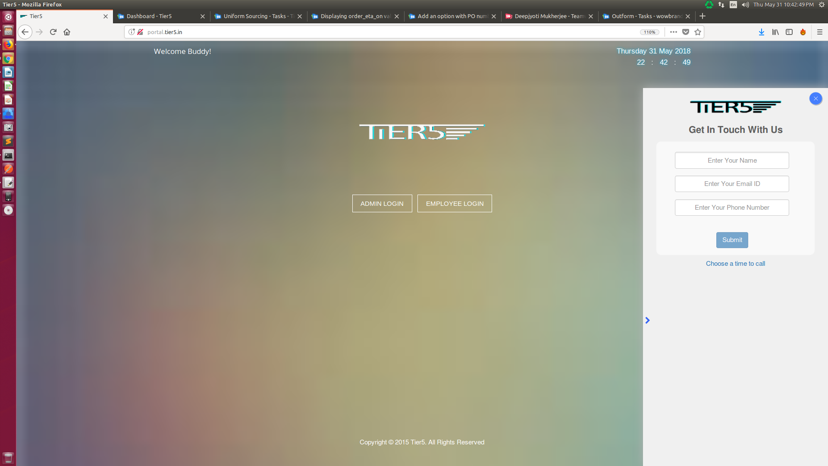

Above picture is for the Widget Chat panel for end user/client.
This panel contain with this following fields:
A. Name:- It is the field where end user will give their name.
B. Email:- It is the field where end user will give their email id.
C. Phone Number:- It is the field where end user will give their phone number.
D. Submit button:- After clicking on this button, end user have to choose any department. Then it will redirect to Chat portal.

When client can start a chat by giving his name, email and phone, which intern treated as new message request to all the agents of the department assigned with that widget used on that website.
That contact will come to the contact list and all the agents will get a notification to their phone number given in there profile
If agents who are getting this request reject it, it will go to rejected list of admin as well as of agents ,now if all the agents attached to the widgets segmented in departments reject the message request then a notification will sent to the admin about the rejection done by the hole department ,and again the message notification sending process will be re-initiated and so on until any agents from any department accept it .Once accepted it will go to admin as well as agents accept list
the agent can transfer that chat thread to any agent or to any department, if it is transferred to any agent the new agent will only have the option to accept or transfer, but if transferred to a department then all the agents in the department have the option of accept, transfer and reject.
Now agent can only mark an ongoing chat thread as resolved which will notify admin as well as it will go to resolved list after chat thread is resolved by the agent any chat came from that client is treated as new message request.
All the chat between agent and client will be held in a web view of client and agent.The client will also have the option to send the chat to his mobile number given by him, so he will receive all the chat to his mobile number by the agent from the mobile number given in the widget.
#Client can also initiate chat from his mobile by directly sending message SMS to the number given in website

Special Feature (Pending):-
There will be some special feature will be incorporated in this system. These are:-
- SMS facility:- if agent or client will exit from this system, then also the chat can be continue by their given phone number.
- Number Porting Facility:- if Admin wants then, admin can easily request to twilio to set the agents phone number as widget number by sending porting request to twilio.
- Notification Facility: If any agent will be offline, then also one notification will go to agents phone number from this system.( from the number which will set at the time of widget /agent creation.

