PHYSICS - VOL 1
UNIT - 1
NAME
:
STANDARD :
SCHOOL
12
:
SECTION :
EXAM NO
:

v ctory R. SARAVANAN. M.Sc, M.Phil, B.Ed.,
PG ASST (PHYSICS)
GBHSS, PARANGIPETTAI - 608 502

www.kalvioli.com

PART - II 2 MARK QUESTIONS AND ANSWERS |  | - Thus The ratio of permittivity of the medium to  the permittivity of free space is called relative  permittivity or dielectric constant. [𝜺_{𝒓} = ^{𝜺} ] .  𝜺𝟎  - It has no unit and for air 𝜀_{𝑟} = 1 and for other dielectric medium 𝜀_{𝑟} > 1  - Give the vector form of Coulomb’s law.  - The force on the point charge 𝒒_{𝟐} exerted by another point charge 𝒒_{𝟏} is  ⃗⃗𝑭⃗ = 𝟏 𝒒𝟏 𝒒𝟐 𝒓̂  𝟐𝟏 𝟒 𝝅 𝜺𝟎 𝒓𝟐 𝟏𝟐  - Simillarly the force on the point charge 𝒒_{𝟏} exerted by another point charge 𝒒_{𝟐} is  ⃗⃗𝑭⃗ = 𝟏 𝒒𝟏 𝒒𝟐 𝒓̂  𝟏𝟐 𝟒 𝝅 𝜺𝟎 𝒓𝟐 𝟐𝟏  - Here, 𝒓̂_{𝟏𝟐} → unit vector directed from 𝒒_{𝟏} to 𝒒_{𝟐}  𝒓̂_{𝟐𝟏} → unit vector directed from 𝒒_{𝟐} to 𝒒_{𝟏}  - Distinguish between Coulomb force and Gravitational force. |  | - Define surface charge density.  - Charge per unit area is called surface charge  density. [𝜎 = ^{𝑞}]  𝐴  - Its S.I unit is 𝑪 𝒎−𝟐  - Define volume charge density.  - Charge per unit volume is called volume charge  density. [𝜌 = ^{𝑞}]  𝑉  - Its S.I unit is 𝑪 𝒎−𝟑  - Define electric field lines.  - A set of continuous lines which are the visual representation of the electric field in some region of space is calle electric field lines.  - Two electric field lines never intersect each other. Why?  - If two lines cross at a point, then there will be two different electric field vectors at the same point.  - If some charge is placed at the intersection point, then it has to move in two different directions at
- What is Electrostatics?
  - The branch of electricity which deals with stationary charges is called electrostatics.
- What is called triboelectric charging?
  - Charging the objects through rubbing is called triboelectric charging.
- Like charges repels. Unlike charges attracts. Prove.
  - A negatively charged rubber rod is repeled by another negatively charged rubber rod.
  - But a negatively charged rubber rod is attracted by a positively charged glass rod.
  - This proves like charges repels and unlike charges attracts.
- State conservation of electric charges.
  - The total electric charge in the universe is constant and charge can neither be created nor be destroyed
  - In any physical process, the net change in charge will be zero. This is called conservation of charges.
- State quantisation of electric charge.  - The charge ‘q’ of any object is equal to an integral multiple of this fundamental unit of charge ‘e’ (i.e) 𝒒 = 𝒏 𝒆  - where, n → integer and 𝒆 = 𝟏. 𝟔 𝑿 𝟏𝟎−𝟏𝟗 𝑪  - State Coulomb’s law in electrostatics.  - According to Coulomb law, the force on the point charge 𝒒_{𝟐} exerted by another point charge 𝒒_{𝟏} is  ⃗⃗𝑭⃗ = 𝒌 𝒒𝟏 𝒒𝟐 𝒓̂  𝟐𝟏 𝒓𝟐 𝟏𝟐  - where, k → constant  𝒓̂_{𝟏𝟐} → unit vector directed from 𝒒_{𝟏} to 𝒒_{𝟐} |  | Coulomb force | Gravitational force |  | the same time, which is physically impossible.  - Hence electric field lines do not intersect.  - What is called electric dipole. Give an example.  - Two equal and opposite charges separated by a small distance constitute an electric dipole.  (e.g) CO, HCl, NH4, H2O  - Define electric dipole moment. Give its unit.  - The magnitude of the electric dipole moment (𝒑) is equal to the product of the magnitude of one of the charges (q) and the distance (2a) between them. (i.e) |𝒑⃗ | = 𝒒. 𝟐𝒂  - Its unit is C m
 |  | It acts between two charges | It acts between two masses
 |  | It can be attractive or  repulsive | It is always attractive | 1
 |  | It is always greater in  magnitude | It is always lesser in  magnitude
 |  | It depends on the nature of  the medium | It is independent of the  medium | 1
 |  | If charges are in motion,  another force called Lorentz force come in to play in addition to Coulomb force | Gravitional force is the  same whether two masses are at rest or in motion
- Define one coulomb (1 C)  - The S.I unit of charge is coulomb (C)  - One Coulomb is that charge which when placed in free space or air at a distance 1 m from an equal and similar charge repels with a force of 9 X 109 N  - Define relative permittivity.  - From Coulomb’s law, the electrostatic force is  ⃗⃗𝑭⃗ = 𝟏 𝒒𝟏 𝒒𝟐 𝒓̂ = 𝟏 𝒒𝟏 𝒒𝟐 𝒓̂  𝟐𝟏 𝟒 𝝅 𝜺 𝒓𝟐 𝟏𝟐 𝟒 𝝅 𝜺𝒐 𝜺𝒓 𝒓𝟐 𝟏𝟐  - Here 𝜀 = 𝜺_{𝒐} 𝜺_{𝒓} is called permittivity of any  medium  - 𝜺_{𝟎} is called permittivity of free space or vacuum and 𝜺_{𝒓} is called relative permittivity. |  | - Define superposition principle.  - According to Superposition principle, the total force acting on a given charge is equal to the vector sum of forces exerted on it by all the other charges.  - Define electric field.  - The electric field at a point ‘P’ at a distance ‘r’ from the point charge ‘q’ is the force experienced by a unit charge. Its S.I unit is N C-1  - Define linear charge density.  - The charge per unit length is called linear charge  density. [𝜆 = ^{𝑞}]  𝑙  - Its S.I unit is 𝑪 𝒎−𝟏 |  | - Define potential difference. Give its unit.  - The electric potential difference is defined as the workdone by an external force to bring unit positive charge from one point to another point against the electric field.  - Its unit is volt (V)  - Define electrostatic potential. Give its unit.  - The electric potential at a point is equal to the work done by an external force to bring a unit positive charge with constant velocity from infinity to the point in the region of the external electric field.  - Its unit is volt (V)
v ctory R. SARAVANAN. M.Sc., M.Phil., B.Ed PG ASST [PHYSICS], GBHSS, PARANGIPETTAI - 608 502 www.kalvioli.com

- Obtain the relation between electric field and electric potential.  - The work done in moving a unit charge through a distance ‘dx’ in an electric field ‘E’ is 𝑑𝑊 = − 𝐸 𝑑𝑥  - Here negative sign indicates work done is against the electric field.  - This work done is equal to the potential difference and hence,  𝑑𝑉 = − 𝐸 𝑑𝑥 (𝑜𝑟) 𝑬 = − 𝒅𝑽  𝒅𝒙  - Thus the electric field is the negative gradient of  electric potential.  - Define equi potential surface.  - An equipotential surface is a surface on which all the points are at the same potential.  - For a point charge the equipotential surfaces are concentric spherical surfaces.  - For a uniform electric field, the equipotential surfaces form a set of planes normal to the electric field.  - Define electrostatic potential energy.  - The electric potential energy of two point charges is equal to the amount of workdone to assemble the charges or workdone in bringing a charge from infinite distance. (i.e) U = W = q V  - Define electric flux.  - The number of electric field lines crossing a given area kept normal to the electric field lines is called electric flux (Φ𝐸).  - Its S.I unit is 𝑵 𝒎𝟐 𝑪−𝟏. It is a scalar quantity.  - State Gauss law.  Gauss law states that if a charge ‘Q’ is enclosed by an arbitrary closed surface, then the total electric  flux through the closed surface is equal to ¹ times  𝜀𝑂  the net charge enclosed by the surface.  Φ = ∮ ⃗𝑬 . 𝒅𝑨⃗ = 𝑸𝒊𝒏𝒔𝒊𝒅𝒆  𝑬 𝜺𝟎  - Define electrostatic shielding .  - By Gauss law, we conclude that the electric field inside the charged spherical shell is zero.  - If a conductor has cavity, then whatever the charges at the surfaces or whatever the electrical diesturbances outside, the electric field inside the cavity is zero. | - A sensitive electrical instrument which is to be protected from external electrical disturnance is kept inside this cavity. This is called electrostatic shielding. (e.g) Faraday cage  - During lightning, it is safer to sit inside bus than in an open ground or under tree. Why?  - The metal body of the bus provides electrostatic shielding, where the electric field is zero.  - During lightning the electric discharge passes through the body of the bus.  - Define electrostatic induction.  - The phenomenom of charging without actual contact of charged body is called electrostatic induction.  - Define dielectrics or insulators.  - A dielectric is a non- conducting material and has no free electrons. The electrons in a dielectric are bound within the atoms.  (e.g) Ebonite. glass and mica  - What are called non-polar molecules. Give examples.  - A non-polar molecule is one in which centres of positive and negative charges coincide.  - It has no permanent dipole moment. (e.g) H2, O2, CO2  - What are called polar molecules. Give examples.  - A polar molecule is one in which the positive and negative charges are separated even in the absence of an external electric field.  - They have a permanent dipole moment. (e.g) H2O, N2O, HCl, NH4  - Define dielectric polarization.  - In the presence of external electric field, dipole moment is induced in the dielectric along the direction of the field.  - Polarisation (𝑝 ) is defined as the total dipole moment per unit volume of the dielectric.  - Define electric susceptibility.  - For dielectrics, the polarization is directly proportional to the strength of the external electric field. (i.e) ⃗𝑷 = 𝝌_{𝒆} 𝑬⃗ 𝒆𝒙𝒕  - where 𝝌_{𝒆} is a constant called the electric  susceptibility which is defined as polarization per unit electric field.  - Its unit is 𝑪𝟐𝑵−𝟏𝒎 | - Define dielectric breakdown.  - When the external electric field applied to dielectric is very large, it tears the atoms apart so that the nound charges become free charges. Then the dielectric starts to conduct electricity. This is called dielectric breakdown.  - Define dielectric strength.  - The maximum electric field the dielectric can withstand before it breakdowns is called dielectric strength.  - The dielectric strength of air is 𝟑 𝑿 𝟏𝟎𝟔 𝑽 𝒎−𝟏  - If the applied electric field is increases beyond this, a spark is produced in the air (i.e) it becomes a conductor  - What is called a capacitor?  - Capacitor is a device used to store electric charge and electric energy.  - It consists of two conducting plates or sheets separated by some distance.  - Capacitors are widely used in many electronic circuits and in many area of science and technology.  - Define capacitance of a capacitor.  - The capacitance of a capacitor is defined as the ratio of the magnitude of charge (Q) on either of the conductor plates to the potential difference  (V) existing between the conductors. (i.e) C = Q/V  - Its unit is farad (F) or C V-1  - Define energy density of a capacitor.  - The energy stored per unit volume of space is defined as energy density and it is derived as,  𝒖 = 𝑼 = 𝟏 𝜺 𝑬𝟐  𝑬 𝒗𝒐𝒍𝒖𝒎𝒆 𝟐 ^{𝒐}  - Define action of point or corona discharge.  - Smaller the radius of curvature, larger the charge density. Hence charges are accumulated at the sharp points.  - Due to this, the electric field near this sharp edge is very high and it ionized the surrounding air.  - The positive ions are repelled and negative ions are attracted towards the sharp edge.  - This reduces the total charge of the conductor near the sharp edge. This is called action of points or corona discharge  www.kalvioli.com

PART - III 3 MARK QUESTIONS AND ANSWERS  - Discuss the basic properties of electric charge.  - Electric charge :  - Like mass, the electric charge is also an intrinsic and fundamental property of particles.  - The unit of electric charge is coulomb  - Conservation of electric charge :  - The total electric charge in the universe is constant and charge can neither be created nor be destroyed.  - In any physical process, the nte change in charge will be zero. This is called conservation of charges  - Quanisation of charge :  - The chage ‘q’ of any object is equal to an integral multiple of this fundamental unit of charge ‘e’ (i.e) 𝒒 = 𝒏 𝒆  - where n → integer and 𝒆 = 𝟏. 𝟔 𝑿 𝟏𝟎−𝟏𝟗 𝑪  - Define superposition principle. Explain how superposition principle explans the interaction between multiple charges.  Superposition principle :  - According to Superposition principle, the total force acting on a given charge is equal to the vector sum of forces exerted on it by all the other charges.  Explanation :  - Consider a system of ‘n’ charges 𝑞₁, 𝑞₂, … , 𝑞_{𝑛}  - By Coulomb’s law, force on 𝑞₁ by 𝑞₂, … , 𝑞_{𝑛} are  ⃗𝐹 = 𝑘 𝑞1 𝑞2 𝑟̂  12 𝑟2 21  21  ⃗𝐹 = 𝑘 𝑞1 𝑞2 𝑟̂  13 𝑟2 31  𝑞 3𝑞1  finally. ⃗𝐹1𝑛 = 𝑘 ¹ ² 𝑟_{𝑛}̂ ₁  𝑟2  𝑛1  - Then total force action on 𝑞₁ due to all charges,  ⃗𝐹𝑡𝑜𝑡 = ⃗𝐹12 + ⃗𝐹13 + … … + ⃗𝐹 1𝑛  1  ⃗⃗𝑭⃗ 𝒕𝒐𝒕 = 𝒌 [𝒒𝟏 𝒒𝟐 𝒓̂ + 𝒒𝟏 𝒒𝟑 𝒓̂ + ⋯ + 𝒒𝟏 𝒒𝒏 𝒓̂ ]  𝟏 𝒓𝟐 𝟐𝟏 𝒓𝟐 𝟑𝟏 𝒓𝟐 𝒏𝟏  𝟐𝟏 𝟑𝟏 𝒏𝟏 | - Explain Electric field at a point dueto system of charges (or) Superposition of electric fields. Superposition of electric field :  - The electric field at an arbitrary point due to system of point charges is simply equal to the vector sum of the electric fields created by the individual point charges. This is called superposition of electric fields.  Explanation :  - Consider a system of ‘n’ charges 𝑞₁, 𝑞₂, … , 𝑞_{𝑛}  - The electric field at ‘P’ due to ‘n’ charges  ⃗⃗𝐸 = 1 𝑞1 𝑟̂  1 4 𝜋 𝜀0 𝑟2 1𝑃  1𝑃  ⃗⃗𝐸 = 1 𝑞2 𝑟̂  2 4 𝜋 𝜀0 𝑟2 2𝑃  2𝑃  finally, ⃗⃗𝐸 = 1 𝑞𝑛 𝑟̂  𝑛 4 𝜋 𝜀0 𝑟2 𝑛𝑃  𝑛𝑃  - The total electric field at ‘P’ due to all these ‘n’  charges will be,  ⃗⃗𝐸 𝑡𝑜𝑡 = ⃗⃗𝐸 1 + ⃗⃗𝐸 2 + … … + ⃗⃗𝐸 𝑛  ⃗⃗𝑬⃗ = 𝟏 [ 𝒒𝟏 𝒓̂ + 𝒒𝟐 𝒓̂ + ⋯ + 𝒒𝒏 𝒓̂ ]  𝒕𝒐𝒕 𝟒 𝝅 𝜺𝟎 𝒓𝟐 𝟏𝑷 𝒓𝟐 𝟐𝑷 𝒓𝟐 𝒏𝑷  𝟏𝑷 𝟐𝑷 𝒏𝑷  - List the properties of electric field lines.  Electric field lines :  - A set of continuous lines which are the visual representation of the electric field in some region of space.  Properties of electric field lines :  - They starts from positive charge and end at negative charge or at infinity.  - The electric field vector at a point in space is tangential to the electric field line at that point.  - The electric field lines are denser in a region where the electric field has larger magnitude and less dense in region where the electric field is of smaller magnitude. (i.e) the number of lines passing through a given surface area perpendicular to the line is proportional to the magnitude of the electric field.  - No two electric field lines intersect each other  - The number of electric field lines that emanate from the positive charge or end at a negative charge is directly proportional to the magnitude of the charges. | - Derive an expression for torque experienced by an electric dipole placed in the uniform electric field. Torque experienced by the dipole in electric field :  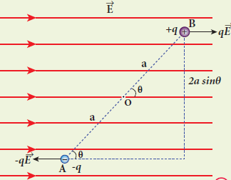  - Let a dipole of moment ⃗⃗𝒑 is placed in an uniform electric field ⃗⃗𝑬⃗  - The force on ‘+q’ = +𝒒⃗⃗𝑬⃗  The force on ‘-q’ = − 𝒒⃗⃗𝑬⃗  - Then the total force acts on the dipole is zero.  - But these two forces constitute a couple and the dipole experience a torque which tend to rotate the dipole along the field.  - The total torque on the dipole about the point ‘O’  ⃗𝜏 = ⃗𝑂⃗⃗⃗𝐴⃗ 𝑋 (− 𝒒⃗⃗𝑬⃗ ) + ⃗𝑂⃗⃗⃗𝐵⃗ 𝑋 (+𝒒⃗⃗𝑬⃗ )  |⃗𝜏 | = |⃗𝑂⃗⃗⃗𝐴⃗ | |− 𝒒⃗⃗𝑬⃗ | sin 𝜃 + |⃗𝑂⃗⃗⃗𝐵⃗ | |𝒒⃗⃗𝑬⃗ | sin 𝜃  𝜏 = (𝑂𝐴 + 𝑂𝐵)𝑞 𝐸 sin 𝜃  𝜏 = 2 𝑎 𝑞 𝐸 sin 𝜃 ∵ [𝑂𝐴 = 𝑂𝐵 = 𝑎]  𝝉 = 𝒑 𝑬 𝐬𝐢𝐧 𝜽  - where, 2 𝑎 𝑞 = 𝑝 → dipole moment  - In vector notation, ⃗⃗𝝉 = ⃗⃗𝒑 𝑿 ⃗⃗𝑬⃗  - The torque is maximum, when 𝜃 = 90°  - Obtain an expression electric potential at a point due to a point charge.  Potential due to a point charge :  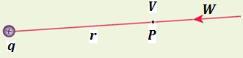  - Consider a point charge +𝒒 at origin.  - ‘P’ be a point at a distance ‘r’ from origin.  - By definition, the electric field at ‘P’ is  ⃗⃗𝐸 = 1 𝑞 𝑟̂ 4 𝜋 𝜀₀ 𝑟2  www.kalvioli.com

- Hence electric potential at ‘P’ is  𝑟 𝑟  𝑉 = − ∫ ⃗⃗𝐸 . ⃗𝑑⃗⃗⃗𝑟 = − ∫ 1 𝑞 𝑟̂ . ⃗𝑑⃗⃗⃗𝑟  4 𝜋 𝜀₀ 𝑟2  ∞ ∞  𝑟  𝑉 = − ∫ 1 𝑞 𝑟̂ . 𝑑𝑟 𝑟̂ [∵ ⃗𝑑⃗⃗⃗𝑟 = 𝑑𝑟 𝑟̂] 4 𝜋 𝜀₀ 𝑟2  ∞ 𝑟  𝑉 = − 𝑞 ∫ 1 𝑑𝑟 [∵ 𝑟̂ . 𝑟̂ = 1] 4 𝜋 𝜀₀ 𝑟2  ∞  𝑞 1 ^{𝑟} 𝑞 1 1  𝑉 = − 4 𝜋 𝜀0 [− 𝑟] = 4 𝜋 𝜀0 [𝑟 − ∞]  ∞  𝑽 = 𝟏 𝒒  𝟒 𝝅 𝜺_{𝟎} 𝒓  - If the source charge is negative (−𝑞) , then the potential also negative and it is given by  𝑽 = − 𝟏 𝒒  𝟒 𝝅 𝜺_{𝟎} 𝒓  - Obtain an expression for potential energy due to a collection of three point charges which are separated by finite distances.  Potential energy of system of three charges :  - Electrostatic potential energy of a system of charges is defined as the work done to assemble the charges  - consider a point charge 𝒒_{𝟏} at ‘A’  - Electric potential at ‘B’ due to 𝒒_{𝟏} is,  𝑉 = 1 𝑞₁  1𝐵 4 𝜋 𝜀0 𝑟12  - To bring second charge 𝒒_{𝟐} to ‘B’, work has to be done against the electric field created by 𝒒_{𝟏}  - The work done on the charge 𝒒_{𝟐} is,  𝑊 = 𝑞 𝑉 = 1 𝑞1 𝑞2 2 1𝐵 4 𝜋 𝜀0 𝑟12  - This work done is stored as electrostatic potential  energy of system of two charges 𝒒_{𝟏} and 𝒒_{𝟐}  𝑼 = 𝟏 𝒒𝟏 𝒒𝟐 − − − −(𝟏)  𝟒 𝝅 𝜺_{𝟎} 𝒓_{𝟏𝟐} | - The potential at ‘C’ due to charges 𝒒_{𝟏} & 𝒒_{𝟐}  𝑉 = 1 𝑞1 & 𝑉 = 1 𝑞2 1𝐶 4 𝜋 𝜀0 𝑟13 2𝐶 4 𝜋 𝜀0 𝑟23  - To bring third charge 𝒒_{𝟑} to ‘C’ , work has to be  done against the electric field due to 𝒒_{𝟏} & 𝒒_{𝟐}.  - Thus work done on charge 𝒒_{𝟑} is,  𝑊 = 𝑞 (𝑉 + 𝑉 ) = 𝑞 1 [ 𝑞1 + 𝑞2 ]  3 1𝐶 2𝐶 3 4 𝜋 𝜀0 𝑟13 𝑟23  (𝑜𝑟) 𝑼 = 𝟏 𝒒𝟏𝒒𝟑 + 𝒒𝟐𝒒𝟑] − − − −(𝟐)  𝟒 𝝅 𝜺_{𝟎} [ 𝒓_{𝟏𝟑} 𝒓_{𝟐𝟑}  - Hence the the total electrostatic potential energy of system of three point charges is  𝑼 = 𝟏 [𝒒𝟏 𝒒𝟐 + 𝒒𝟏𝒒𝟑 + 𝒒𝟐𝒒𝟑] − − − (𝟑)  𝟒 𝝅 𝜺𝟎 𝒓𝟏𝟐 𝒓𝟏𝟑 𝒓𝟐𝟑  - Obtain an expression for electrostatic potential  energy of a dipole in a uniform electric field. Potential energy of dipole in uniform electric field:  - Let a dipole of moment ⃗⃗𝒑 is placed in a uniform electric field ⃗⃗𝑬⃗  - Here the dipole experience a torque, which rotate the dipole along the field.  - To rotate the dipole from 𝜃′ to 𝜃 against this torque, work has to be done by an external torque  (𝜏_{𝑒𝑥𝑡}) and it is given by,  θ θ  𝑊 = ∫ 𝜏_{𝑒𝑥𝑡} 𝑑θ = ∫ 𝑝 𝐸 sin 𝜃 𝑑θ  θ′ θ′  𝑊 = 𝑝 𝐸 [− cos 𝜃]^{θ} = −𝑝 𝐸 [𝑐𝑜𝑠 𝜃 − 𝑐𝑜𝑠 𝜃′ ]  θ′  𝑊 = 𝑝 𝐸 [𝑐𝑜𝑠 𝜃′ − 𝑐𝑜𝑠 𝜃]  - This work done is stored as electrostatic potential energy of the dipole.  - Let the initial angle be 𝜃′ = 90° , then  𝑈 = 𝑊 = 𝑝 𝐸 [𝑐𝑜𝑠 90° − 𝑐𝑜𝑠 𝜃]  𝑼 = − 𝒑 𝑬 𝐜𝐨𝐬 θ = − ⃗⃗𝒑 . ⃗⃗𝑬⃗  - If 𝜃 = 180° , then potential energy is maximum  - If 𝜃 = 0° , then potential energy is mimimum | - Explain the process of electrostatic induction. Electrostatic induction:  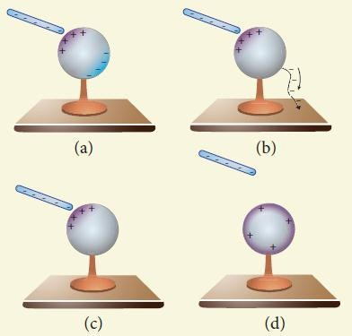  - The type of charging without actual contact of charged body is called electrostatic induction.  - Let a negatively charged rubber rod is brought near to spherical conductor, the electrons in the conductor are repelled to farther side and hence positive charges are induced near the region of the rod. So the distribution of charges are not uniform, but the total charge is zero  - If the conducting sphere is connected to ground, the electrons are flows to the ground, but the positive charges will not flow to the ground, because they are attracted by the negative charges of the rod.  - When the grounding wire is removed from the sphere, the positive charges remain near the rod.  - If the charged rod is taken away, the positive charges are distributed uniformly on the surface of the sphere.  - Thus the neutral conducting sphere becomes positively charged without any contact.  - Derive an expression for capacitance of parallel plate capacitor.  Capacitance of parallel plate capacitor :  www.kalvioli.com
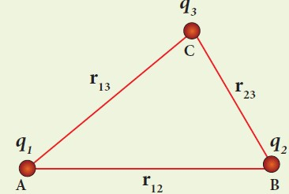
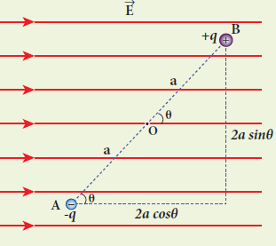
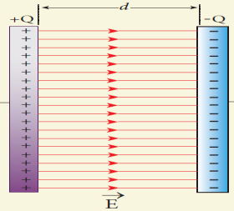

- Consider a capacitor consists of two parallel plates each of area ‘A’ separated by a distance ‘d’  - Let ‘𝝈′ be the surface charge density of the plates.  - The electric field between the plates,  𝑬 = 𝝈 = 𝑸 − − − − − − − (1)  𝜺_{𝑶} 𝑨 𝜺_{𝑶}  - Since the field is uniform, the potential difference between the plates,  𝑽 = 𝑬 𝒅 = [ 𝑸 ] 𝒅 − − − − − (2)  𝑨 𝜺_{𝑶}  - Then the capacitance of the capacitor,  𝐶 = 𝑄 = 𝑄  𝑉 [𝐴𝑄 ] 𝑑  𝜀_{𝑂}  𝑪 = 𝜺 𝑶 𝑨 − − − − − − − (𝟑)  𝒅  - Thus capacitance is,  - directly proportional to the Area (A) and  - inversely proportional to the separation (d)  - Derive an expression for energy stored in capacitor Energy stored in capacitor:  - Capacitor is a device used to store charges and energy.  - When a battery is connected to the capacitor, electrons of total charge ‘-Q’ are transferred from one plate to other plate. For this work is done by the battery.  - This work done is strored as electrostatic energy in capacitor.  - To transfer ′𝑑𝑄′ for a potential difference ‘V’, the work done is  𝑑𝑊 = 𝑉 𝑑𝑄 = 𝑄 𝑑𝑄 [∵ 𝑉 = 𝑄]  𝐶 𝐶  - The total work done to charge a capacitor,  𝑄 𝑄 1 𝑄2 𝑄 𝑄2  𝑊 = ∫ 𝐶 𝑑𝑄 = 𝐶 [ 2 ] = 2 𝐶  0 0  - This work done is stored as electrostatic energy of the capacitor, (i.e)  𝑸𝟐 𝟏  𝑼_{𝑬} = 𝟐 𝑪 = 𝟐 𝑪 𝑽𝟐 [∵ 𝑄 = 𝐶 𝑉]  - We know that, 𝑉 = 𝐸 𝑑 & 𝐶 = ^{𝜀𝑂} ^{𝐴}  𝑑  ∴ 𝑈 = 1 𝜀 𝑂 𝐴 (𝐸 𝑑)2 = 1 𝜀 (𝐴 𝑑) 𝐸2  𝐸 2 𝑑 2 ^{𝑂}  - where, (𝐴 𝑑) → 𝑣𝑜𝑙𝑢𝑚𝑒 | - The energy stored per unit volume of space is defined as energy density ((𝒖_{𝑬}).  𝒖 = 𝑼𝑬 = 𝟏 𝜺 𝑬𝟐  𝑬 𝒗𝒐𝒍𝒖𝒎𝒆 𝟐 ^{𝑶}  - Explain in detail how charges are distributed in a  conductor and the principle behind the lightning conductor.  Distribution of charges in a conductor :  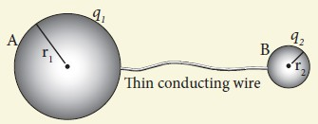  - Consider two conducting spheres ‘A’ and ‘B’ of radii 𝒓_{𝟏} and 𝒓_{𝟐}. Let 𝒓_{𝟏} > 𝒓_{𝟐}  - Let the two spheres are connected by a thin conducting wire.  - If a charge ‘Q’ is given to either A or B, this charge is redistributed in both the spheres until their potential becomes same.  - Now they are uniformly charged and attain electrostatic equilibrium.  - At this stage, let the surface charge densities of A and B are 𝜎₁ and 𝜎₂ respectively, then  Charge residing on suface of A = 𝑞₁ = 𝜎₁4 𝜋 𝑟2  1  Charge residing on suface of B = 𝑞₂ = 𝜎₂4 𝜋 𝑟2  2  - Then the total charge ; Q = 𝑞₁ + 𝑞₂  - There is no net charge inside the conductors.  - Electrostic potential on the surface of A and B is  𝑉 = 1 𝑞1 & 𝑉 = 1 𝑞2  𝐴 4 𝜋 𝜀₀ 𝑟₁ ^{𝐵} 4 𝜋 𝜀₀ 𝑟₂  - Under elecrostic equilibrium. 𝑉_{𝐴} = 𝑉_{𝐵}  ∴ 1 𝑞₁ = 1 𝑞₂  4 𝜋 𝜀₀ 𝑟₁ 4 𝜋 𝜀₀ 𝑟₂  𝑞₁ = 𝑞₂  𝑟₁ 𝑟₂  𝜎₁4 𝜋 𝑟2 𝜎 ₂4 𝜋 𝑟2  1 = 2  𝑟₁ 𝑟₂  𝜎₁ 𝑟₁ = 𝜎₂ 𝑟₂  (𝑜𝑟) 𝝈 𝒓 = 𝒄𝒐𝒏𝒔𝒕𝒂𝒏𝒕  - Thus the surface charge density is inversely proportional to the radius of the sphere.  - Hence for smaller radius , the charge density will be larger and vice versa | Principle of lightning conductor (Action of point) :  - Action of point is the principle behind the lightning conductor.  - We know that smaller the radius of curvature, the larger is the charge density.  - If the conductor has sharp end which has larger curvature (smaller radius), it has a large charge accumulation.  - As a result, the electric field near this edge is very high and it ionizes the surrounding air.  - The positive ions are repelled at the sharp edge and negative ions are attracted towards the sharper edge.  - This reduces the total charge of the conductor near the sharp edge. This is called action of points or corona discharge.  - Explain the principle, construction and action of lightning conductor.  Lightning conductor :  - This is a device used to protect tall building from lightning strikes;  - It woks on the principle of acion of points or corona discharge.  - It consists of a long thick copper rod passing from top of the building to the ground.  - The upper end of the rod has a sharp spike or a sharp needle. The lower end of the rod is connected to the copper plate which is buried deep in to the ground.  - When a negatively charged cloud is passing above the building, it induces a positive charge on the spike.  - Since the charge density is large at the spike, action of point takes place.  - This positive charge ionizes the surrounding air which in turn neutralizes the negative charge in the cloud.  - The negative charge pushed to the spikes passes through the copper rod and is safely diverted to the Earth.  - Thus the lighting arrester does not stop the lightning, but it diverts the lightning to the ground safely  www.kalvioli.com
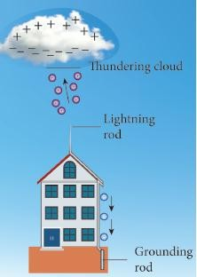

- Give the applications and disadvantage of  capacitors  Applications of capacitor:  - Flash capacitors are used in digital camera to take photographs  - During cardiac arrest, a device called heart defibrillator is used to give a sudden surge of a large amount of electrical energy to the patient’s chest to retrieve the normal heart function. This defibrillator uses a capacitor of 175 µF charged to a high voltage of around 2000 V  - Capacitors are used in the ignition system of automobile engines to eliminate sparking.  - Capacitors are used to reduce power fluctuations in power supplies and to increase the efficiency of power transmission.  Disadvantages :  - Even after the battery or power supply is removed, the capacitor stores charges and energy for some time. It caused unwanted shock.  - Define equipotential surface. Give its properties. Equipotential surface:  - An equipotential surface is a surface on which all the points are at the same potential.  - For a point charge the equipotential surfaces are concentric spherical surfaces.  - For a uniform electric field, the equipotential surfaces form a set of planes normal to the electric field.  Properties :  - The wor kdone to move a charge ‘q’ between any two points A and B is 𝑊 = 𝑞 (𝑉_{𝐴} − 𝑉_{𝐵}). If A and B lie on the same equipotential surface then 𝑉_{𝐴} = 𝑉_{𝐵} Hence work done is zero (𝑊 = 0)  - The electric field is always normal to an equipotential surface.  - Write a note on microwave oven. Microwave oven :  - It works on the principle of torque acting on an electric dipole.  - The food we consume has water molecules which are permanent electric dipoles. Oven produce microwaves that are oscillating electromagnetic fields and produce torque on the water molecules. |  | - Due to this torque on each water molecule, the | PART - IV | 5 MARK QUESTIONS & ANSWERS
 |  | molecules rotate very fast and produce thermal
- Explain in detail Coulomb’s law and its various aspects. Coulomb’s law :
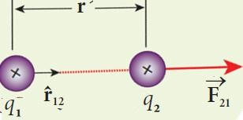
  - Consider two point charges 𝒒_{𝟏} and 𝒒_{𝟐} separated by a distance ′𝒓′
  - According to Coulomb law, the force on the point charge 𝒒_{𝟐} exerted by 𝒒_{𝟏} is
⃗⃗𝑭⃗ = 𝒌 𝒒𝟏 𝒒𝟐 𝒓̂
𝟐𝟏 𝒓𝟐 𝟏𝟐
  - where, k → constant
𝒓̂_{𝟏𝟐} → unit vector directed from 𝒒_{𝟏} to 𝒒_{𝟐}
Important aspects :
  - Coulomb law states that the electrostatic force is
    - directly proportional to the product of the magnitude of two point charges
    - inversely proportional to the square of the distance between them
  - The force always lie along the line joining the two charges.
  - In S.I units, 𝒌 = ^{𝟏} = 𝟗 𝑿 𝟏𝟎𝟗 𝑵 𝒎𝟐𝑪−𝟐
𝟒 𝝅𝜺𝟎
  - Here is the permittivity of free space or vacuum and its value is
𝜺 = 𝟏 = 𝟖. 𝟖𝟓 𝑿 𝟏𝟎−𝟏𝟐 𝑪𝟐 𝑵−𝟏𝒎−𝟐
𝟎 𝟒 𝝅𝒌
  - The magnitude of electrostatic force between two
charges each of 1 C separated by a distance of 1 m is 𝟗 𝑿 𝟏𝟎𝟗 𝑵
  - The Coulomb law in vacuum and in medium are,
⃗𝑭 = 𝟏 𝒒𝟏 𝒒𝟐 𝒓̂
𝟐𝟏 𝟒 𝝅𝜺𝟎 𝒓𝟐 𝟏𝟐
& ⃗𝑭 = 𝟏 𝒒𝟏 𝒒𝟐 𝒓̂
𝟐𝟏 𝟒 𝝅𝜺 𝒓𝟐 𝟏𝟐
where, 𝜀 = 𝜀_{𝑜}𝜀_{𝑟} −→ permittivity of the medium Thus the relative permittivity of the given medium
is defined as , 𝜀_{𝑟} = ^{𝜀} . For air or vacuum, 𝜀_{𝑟} = 1
𝜀𝑜
and for all other media 𝜀_{𝑟} > 1
  - Coulomb’s law has same structure as Newton’s law of gravitation. (i.e)
𝐹 = 𝑘 𝑞1𝑞2 & 𝐹 = 𝐺 𝑚1𝑚2
𝐶𝑜𝑢𝑙𝑜𝑚𝑏 𝑟2 𝑁𝑒𝑤𝑡𝑜𝑛 𝑟2
www.kalvioli.com
 |  | energy.
 |  | - Thus, heat generated is used to heat the food.
 | -

- Here 𝑘 = 9 𝑋 109 𝑁 𝑚2𝐶−2 and  𝐺 = 6.626 𝑋 10−11 𝑁 𝑚2𝑘𝑔−2  Since ‘k’ is much more greater than ‘G’, the electrostatic force is always greater than gravitational force for smaller size objects  - Electrostatic force between two point charges depends on the nature of the medium in which two charges are kept at rest.  - Depending upon the nature of the charges, it may either be attractive or repulsive  - If the charges are in motion, another force called Lorentz force come in to play in addition with Coulomb force.  - Electrostatic force obeys Newton’s third law. (i.e)  ⃗𝑭 𝟐𝟏 = − ⃗𝑭 𝟏𝟐  - Define electric field. Explain its various aspects.  Electric field :  - The electric field at the point ‘P’ at a distance ‘r’ from the point charge ‘q’ is the force experienced by a unit charge and is given by  ⃗⃗⃗  ⃗⃗𝑬⃗ = 𝑭 = 𝟏 𝒒 𝒓̂  𝒒_{𝒐} 𝟒 𝝅 𝜺_{𝒐} 𝒓𝟐  Important aspects :  - If ‘q’ is positive, the electric field points away and if ‘q’ is negative the electric field points towards the source charge.  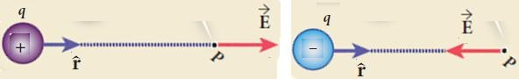  - The force experienced by the test charge 𝒒_{𝒐} placed in electric field ⃗⃗𝐸 is , ⃗⃗𝑭⃗ = 𝒒_{𝒐} ⃗⃗𝑬⃗  - The electric field is independent of test charge 𝒒_{𝒐}  and it depends only on souce charge 𝒒  - Electric field is a vector quantity. So it has unique direction and magnitude at every point.  - Since electric field is inversely proportional to the distance, as distance increases the field decreases.  - The test charge is made sufficiently small such that it will not modify the electric field of the source charge.  - For continuous and finite size charge distributions, integration techniques must bt used  - There are two kinds of electric field. They are  - Uniform or constant field  - Non uniform field | - How do we determine the electric field due to a  continuous charge distribution? Explain. Continuos distribution of charges  - Consider a charged object of irregularshape which is divided into a large number of charge elements ∆𝑞₁, ∆𝑞₂, ∆𝑞₃, … ∆𝑞_{𝑛}  - The electric field at ‘P’ due to this charged object is equal to sum of all the charged elements. (i.e)  ⃗⃗𝐸 = 1 [∆𝑞1 𝑟̂ + ∆𝑞2 𝑟̂ + ⋯ + ∆𝑞𝑛 𝑟̂ ] 4 𝜋 𝜀𝑜 𝑟12 1𝑃 𝑟 2 2𝑃 𝑟 2 𝑛𝑃  𝑃 2𝑃 𝑛𝑃  𝒏  ⃗⃗𝑬⃗ = 𝟏 ∑ ∆𝒒𝒊 𝒓̂  𝟒 𝝅 𝜺𝒐 𝒓 𝟐 𝒊𝑷  𝒊=𝟏 𝒊𝑷  - For continuous distribution of charge, we have  ∆𝑞 → 0 (= 𝑑𝑞). Hence  ⃗⃗𝑬⃗ = 𝟏 ∫ 𝒅𝒒 𝒓̂ − − − − − − − (𝟏)  𝟒 𝝅 𝜺_{𝒐} 𝒓𝟐  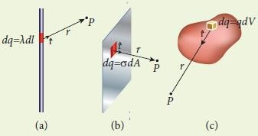  - Linear charge distribution :  - If the charge ‘Q’ is uniformly distributed along the wire of length ‘L’, then charge per unit  length (i.e) linear charge density ; 𝜆 = ^{𝑄}  𝐿  - Hence, 𝑑𝑞 = 𝜆 𝑑𝑙  - Then the electric field due to line of total charge Q is  ⃗⃗𝑬⃗ = 𝟏 ∫ 𝝀 𝒅𝒍 𝒓̂ = 𝝀 ∫ 𝒅𝒍 𝒓̂  𝟒 𝝅 𝜺_{𝒐} 𝒓𝟐 𝟒 𝝅 𝜺_{𝒐} 𝒓𝟐  - Surface charge distribution :  - If the charge ‘Q’ is uniformly distributed on the surface of area ‘A’, then charge per unit  area (i.e) surface charge density ; 𝜎 = ^{𝑄}  𝐴  - Hence, 𝑑𝑞 = 𝜎 𝑑𝐴 | - Then the electric field due to surface of total  charge Q is  ⃗⃗𝑬⃗ = 𝟏 ∫ 𝝈 𝒅𝑨 𝒓̂ = 𝝈 ∫ 𝒅𝑨 𝒓̂  𝟒 𝝅 𝜺_{𝒐} 𝒓𝟐 𝟒 𝝅 𝜺_{𝒐} 𝒓𝟐  - Volume charge distribution :  - If the charge ‘Q’ is uniformly distributed in a volume ‘V’, then charge per unit volume (i.e)  volume charge density ; 𝜌 = ^{𝑄}  𝑉  - Hence, 𝑑𝑞 = 𝜌 𝑑𝑉  - Then the electric field due to volume of total charge Q is  ⃗⃗𝑬⃗ = 𝟏 ∫ ρ 𝒅𝑽 𝒓̂ = ρ ∫ 𝒅𝑽 𝒓̂  𝟒 𝝅 𝜺_{𝒐} 𝒓𝟐 𝟒 𝝅 𝜺_{𝒐} 𝒓𝟐  - Calculate the electric field due to a dipole on its axial line.  Electric field due to dipole on its axial line :  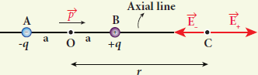  - Consider a dipole AB along X - axis. Its diplole moment be 𝒑 = 𝟐𝒒𝒂 and its direction be along  − 𝒒 to + 𝒒 .  - Let ‘C’ be the point at a distance ‘r’ from the mid point ‘O’ on its axial line.  - Electric field at C due to +𝒒  ⃗𝑬 = 𝟏 𝒒 𝒑̂  + 𝟒 𝝅 𝜺_{𝒐} (𝒓 − 𝒂)𝟐  - Electric field at C due to −𝒒  ⃗𝑬 = − 𝟏 𝒒 𝒑̂  − 𝟒 𝝅 𝜺_{𝒐} (𝒓 + 𝒂)𝟐  - Since +𝒒 is located closer to pont ‘C’ than −𝒒 ,  ⃗𝑬 + > 𝑬⃗ −  - By superposition principle, the total electric field at ‘C’ due to dipole is,  𝐸⃗ 𝑡𝑜𝑡 = 𝐸⃗ + + 𝐸⃗ −  𝐸⃗ = 1 𝑞 𝑝̂ − 1 𝑞 𝑝̂  𝑡𝑜𝑡 4 𝜋 𝜀_{𝑜} (𝑟 − 𝑎)2 4 𝜋 𝜀_{𝑜} (𝑟 + 𝑎)2  𝐸⃗ = 1 𝑞 [ 1 − 1 ] 𝑝̂  𝑡𝑜𝑡 4 𝜋 𝜀_{𝑜} (𝑟 − 𝑎)2 (𝑟 + 𝑎)2  ⃗ 1 (𝑟 + 𝑎)2 − (𝑟 − 𝑎)2  𝐸𝑡𝑜𝑡 = 4 𝜋 𝜀_{𝑜} 𝑞 [ (𝑟 − 𝑎)2 (𝑟 + 𝑎)2 ] 𝑝̂  www.kalvioli.com
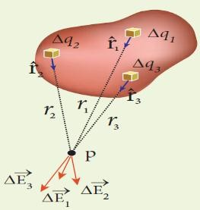

⃗ 1 𝑟2 + 𝑎2 + 2 𝑟 𝑎 − 𝑟2 − 𝑎2 + 2 𝑟 𝑎  𝐸𝑡𝑜𝑡 = 4 𝜋 𝜀_{𝑜} 𝑞 [ 〈(𝑟 − 𝑎)(𝑟 + 𝑎)〉2 ] 𝑝̂  𝐸⃗ = 1 𝑞 [ 4 𝑟 𝑎 ] 𝑝̂  𝑡𝑜𝑡 4 𝜋 𝜀_{𝑜} 〈𝑟2 − 𝑎2〉2  - Here the direction of total electric field is the dipole moment ⃗⃗𝒑 .  - If 𝑟 ≫ 𝑎 , then neglecting 𝑎2. We get  𝐸⃗ 1 4 𝑟 𝑎 1 4 𝑎  𝑡𝑜𝑡 = 4 𝜋 𝜀𝑜 𝑞 [ 𝑟4 ] 𝑝̂ = 4 𝜋 𝜀𝑜 𝑞 [ 𝑟3 ] 𝑝̂  𝑬⃗ 𝟏 𝟐 ⃗⃗𝒑  𝒕𝒐𝒕 = 𝟒 𝝅 𝜺𝒐 𝒓𝟑 [ 𝑞 2𝑎 𝑝̂ = ⃗𝑝 ]  - Calculate the electric field due to a dipole on its equatorial line.  Electric field due to dipole on its equatorial line :  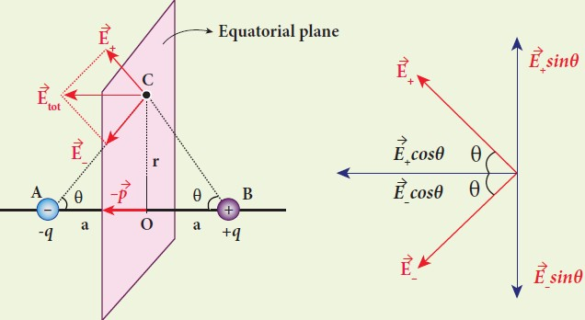  - Consider a dipole AB along X - axis. Its diplole moment be 𝒑 = 𝟐𝒒𝒂 and its direction be along  − 𝒒 to + 𝒒 .  - Let ‘C’ be the point at a distance ‘r’ from the mid point ‘O’ on its equatorial plane.  - Electric field at C due to +𝒒 (along BC)  | 𝑬⃗ | = 𝟏 𝒒  + 𝟒 𝝅 𝜺_{𝒐} (𝒓𝟐 + 𝒂𝟐)  - Electric field at C due to −𝒒 (along CA)  | 𝑬⃗ 𝟏 𝒒  −| = 𝟒 𝝅 𝜺_{𝒐} (𝒓𝟐 + 𝒂𝟐)  - Here | 𝑬⃗ +| = | ⃗𝑬 −|  - Resolve 𝑬⃗ + and ⃗𝑬 − in to two components.  - Here the perpendicular components | 𝑬⃗ +| 𝒔𝒊𝒏 𝜽 and | 𝑬⃗ −| 𝒔𝒊𝒏 𝜽 are equal and opposite will cancel each other | - But the horizontal components | 𝑬⃗ +| 𝒄𝒐𝒔 𝜽 and  | 𝑬⃗ −| 𝒄𝒐𝒔 𝜽 are equal and in same direction (−𝒑̂) will added up to give total electric field. Hence  𝐸⃗ 𝑡𝑜𝑡 = | 𝐸⃗ +| 𝑐𝑜𝑠 𝜃 (−𝑝̂) + | 𝐸⃗ −| 𝑐𝑜𝑠 𝜃 (−𝑝̂) (𝑜𝑟) 𝐸⃗ 𝑡𝑜𝑡 = − 2 | 𝐸⃗ +| 𝑐𝑜𝑠 𝜃 𝑝̂  𝐸⃗ = − 2 [ 1 𝑞 ] cos 𝜃 𝑝̂  𝑡𝑜𝑡 4 𝜋 𝜀_{𝑜} (𝑟2 + 𝑎2)  𝐸⃗ 1 2 𝑞 𝑎  𝑡𝑜𝑡 = − [ 2 2 ] 1 𝑝̂  4 𝜋 𝜀_{𝑜} (𝑟 + 𝑎 ) (𝑟2 + 𝑎2)2  𝐸⃗ = − 1 2 𝑞 𝑎 𝑝̂  𝑡𝑜𝑡 4 𝜋 𝜀𝑜 (𝑟2 + 𝑎2) 3  2  𝐸⃗ 1 𝑝 𝑝̂ = − 1 ⃗𝑝  𝑡𝑜𝑡 = − 4 𝜋 𝜀_{𝑜} ( )3 4 𝜋 𝜀_{𝑜} 3  𝑟2 + 𝑎2 2 (𝑟2 + 𝑎2)2  - If 𝑟 ≫ 𝑎 then neglecting 𝑎2  𝑬⃗ = − 𝟏 ⃗⃗𝒑 [ 𝑞 2𝑎 𝑝̂ = 𝑝 𝑝̂ = ⃗𝑝 ]  𝒕𝒐𝒕 𝟒 𝝅 𝜺𝒐 𝒓𝟑  - Derive an expression for electro static potential  due to electric dipole.  Electrostatic potential due to dipole :  - Consider a dipole AB along X - axis. Its diplole moment be 𝒑 = 𝟐𝒒𝒂 and its direction be along  − 𝒒 to + 𝒒  - Let ‘P’ be the point at a distance ‘r’ from the mid point ‘O’  - Let ∠𝑃𝑂𝐴 = 𝜃, 𝐵𝑃 = 𝑟₁ and 𝐴𝑃 = 𝑟₂  - Electric potential at P due to +𝒒 V = 1 q  1 4 πε₀ r₁  - Electric potential at P due to −𝒒  V = − 1 q  2 4 πε₀ r₂  - Then total potential at ‘P’ due to dipole is  V = V + 𝑉 = 1 q [ 1 − 1 ] − − − (1)  1 2 4 πε0 r1 r2 | - Apply cosine law in Δ BOP  r 2 = r2 + a2 − 2 r a cos θ  1  a2 2 a  r 2 = r2 [1 + − cos θ]  1 r2 r  - If 𝑎 ≪ 𝑟 then neglecting ^{𝑎}2  𝑟2  r 2 = r2 [1 − 2 a cos θ]  1 r  1  r = r [1 − 2d cos θ 2  1 r ]  1  1 1 2 a ⁻2  r1 = r [1 − r cos θ]  1 = 1 [1 + a cos θ] – − − − (2)  r₁ r r  - Apply cosine law in Δ AOP  r 2 = r2 + a2 + 2 r a cos (180° − θ)  2  a2 2 a  r 2 = r2 [1 + r2 + r cos θ]  2  - If 𝑎 ≪ 𝑟 then neglecting ^{𝑎}2  𝑟2  r 2 = r2 [1 + 2 a cos θ]  2 r  1  r = r [1 + 2 a cos θ]2  2 r  1 1 2 a ⁻1  2  r2 = r [1 + r cos θ]  1 = 1 [1 + a cos θ] – − − − (3)  r₂ r r  - Put equation (2) and (3) in (1)  𝑉 = 1 𝑞 1 [1 + 𝑎 𝑐𝑜𝑠 𝜃] − 1 [1 − 𝑎 𝑐𝑜𝑠 𝜃]} 4𝜋𝜀₀ {𝑟 𝑟 𝑟 𝑟  𝑉 = 1 𝑞 [1 + 𝑎 𝑐𝑜𝑠 𝜃 − 1 + 𝑎 𝑐𝑜𝑠 𝜃] 4𝜋𝜀₀ 𝑟 𝑟 𝑟  𝑉 = 1 𝑞 2 𝑎 𝑐𝑜𝑠 𝜃 = 1 2 𝑞 𝑎 𝑐𝑜𝑠 𝜃 4𝜋𝜀₀ 𝑟 𝑟 4𝜋𝜀₀ 𝑟2  𝑽 = 𝟏 𝒑 𝒄𝒐𝒔 𝜽 [𝑝 = 2𝑞𝑎]  𝟒𝝅𝝐_{𝟎} 𝒓𝟐  (𝒐𝒓) 𝑽 = 𝟏 ⃗⃗𝒑⃗⃗⃗ . 𝒓̂ [𝑝 𝑐𝑜𝑠 𝜃 = ⃗⃗𝑝⃗⃗⃗ . 𝑟̂]  𝟒𝝅𝝐_{𝟎} 𝒓𝟐  - Here 𝑟̂ is the unit vector along OP  www.kalvioli.com
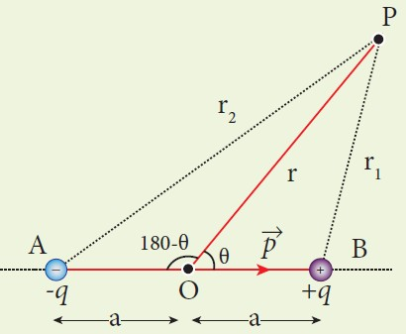

case -1 : If θ = 0° ; 𝑐𝑜𝑠 θ = 1 then,  𝑽 = 𝟏 𝒑  𝟒𝝅𝜺_{𝟎} 𝒓𝟐  Case -2 : If θ = 180° ; 𝑐𝑜𝑠θ = −1 then,  𝑽 = − 𝟏 𝒑  𝟒𝝅𝜺_{𝟎} 𝒓𝟐  Case -3 : If θ = 90°; 𝑐𝑜𝑠θ = 0 then,  𝑽 = 𝟎  - Obtain an expression for electric field due to an infinitely long charged wire.  Electric field due to infinitely long charged wire :  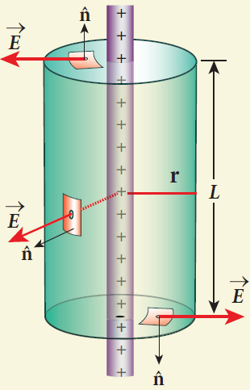  - Consider an infinitely long straight wire of uniform linear charge density ‘λ’  - Let ‘P’ be a point at a distance ‘r’ from the wire. Let ‘E’ be the electric field at ‘P’  - Consider a cylindrical Gaussian surface of length ‘L’ and radius ‘r’  - The electric flux through the top surface,  Φ_{𝑡𝑜𝑝} = ∫ ⃗⃗𝐸 . ⃗𝑑⃗⃗⃗𝐴⃗ = ∫ 𝐸 𝑑𝐴 cos 90° = 0  - The electric flux through the bottom surface,  Φ_{𝑏𝑜𝑡𝑡𝑜𝑚} = ∫ ⃗⃗𝐸 . 𝑑⃗⃗⃗⃗𝐴⃗ = ∫ 𝐸 𝑑𝐴 cos 90° = 0  - The electric flux through the curved surface,  Φ_{𝑐𝑢𝑟𝑣𝑒} = ∫ ⃗⃗𝐸 . 𝑑⃗⃗⃗⃗𝐴⃗ = ∫ 𝐸 𝑑𝐴 cos 0° = 𝐸 ∫ 𝑑𝐴 Φ_{𝑐𝑢𝑟𝑣𝑒} = 𝐸 2 𝜋 𝑟 𝐿  - Then the total electric flux through the Gaussian  surface,  Φ𝐸 = Φ𝑡𝑜𝑝 + Φ𝑏𝑜𝑡𝑡𝑜𝑚 + Φ𝑐𝑢𝑟𝑣𝑒  𝚽_{𝑬} = 𝑬 (𝟐 𝝅 𝒓 𝑳) | - By Gauss law,  Φ = 𝑄𝑖𝑛  𝐸 𝜀𝑜  𝐸 (2 𝜋 𝑟 𝐿) = 𝜆 𝐿  𝜀_{𝑜}  𝑬 = 𝝀  𝟐 𝝅 𝜺_{𝒐} 𝒓  - In Vector notation,  𝑬⃗⃗⃗ = 𝝀 𝒓̂  𝟐 𝝅 𝜺_{𝒐} 𝒓  - Here ̂𝒓 → unit vector perpendicular to the curved surface outwards.  - If 𝜆 > 0 , then ⃗⃗𝐸 points perpendicular outward (𝑟̂) from the wire and if 𝜆 < 0 , then ⃗⃗𝐸 points perpendicular inward (− 𝑟̂)  - Obtain an expression for electric field due to an charged infinite plane sheet.  Electric field due to charged infinite plane sheet :  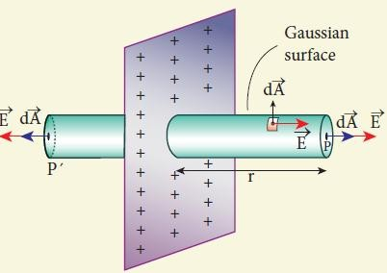  - Consider an infinite plane sheet of uniform surface charge density ‘𝜎’  - Let ‘P’ be a point at a distance ‘r’ from the sheet. Let ‘E’ be the electric field at ‘P’  - Here the direction of electric field is perpendicularly outward from the sheet.  - Consider a cylindrical Gaussian surface of length ‘2r’ and area of cross section ‘A’  - The electric flux through plane surface ‘P’  Φ_{𝑃} = ∫ ⃗⃗𝐸 . ⃗𝑑⃗⃗⃗𝐴⃗ = ∫ 𝐸 𝑑𝐴 cos 0° = ∫ 𝐸 𝑑𝐴  - The electric flux through plane surface ‘P′’  𝚽_{𝑷′} = ∫ ⃗⃗𝐸 . ⃗𝑑⃗⃗⃗𝐴⃗ = ∫ 𝐸 𝑑𝐴 cos 0° = ∫ 𝐸 𝑑𝐴 | - The electric flux through the curved surface,  Φ_{𝑐𝑢𝑟𝑣𝑒} = ∫ ⃗⃗𝐸 . ⃗𝑑⃗⃗⃗𝐴⃗ = ∫ 𝐸 𝑑𝐴 cos 90° = 0  - The total electric flux through through the Gaussian surface,  Φ𝐸 = Φ𝑃 + 𝚽𝑷′ + Φ𝑐𝑢𝑟𝑣𝑒  𝚽_{𝑬} = ∫ 𝐸 𝑑𝐴 + ∫ 𝐸 𝑑𝐴 + 0 = 2 𝐸 ∫ 𝑑𝐴  𝚽_{𝑬} = 𝟐 𝑬 𝑨  - By Gauss law,  Φ = 𝑄𝑖𝑛  𝐸 𝜀𝑜  2 E A = 𝜎 𝐴  𝜀_{𝑜}  𝐄 = 𝝈  𝟐 𝜺_{𝒐}  - In vector notation,  ⃗𝑬⃗⃗ = 𝝈 𝒏̂  𝟐 𝜺_{𝒐}  - Here ̂𝒏 → unit vector perpendicular to the plane sheet outwards.  - If 𝜎 > 0 , then ⃗⃗𝐸 points perpendicular outward (𝑛̂) from the plane sheet and if 𝜎 < 0 , then ⃗⃗𝐸 points perpendicular inward (− 𝑛̂)  - Obtain an expression for electric field due to an uniformly charged spherical shell.  Electric field due to charged spherical shell :  - Consider an uniformly charged spherical shell of radius ‘R’ and charge ‘Q’  1) At a point outside the shell (𝒓 > 𝑹) :  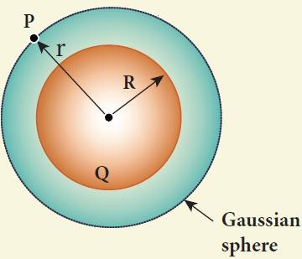  - Let P be the point outside the shell at a distance ‘r’ from its centre.  - Here electric field points radially outwards if Q >0 and radially inward if Q < 0.  www.kalvioli.com

- Consider a spherical Gaussian surface of radius ‘r’ which encloses the total charge ‘Q’  - Since 𝐸⃗ and 𝑑⃗⃗⃗⃗𝐴⃗ are along radially outwards, we have 𝜃 = 0°  - The electric flux through the Gaussian surface,  Φ_{𝐸} = ∮ 𝐸⃗ . ⃗𝑑⃗⃗⃗𝐴⃗ = ∮ 𝐸 𝑑𝐴 𝑐𝑜𝑠 0°  𝚽_{𝑬} = 𝑬 ∮ 𝒅𝑨 = 𝑬 (𝟒 𝝅 𝒓𝟐)  - By Gauss law,  Φ = 𝑄𝑖𝑛  𝐸 𝜀𝑜  𝐸 (4 𝜋 𝑟2) = 𝑄  𝜀_{𝑜}  𝑬 = 𝟏 𝑸  𝟒 𝝅 𝜺_{𝒐} 𝒓𝟐  - In vector notation,  𝑬⃗⃗⃗ = 𝟏 𝑸 𝒓̂  𝟒 𝝅 𝜺_{𝒐} 𝒓𝟐  - Here ̂𝒓 → unit vector acting radiallyh outward from the spherical surface.  2) At a point on the surface of the shell (𝒓 = 𝑹):  - If the point lies on the surface of the charged shell, then = 𝑹 . Then the electric field,  𝑬⃗⃗⃗ = 𝟏 𝑸 𝒓̂  𝟒 𝝅 𝜺_{𝒐} 𝑹𝟐  3) At a point inside the shell (𝒓 < 𝑹) ∶  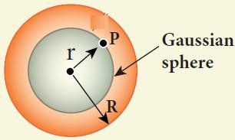  - Let ‘P’ be the point inside the charged shell at a distance ‘r’ from its centre.  - Consider the spherical Gaussian surface of radius ‘r’  - Since there is no charge inside the Gaussian surface, Q = 0  - Then from Gauss law,  Φ = ∮ 𝐸⃗ . ⃗𝑑⃗⃗⃗𝐴⃗ = 𝑄𝑖𝑛  𝐸 𝜀𝑜  𝐸 (4 𝜋 𝑟2) = 0  𝑬 = 𝟎 | - Thus the electric field due to the uniform charged spherical shell is zero at all points inside the shell.  - Obtain Gauss law from Coulomb’s law.  Gauss law from Coulomb’s law :  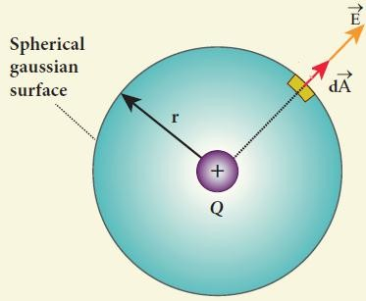  - Consider a charged particle of charge ‘+q’  - Draw a Gaussian spherical surface of radius ‘r’ around this charge.  - Due to symmentry, the electric field ⃗⃗𝐸 at all the points on the spherical surface have same magnitude and radially outward in direction.  - If a test charge ‘𝑞_{𝑜}’ is placed on the Gaussian surface, by Coulomb law the force acting it is,  |⃗𝐹 | = 1 𝑄 𝑞𝑜  4 𝜋 𝜀_{𝑜} 𝑟2  - By definition, the electric field,  |⃗𝐹 | 1 𝑄  |⃗⃗𝐸 | = 𝑞 = 4 𝜋 𝜀 𝑟2 − − − −(1)  𝑜 𝑜  - Since the area element ⃗𝑑⃗⃗⃗𝐴⃗ is along the electric field 𝐸⃗ , we have 𝜃 = 0°. Hence the electric flux through the Gaussian surface is,  Φ_{𝐸} = ∮ 𝐸⃗ . ⃗𝑑⃗⃗⃗𝐴⃗ = ∮ 𝐸 𝑑𝐴 cos 0° = 𝐸 ∮ 𝑑𝐴  - Here ∮ 𝑑𝐴 = 4 𝜋 𝑟² → area of Gaussian sphere  - Put in equation (1)  Φ = 1 𝑄 𝑋 4 𝜋 𝑟2  𝐸 4 𝜋 𝜀_{𝑜} 𝑟2  ∴ 𝚽 = 𝑸  𝑬 𝜺𝒐  - This is known as Gauss law.  Result :  - The total electric flux through the closed surface depends only on the charges enclosed by the surface and independent of charges outside the surface. | - The total electric flux is independent of the location of charges inside the closed surface and shape on the closed surface.  - Gauss law is another form of Coulomb law and also applicable to charges in motion.  - Discuss the various properties of conductors in electrostatic equilibrium.  Conductors in electrostatic equilibrium :  - An electrical conductor has a large number of mobile charges which are free to move in the material.  - The resultant motion is zero and it implies that the conductor is in electrostatic equilibrium.  - Thus at electrostatic equilibrium, there is no net current in the conductor.  - A conductor at electrostatic equilibrium has the following properties.  Property - 1 : The electric field is zero everywhere inside the conductor. This is tre regardless of whether the conductor is solid or hollow.  - The electric field is not zero inside the metal, then there will be a force on the mobile charge carriers due to this electric field.  - As a result, there will be a net motion of the mobile charges, which contradicts the conductors being in electrostatic equilibrium.  - Thus the electric field is zero every where inside the conductor.  Property - 2 : Theer is no net charge inside the conductors. The charges must reside only on the surface of the conductors.  - Form Gauss’s law, this implies that there is no net charge inside the conductor. Even if some charge is introduced inside the conductor, it immediately reaches the surface of the conductor.  Property - 3 : The electric field outside the conductor is perpendicular to the surface of the conductor and has a magnitude of 𝝈 , where 𝝈 is  𝜺𝒐  the surface charge density at that point  - If the electric field has components parallel to the surface of the conductor, then free electrons on the surface of the conductor would experience acceleration. This means that the conductor is not in equilibrium.  www.kalvioli.com

- Therefore at electrostactic equilibrium, the electric field must be perpendicular to the surface of the conductor.  - For cylindrical Gaussian surface, the total electric flux is 𝚽_{𝑬} = 𝑬 𝑨 and the total charge inside the surface is 𝑸 = 𝝈 𝑨  - By Gauss law,  Φ = 𝑄  𝐸 𝜀𝑜  ∴ E A = σ A  𝜀_{𝑜}  (or) 𝐄 = 𝛔  𝜺_{𝒐}  - In vector notation,  ⃗𝐄 = 𝛔 𝐧̂  𝜺_{𝒐}  Property - 4 : The electrostatic potential has the same value on the surface and inside of the conductor.  - The conductor has no parallel electric component on the surface which means that charges can be moved on the surface without doing any work.  - This is possible only if the electrostatic potential is constant at all points on the surface and there is no potential difference between any two points on the surface.  - Since the electric field is zero inside the conductor, the potential is the same as the surface of the conductor.  - Thus at electro static equilibrium, the conductor is always at equipotential.  12. Explain dielectrics in detail and how an electric field is induced inside a dielectric.  Electric field induced inside a dielectric :  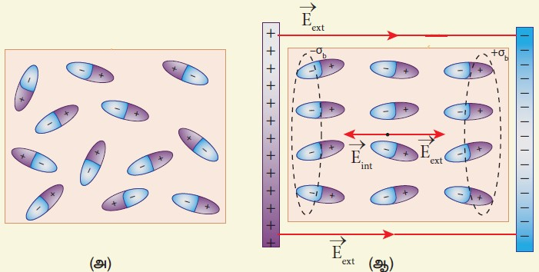 | - When an external electric field is applied on a conductor, the charges are aligned in such a way that an internal electric field is created which cancels the external electric field.  - But in dielectric, which has no free electrons, the external electric field only realigns the charges so that an internal electric field is produced.  - The magnitude of the internal electric field is smaller than that of external electric field.  - Therefore the net electric field inside the dielectric field is not zero, but is parallel to an external electric field with magnitude less than that of the external electric field.  - For example, let a rectangular dielectric slab is placed between two oppositely charged plates.  - The uniform electric field between the plates acts as the external electric field 𝐸⃗ 𝑒𝑥𝑡 which polarizes the dielectric slab.  - Thus positive charges are induced on one side and negative charges are induced on the other side of the slab.  - So the dielectric in the external field is equivalent to two oppositely charged sheets with the surface charge densities . These charges are called bound charges.  - They are not free to move like free electrons in conductor.  - Explain in detail the effect of dielectric placed in a parallel plate capacitor when the capacitor is disconnected from the battery.  Effect of dielectrics when the capacitor is disconnected from the battery :  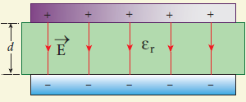  - Consider a parallel plate capacitor.  - Area of each plates = A Distance between the plates = 𝑑  Voltage of battery = 𝑉_{𝑜}  Total charge on the capacitor = 𝑄_{𝑜}  - So the capacitance of capacitor without dielectric,  𝐶 = 𝑄𝑜  𝑜 𝑉𝑜 | - The battery is then disconnected from the capacitor and the dielectric is inserted between the plates. This decreases the electric field.  - Electric field without dielectric = 𝐸_{𝑜} Electric field with dielectric = E Relative permittivity or dielectric constant = 𝜀_{𝑟}  ∴ 𝐸 = 𝐸𝑜  𝜀_{𝑟}  - Since 𝜀_{𝑟} > 1, we have 𝐸 < 𝐸_{𝑜}  - Hence electrostatic potential between the plates is reduced and at the same time the charge 𝑄_{𝑜} remains constant.  𝑉 = 𝐸 𝑑 = 𝐸𝑜 𝑑 = 𝑉𝑜  𝜀_{𝑟} 𝜀_{𝑟}  - Then the capacitance of a capacitor with dielectric,  𝐶 = 𝑄𝑜 = 𝑄𝑜 = 𝜀 𝑄𝑜 = 𝜀 𝐶  𝑉 [𝑉𝑜 ] 𝑟 𝑉𝑜 𝑟 𝑜  𝜀_{𝑟}  - Since 𝜀_{𝑟} > 1, we have 𝐶 > 𝐶_{𝑜}.  - Thus insertion of dielectric slab increases the capacitance.  - We have, 𝑪_{𝒐} = ^{𝜺𝟎} ^{𝑨}  𝒅  ∴ 𝑪 = 𝜺_{𝒓} 𝜺_{𝟎} 𝑨 = 𝜺 𝑨  𝒅 𝒅  Where, 𝜺_{𝒓} 𝜺_{𝟎} = 𝜺 → permitivity of the dielectric medium  - The energy stored in the capacitor without dielectric,  1 𝑄 2  𝑈_{𝑜} = ^{𝑜}  2 𝐶_{𝑜}  - After the dielectric is inserted,  𝟏 𝑸 𝟐 𝟏 𝑸 𝟐 𝑼_{𝒐}  𝑼 = ^{𝒐} = ^{𝒐} =  𝟐 𝑪 𝟐 𝜺_{𝒓} 𝑪_{𝒐} 𝜺_{𝒓}  - Since 𝜀_{𝑟} > 1, we have 𝑈 < 𝑈_{𝑜}  - There is a decrease in energy because, when the dielectric is inserted, the capacitor spend some energy to pulling the dielectric slab inside.  www.kalvioli.com

- Explain in detail the effect of dielectric placed in a parallel plate capacitor when the battery remains connected to the capacitor.  Effect of dielectrics when the battery remains connected to the capacitor:  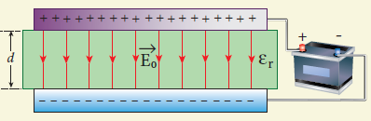  - Consider a parallel plate capacitor.  - Area of each plates = A Distance between the plates = 𝑑  Voltage of battery = 𝑉_{𝑜}  Total charge on the capacitor = 𝑄_{𝑜}  - So the capacitance of capacitor without dielectric,  𝐶 = 𝑄𝑜  𝑜 𝑉𝑜  - Dielectric is inserted between the plates and the battery is remains in connected with the capacitor.  - So the charges stored in the capacitor is increased.  - Total charge without dielectric = 𝑄_{𝑜} Total charge with dielectric = 𝑄 Relative permittivity (dielectric constat) = 𝜀_{𝑟}  ∴ 𝑸 = 𝜺_{𝒓} 𝑸_{𝒐}  - Since 𝜀_{𝑟} > 1, we have 𝑄 < 𝑄_{𝑜}  - Here the potential difference between the plates remains constant. But the charges increases and the new capacitance will be  𝐶 = 𝑄 = 𝜀𝑟 𝑄𝑜 = 𝜀 𝐶  𝑉𝑜 𝑉𝑜 𝑟 𝑜  - Since 𝜀_{𝑟} > 1, we have 𝐶 > 𝐶_{𝑜}  - Hence capacitance increases with the insertion of dielectric slab.  - We know that, 𝑪_{𝒐} = ^{𝜺𝟎} ^{𝑨}  𝒅  ∴ 𝑪 = 𝜺_{𝒓} 𝜺_{𝟎} 𝑨 = 𝜺 𝑨  𝒅 𝒅  Where, 𝜺_{𝒓} 𝜺_{𝟎} = 𝜺 → permitivity of the dielectric medium  - The energy stored in the capacitor without dielectric,  𝑈 = 1 𝐶 𝑉 2  𝑜 2 𝑜 𝑜  - After the dielectric is inserted,  𝑼 = 𝟏 𝑪 𝑽 𝟐 = 𝟏 𝜺 𝑪 𝑽 𝟐 = 𝜺 𝑼  𝟐 𝒐 𝟐 𝒓 𝒐 𝒐 𝒓 𝒐 | - Since 𝜀_{𝑟} > 1, we have 𝑈 > 𝑈_{𝑜}  - So there is increase in energy when the dielectric is inserted  - Derive the expression for resultant capacitance, when capacitors are connected in series and in parallel.  Capacitors in series :  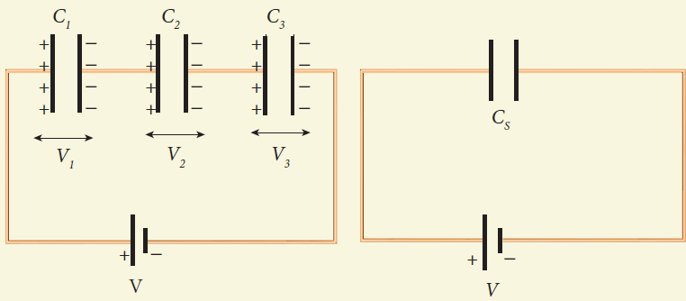  - Consider three capacitors of capacitance  𝐶₁, 𝐶₂and 𝐶₃ connected in series with a battery of voltage V  - In series connection,  - Each capacitor has same amount of charge (Q)  - But potential difference across each capacitor will be different.  - Let 𝑉₁, 𝑉₂, 𝑉₃ be the potential difference across  𝐶₁, 𝐶₂, 𝐶₃ respectively, then  𝑉 = 𝑉₁ + 𝑉₂ + 𝑉₃  𝑉 = 𝑄 + 𝑄 + 𝑄 [∵ 𝑄 = 𝐶 𝑉]  𝐶1 𝐶2 𝐶3  𝑉 = 𝑄 [ 1 + 1 + 1 ] − − − − − (1)  𝐶1 𝐶2 𝐶3  - Let 𝐶_{𝑆} be the equivalent capacitance of capacitor  in series connection, then  𝑉 = 𝑄 − − − − − (2)  𝐶_{𝑆}  - From (1) and (2) , we have  𝑄 = 𝑄 [ 1 + 1 + 1 ]  𝐶𝑆 𝐶1 𝐶2 𝐶3  𝟏 𝟏 𝟏 𝟏  𝑪_{𝑺} = 𝑪_{𝟏} + 𝑪_{𝟐} + 𝑪_{𝟑}  - Thus the inverse of the equivalent capacitance of capacitors connected in series is equal to the sum of the inverses of each capacitance.  - This equivalent capacitance 𝑪_{𝑺} is always less than the smallest individual capacitance in the series | Capacitors in parallel :  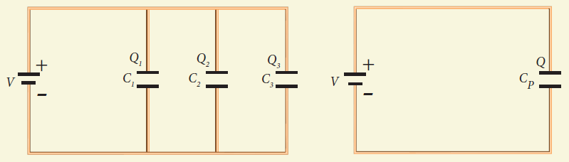  - Consider three capacitors of capacitance  𝐶₁, 𝐶₂and 𝐶₃ connected in parallel with a battery of voltage V  - In parallel connection,  - Each capacitor has same potential difference (V)  - But charges on each capacitor will be different  - Let 𝑄₁, 𝑄₂, 𝑄₃ be the charge on 𝐶₁, 𝐶₂, 𝐶₃  respectively, then  𝑄 = 𝑄₁ + 𝑄₂ + 𝑄₃  𝑄 = 𝐶₁𝑉 + 𝐶₂𝑉 + 𝐶₂𝑉 [∵ 𝑄 = 𝐶 𝑉]  𝑄 = 𝑉 [𝐶₁ + 𝐶₂ + 𝐶₂] − − − − − (1)  - Let 𝐶_{𝑃} be the equivalent capacitance of capacitor in parallel connection, then  𝑄 = 𝐶_{𝑃} 𝑉 − − − − − (2)  - From (1) and (2),  𝐶_{𝑃} 𝑉 = 𝑉 [𝐶₁ + 𝐶₂ + 𝐶₂]  𝑪_{𝑷} = 𝑪_{𝟏} + 𝑪_{𝟐} + 𝑪_{𝟐}  - Thus the equivalent capacitance of capacitors connected in parallel is equal to the sum of the individual capacitances.  - The equivalent capacitance 𝑪_{𝑷} in a parallel connection is always greater than the largest individual capacitance.  www.kalvioli.com

- Explain in detail the construction and working of Van de Graff generator.  Van de Gralff generator :  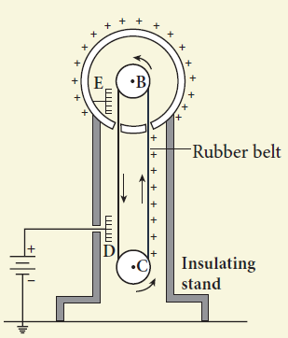  - It is designed by Robert Van de Graff.  - It produce large electro static potential difference of about 107 𝑉  Principle :  - Electro static induction  - Action of points  Construction :  - It consists of large hollow spherical conductor ‘A’ fixed on the insulating stand.  - Pulley ‘B’ is mounted at the centre of the sphere and another pulley ‘C’ is fixed at the bottom.  - A belt made up of insulating material like silk or rubber runs over the pulleys.  - The pulley ‘C’ is driven continuously by the electric motor.  - Two comb shaped metallic conductor D and E are fixed near the pulleys.  - The comb ‘D’ is maintained at a positive potential of 104 𝑉 by a power supply.  - The upper comb ‘E’ is connected to the inner side of the hollow metal sphere.  Working :  - Due to the high electgric field near comb ‘D’, air between the belt and comb ‘D’ gets ionized. | - The positive charges are pushed towards the belt and negative charges are attracted towards the comb ‘D’  - The positive charges stick to the belt and move up.  - When the positive charges reach the comb ‘E’ a large amount of negative and positive charges are induced on either side of comb ‘E’ due to electrostatic induction.  - As a result. the positive charges are pushed away from the comb ‘E’ and they reach the outer surface of the sphere.  - These positive charges are distributed uniformly on the outer surface of the hollow sphere.  - At the same time, the negative charges neutralize the positive charges in the belt due to corona discharge before it passes over the pulley.  - When the belt descends, it has almost no net charge.  - This process continues until the outer surface produces the potential difference of the order of 107 𝑉 which is the limiting value.  - Beyond this, the charges starts leaking to the surroundings due to ionization of air.  - It is prevented by enclosing the machine in a gas filled steel chamber at very high pressure.  Applications :  - The high voltage produced in this Van de Graff generator is used to accelerate positive ions (protons and deuterons) for nuclear disintegrations and other applications. | www.kalvioli.com

