 | Assignment No. 01  Semester: Fall 2018  Theory of Automata – CS402 | Total Marks: 20  Due Date: 4/12/2018
Objectives:
Objective of this assignment is to assess the understanding of students about the concept of languages, regular expressions and finite automata.

Instructions:
Please read the following instructions carefully before submitting assignment:
- You should consult the recommended books, PowerPoint slides and audio lectures to clarify your concepts.
- You are supposed to submit your assignment in .doc format. Any other formats like scan images, PDF, zip, rar and bmp etc will not be accepted.
- It should be clear that your assignment will not get any credit if:
- The assignment is submitted after due date.
- The assignment is copied from Internet or from any other student.
- The submitted assignment does not open or file is corrupt.

Note: No assignment will be accepted after the due date through email in any case (load shedding, server down, internet malfunctioning etc.).
It is recommended to upload solution file at least two days before its closing date.

For any query about the assignment, contact at cs402@vu.edu.pk

Question No 1: Marks: 5+5=10
- Let the language L is defined by the following Regular Expression:
ab*c(a+b)c

Which of the following string(s) is/are part of language L?
1. acac
2. acbbbc
3. abcac
4. abcc

- Let us consider we have a language L, Language of all strings that has exactly 1 triple “b” defined over alphabet set Σ = {a, b}. Construct Regular Expression for language L.

Question No 2: Marks=10
Find the concatenation of the following two FAs. Provide its transition table and transition diagram.

FA1:
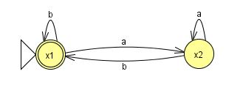

FA2:

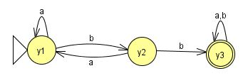

BEST OF LUCK

