Functional Design Coach Application v2.04

Inhoud
1. General layout 2
1.1. Top menu 2
1.2. Screen orientation 3
1.3. Branding 3
2. Flow Coach application 3
2.1. Login 3
2.2. Location selection 4
2.3. PAGE|Home page 5
2.4. PAGE|Check Result 10
2.5. Consult 14
2.6. Cardio test analyses 20
2.7. Follow-Up report 24
Follow Up Report : 12-week program – MOVE 28
2.8. Program Activation (Phase 3 & 4) 30
2.9. Extra credits 32

General layout (65 points)

Top menu

Back – Home – Menu buttons
(the arrow pointing left) = Back: goes back to the previous screen
(The house = the ‘Home’ screen with the leads, consults, search and chat functions)
(Menu) = is the general menu dropdown of the Coach app
  - Menu:
    - Profile Coach
      - Logout
      - Login details
      - Take or change photo
      - Linked clubs
      - Contact info: telephone, email, Facebook, other?
(All this info is to be set in the Back office under the corresponding coach in ‘Coach Management’)
    - Check results
    - Mind Questionnaire results
    - Consults
      - Fill in screens
      - Cardio Consult screen
      - Cardio test Analyses
      - MOVESMART reports (first and follow-up)
    - Follow-Up Reports
    - Extra credits (at discretion of coach to allocate to clients)

Screen orientation

Optimized for landscape mode on tablets only (size >= 7”?)

Branding

MOVESMART.company styling including color scheme, image and tagline. No private labelling.

Flow Coach application

Login (130 Points)

- Coach uses credentials (only once or until logout is selected from the menu)
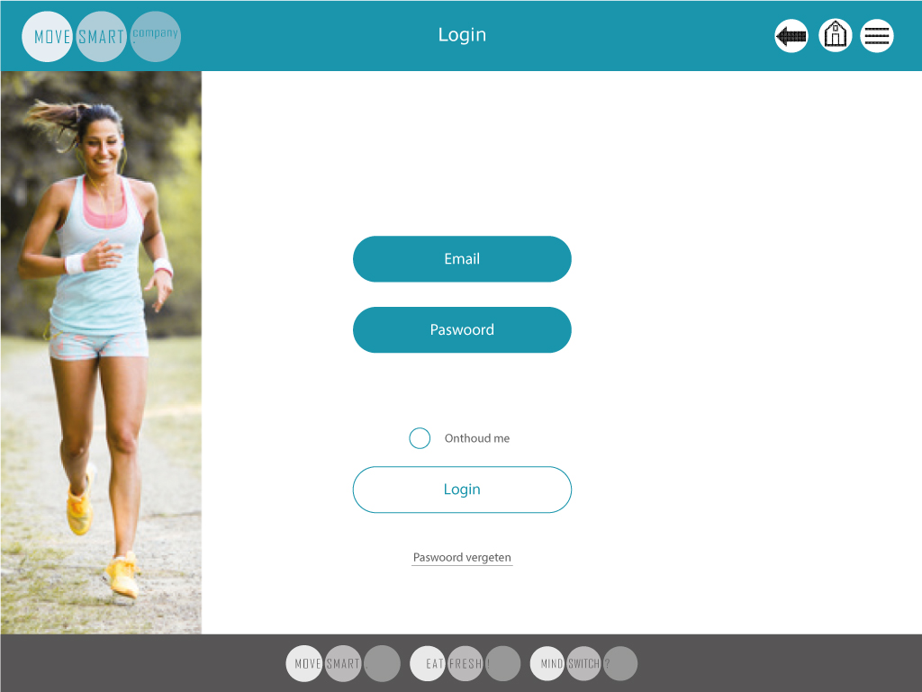

When the coach has forgotten his password, he can follow the procedure to obtain a new password by pressing <Forgot password>.

Location selection (65 Points)

- Coach selects the club/location from the list of clubs/locations he is linked to (as per his profile recorded in the Backoffice)
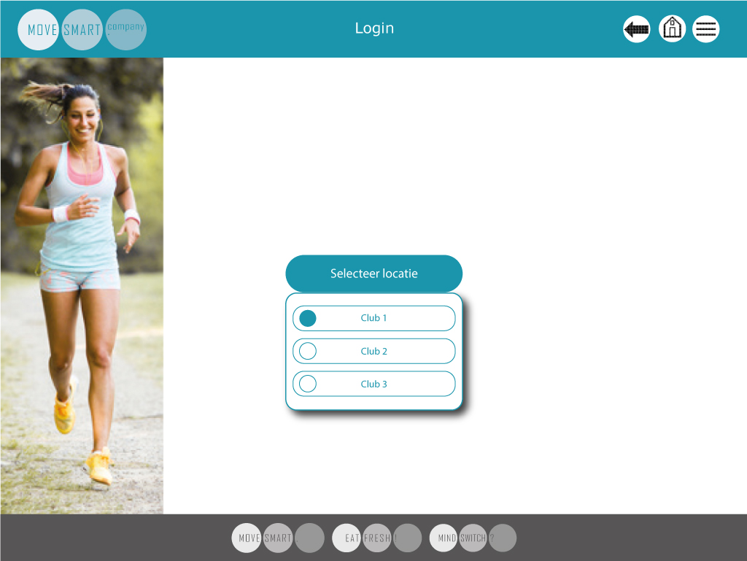

- When the login is correct, the coach is sent to PAGE|Home page.
Note: - this functionality can’t be implemented as it is already implemented & the flow was
Company > Number of clubs > one coach has many clubs in same parent company
Coach Can be related to one company but have number of clubs & this functionality already exist in backend

But, Somehow Movesmart made this club as a company then all relation goes wrong & now if we made this functionality to relate a coach with different clubs/company that is not actually right according to business, then we need to refine whole client app relation again & need to refine whole DB & backoffice again

PAGE|Home page (390 Points)

The Home page is showing 4 elements/functions: New Leads; Consults; Search Client and Chat.
- In the ‘New Leads’ list an overview is given of all new entries of leads that have requested to be contacted by a coach as per the selection from the Client app. In the Client app either only the Club, the Main Coach or Main Coach and Normal Coaches are listed. Hence the new entries are linked to the Main Coach or a Normal Coach. By default, the coach that is selected by the new client is shown in the new leads list. However, the Main Coach can re-allocate a new lead to a different Coach to contact and lead this client.
- A main coach will see all the new leads, a normal coach only the ones linked to him.
- New leads that have been contacted and for whom a consult appointment is made will disappear from the ‘New Leads’ list. They will now be shown in the Consults list.
- Chat will be a Whats-app-like functionality. For this some R&D is still required.

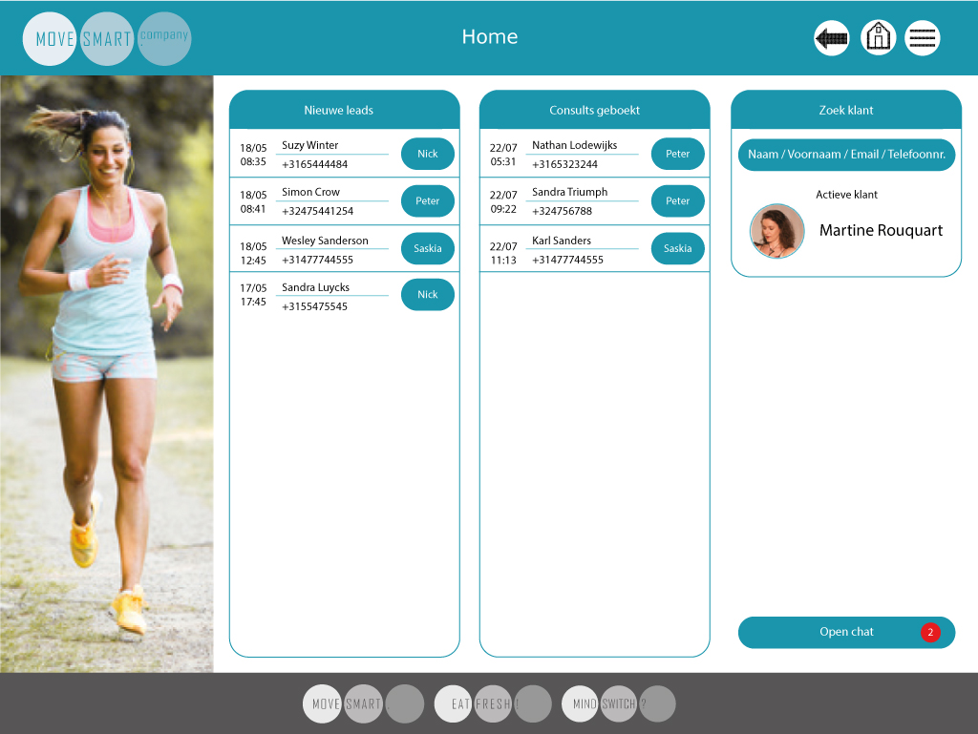

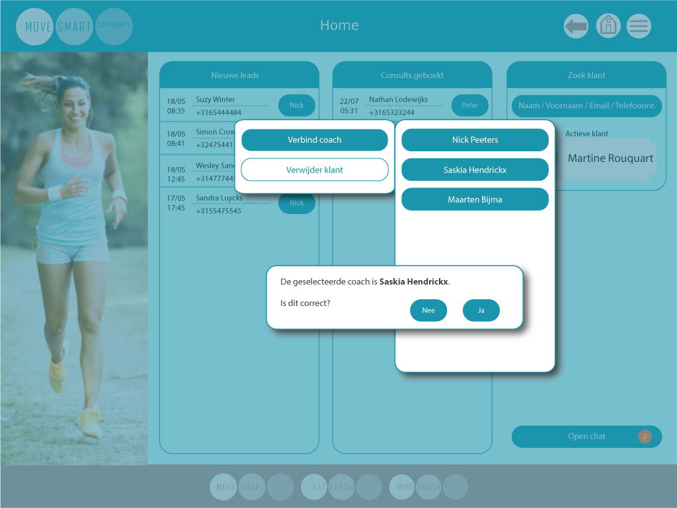
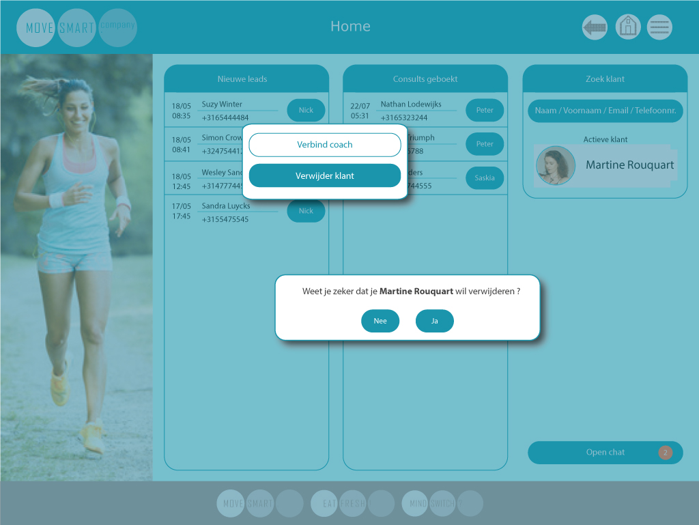

- A chat function can be activated from the Home screen (below right). The chat function allows the coach and client to have contact in a “Whats-app” kind of way. This will be the main means of communication between client and coach throughout the MOVESMART programme.

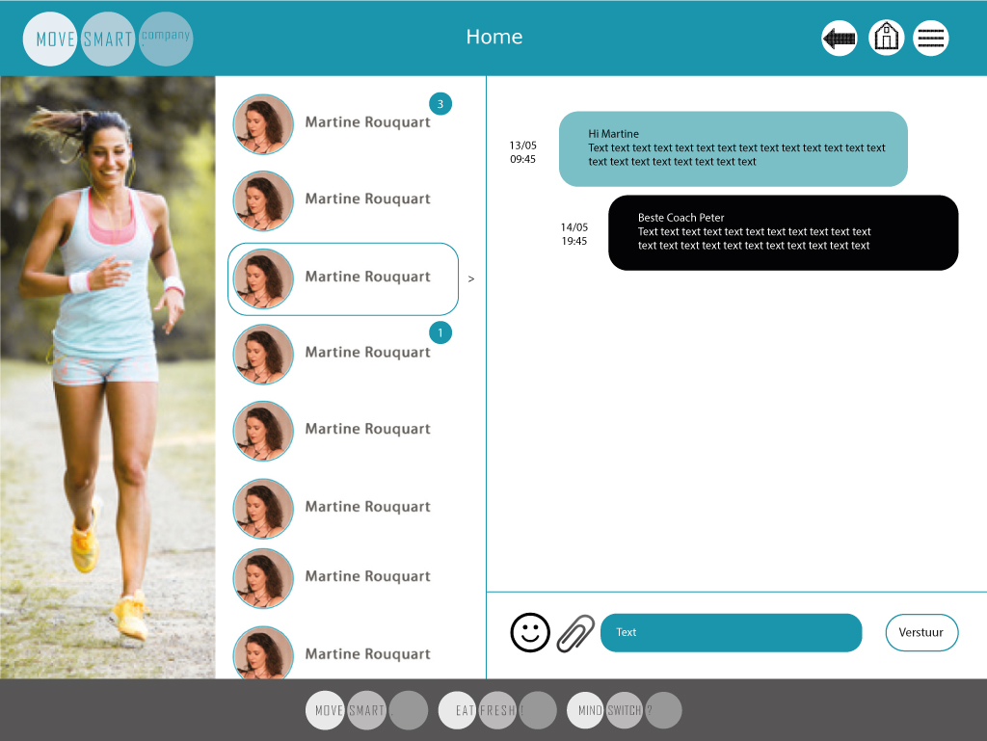

- When pressing the menu button, the coach can select the different modules in the coach app.
Keep in mind, only when a client is selected in the search function the buttons related to the client are active. Else they should not be active and lighter in appearance (this means only Coach profile is active then).

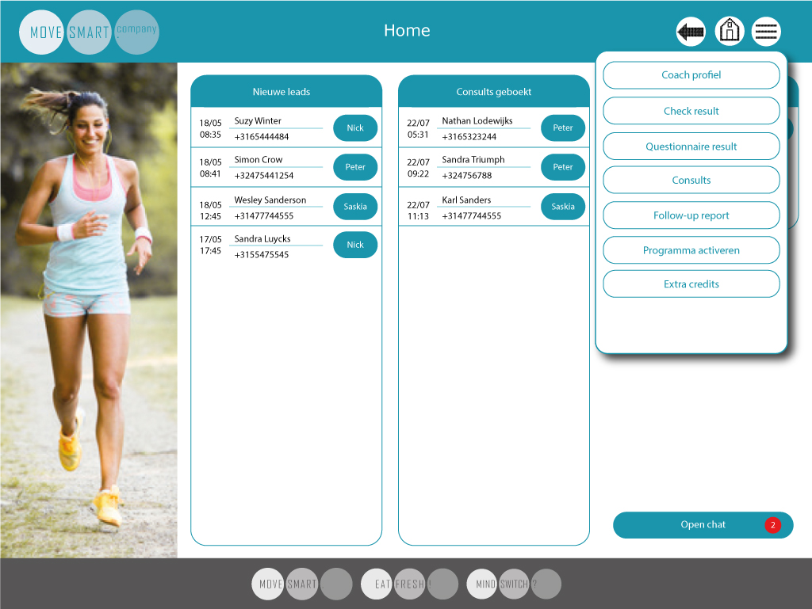

- So after the coach has selected a client, all other menu items will be activated.

The selection is in the search function by name, first name, email or phone number.
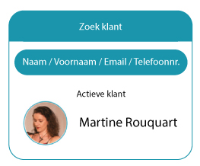

- When the coach then selects ‘Check Result’ from the menu, the check result page of the corresponding client will be shown.

PAGE|Check Result (260 Points)
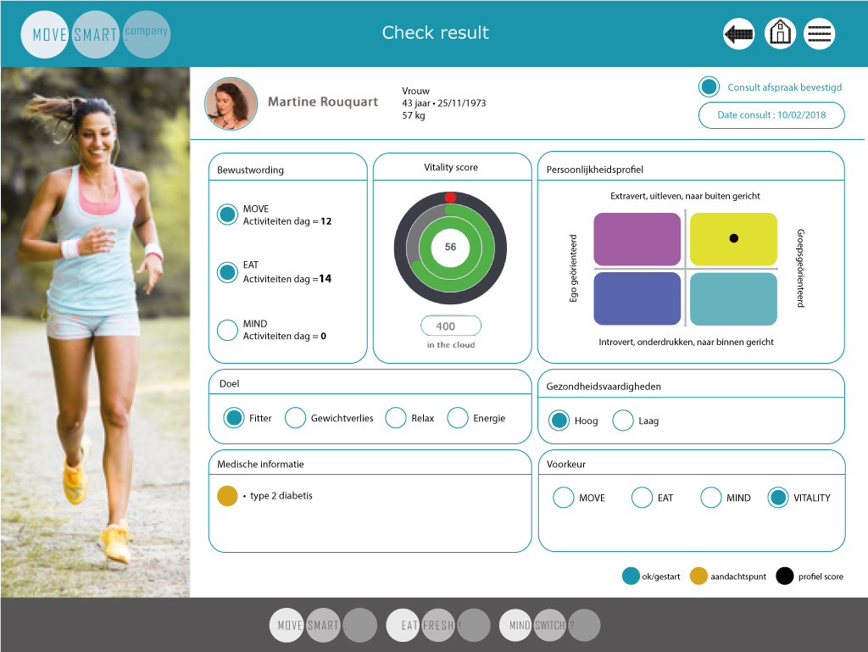

The Check Result page is to show the results as per the Check questionnaire carried out by the new client via the MOVESMART Client app. The following parameters are to be shown:

- The status of phase 1 activities (Bewustwording) is shown (in the example screen MOVE and EAT are active and MIND is not active)
- Vitality score (graph)
- Credits ‘in the cloud’
- Personality profile
- Personal goal
- UPCC skills
- Medical info
- Preference for mode of behaviour change:
            - MOVE
            - EAT
            - MIND
            - Vitality (= combi of MOVE/EAT/MIND)

- Coach calls new lead.
The Check Result page is to serve as the input information sheet for the coach to prepare his first contact with the new lead.

- Lead conversion to Client is done in the Check Result page by activating the parameter: ‘Appointment consult confirmed (Consult afspraak bevestigen)’. This activation will automatically trigger the activation of the Mind questionnaire for the new client. [See Client app functional design for further explanation.]
Keep in mind that the date needs to be filled in (show the popup if the date was not selected).

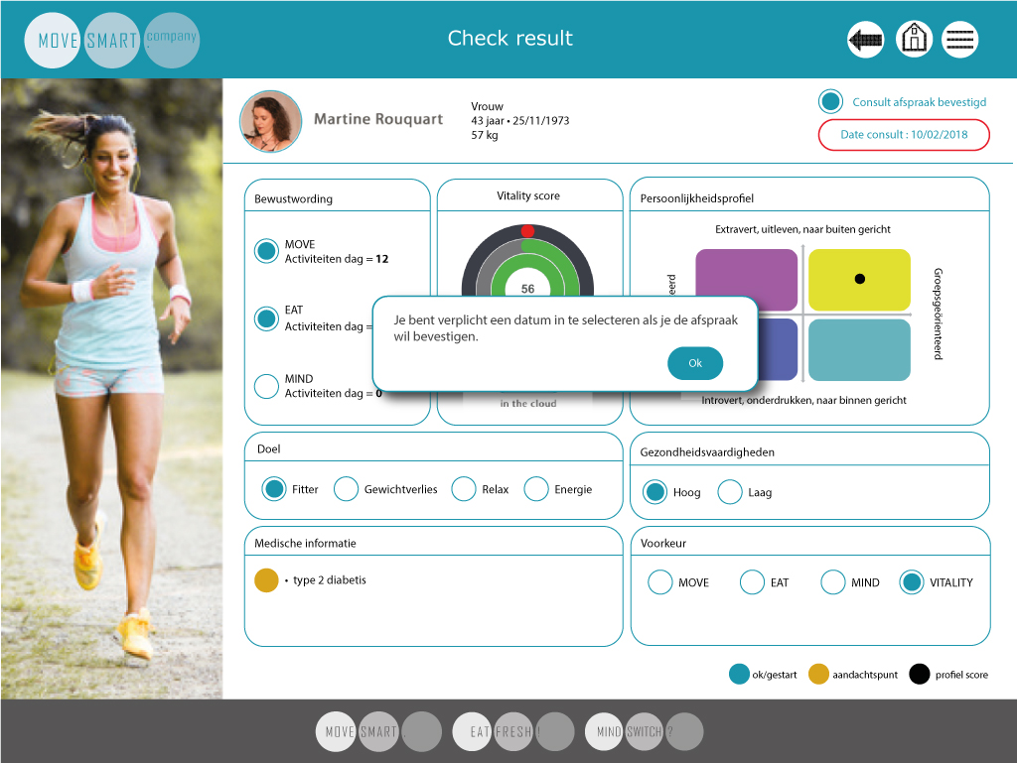
- Date stamp for consult: is to be put manually in the Check Result page in the field ‘date consult’ by a date picker. A reminder notification or auto message in the chat function, is to be sent to the Client automatically 3 days before the consult is taking place.

- After confirmation of appointment the coach can return to → PAGE|Home page, by pressing the Home icon in the top.

- After the first contact follow-up communication (chat) between coach and client can take place. For example, info about 1st Coach session can be confirmed:
  - Time and date
  - What to expect
  - What to bring
  - Etc

Consult (1040 points)

- Coach selects client from Consults list in PAGE|Home page
- The coach can press on ‘Questionnaire results’ button in the Menu to view the results of the Mind questionnaire filled out by the client prior to the first consult. A few examples of the layout are shown below.

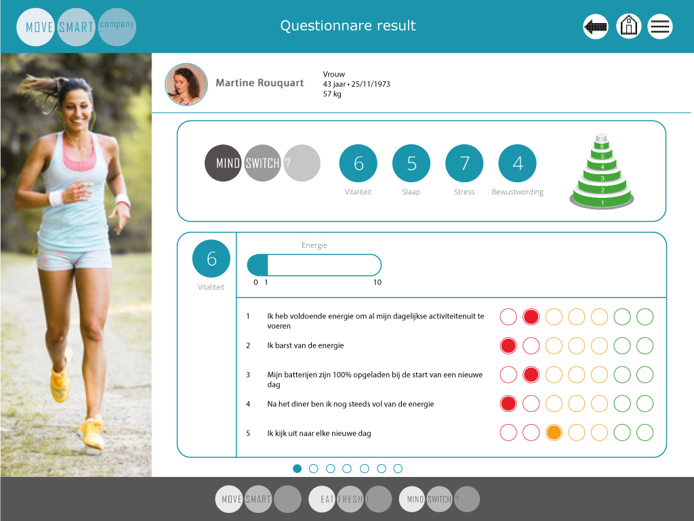

- Select button “Consult” in the Menu

- Goes to consult pages
  - Page 1 General – Blood values and body composition
  - Page 2 Cardio
  - Page 3 Flexibility/Strength

- Enter page 1. General - Blood values and body composition

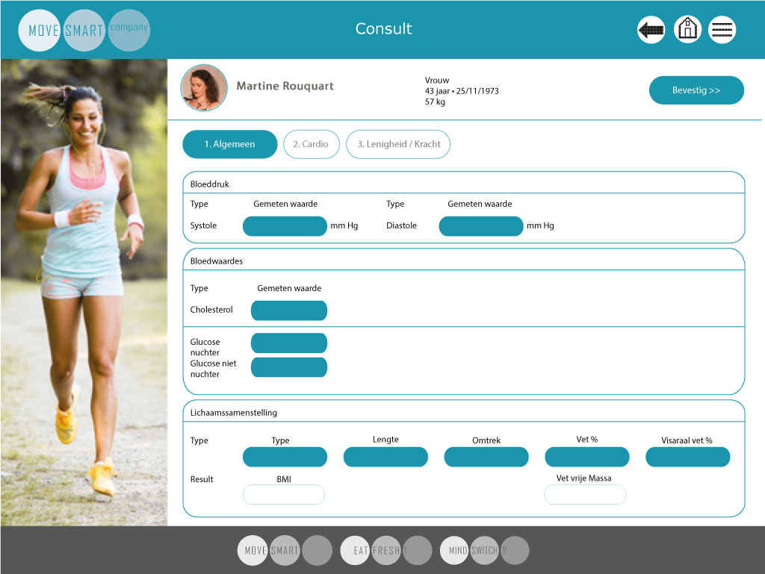
- Entry fields are:
  - Systolic and diastolic
  - Cholesterol
  - Glucose
  - Weight
  - Length
  - Waist
  - Fat%
  - Visceral Fat%

- BMI and Fat free weight are calculated from above entry fields.

After all entry fields are entered with values, these need to be confirmed by means of pressing <<Bevestig >> button. Upon confirmation the values are to be saved in the database.

- Enter page 2 – Cardio test

- Next the cardio test should be executed.
- The cardio test screen to start the cardio test should be opened
- Check/adjust Test date, Test level, Test option
- Scan Heart rate device
- Now, after pressing the <<Bevestig>> button, the screen to select the client in the test page is shown (see further screens in this doc). Once the correct client is opened in full screen, the coach can start the test by pressing the ‘Start’ button in the screen or on the bike (i.e. TRUE or Ergoline).
- At the end of the cardio test the values are to be kept in the database as well as a print screen of the test session should be made available in the coach app.

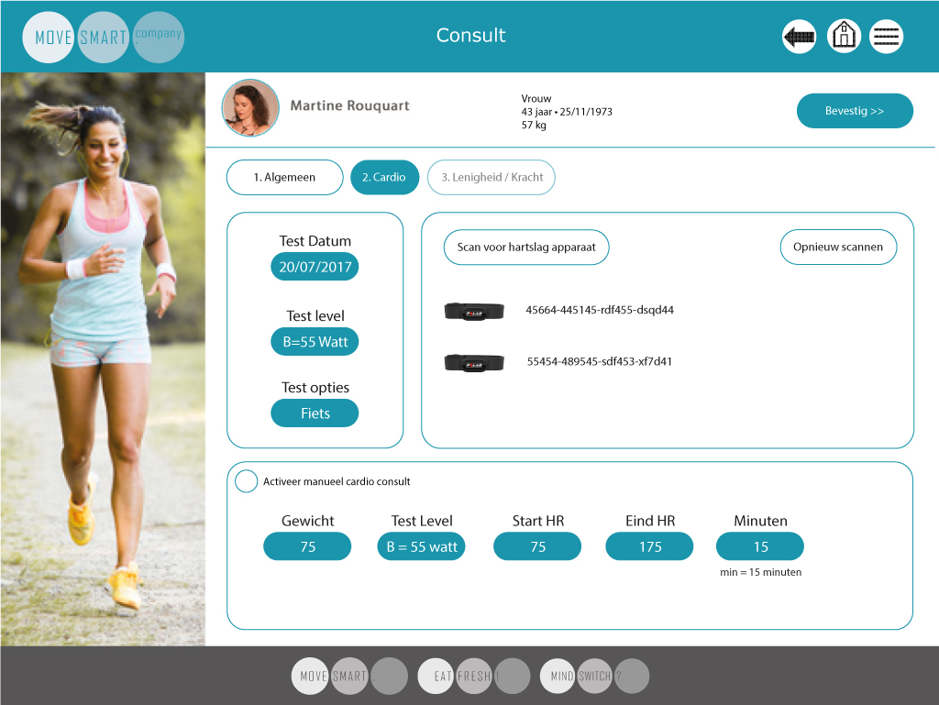

The option to activate a manual test is for those clients for whom a cardio test cannot be executed for medical or other reasons. The client will be set to MOVE level 1 and credits are linked to that level as well.
Based on the HR values and other parameters entered in the software will calculate the HR zones for the client.
The calculation is as follows: Normal calculation of the HR zones and the corresponding HR frequencies zones. The only difference is the calculation of the credits. When the parameter is set to Manual, the (IAND) HR value is entered, all corresponding HR zones will be calculated. Then pressing the ‘Save’-button will set the client to MOVE level 1 and the credits calculation will be based on MOVE level 1.
This means the client can train, but will begin and stay at MOVE level 1, for as long as he did not undergo a complete consult.

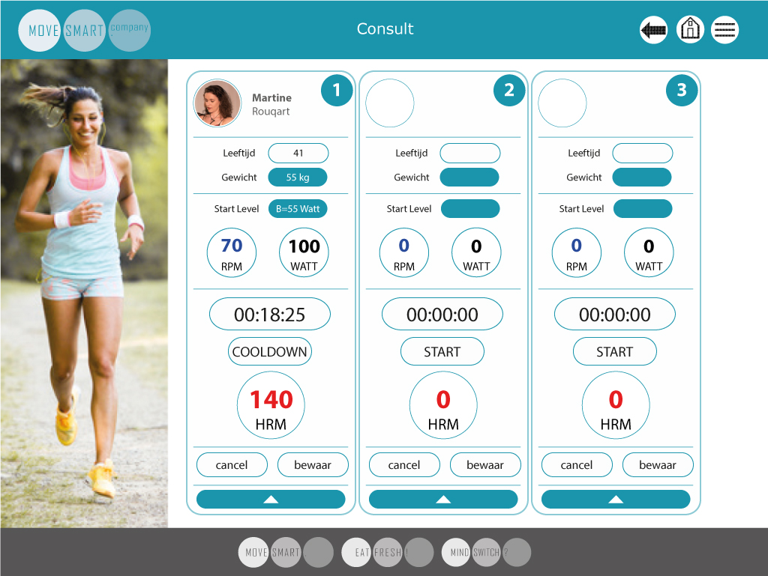

Opening a client detail screen, where the cardio test can be started, set to cooldown and stopped is shown when we open the page.

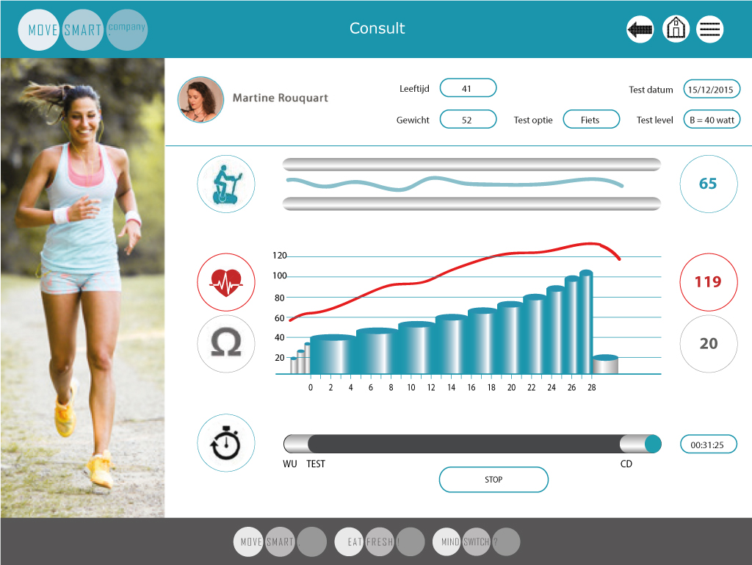

- Enter page 3 – Flexibility/Strength

Once the cardio test is done, the consult continues with flexibility/strength parameters.

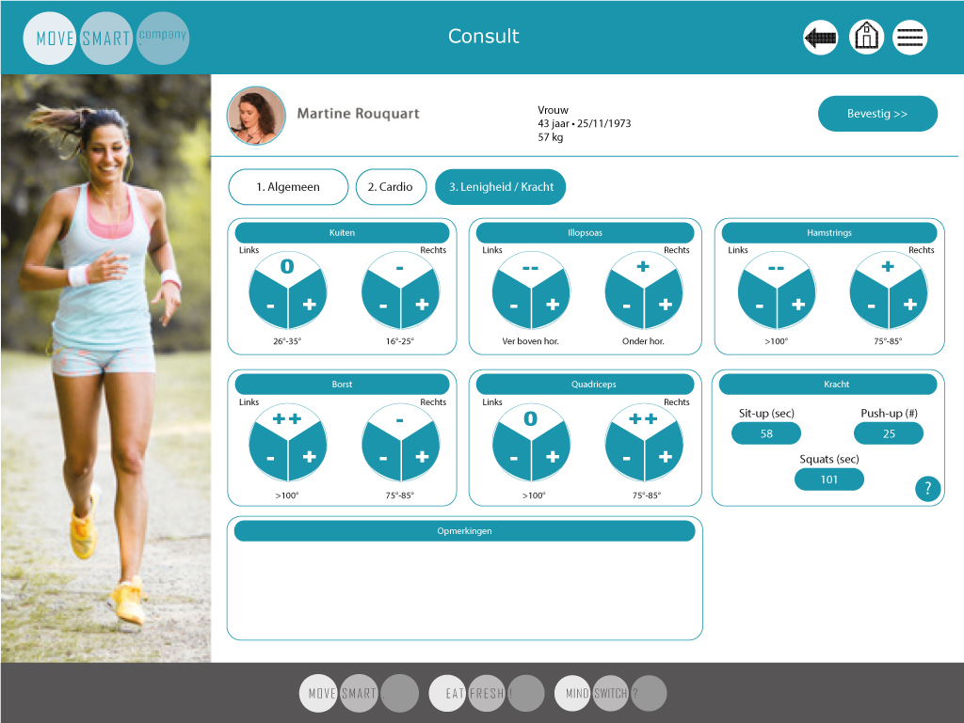

After entering those and confirming by means of pressing <<Bevestig>>, the consult entry activities are completed and analysing the cardio test can begin.

Cardio test analyses (260 Points)

- The cardio test can be analysed by showing both the HR/time graph as well as the HR/workload graph (= FIT graph).
- This graph allows the coach to work on the graph to define the IANT

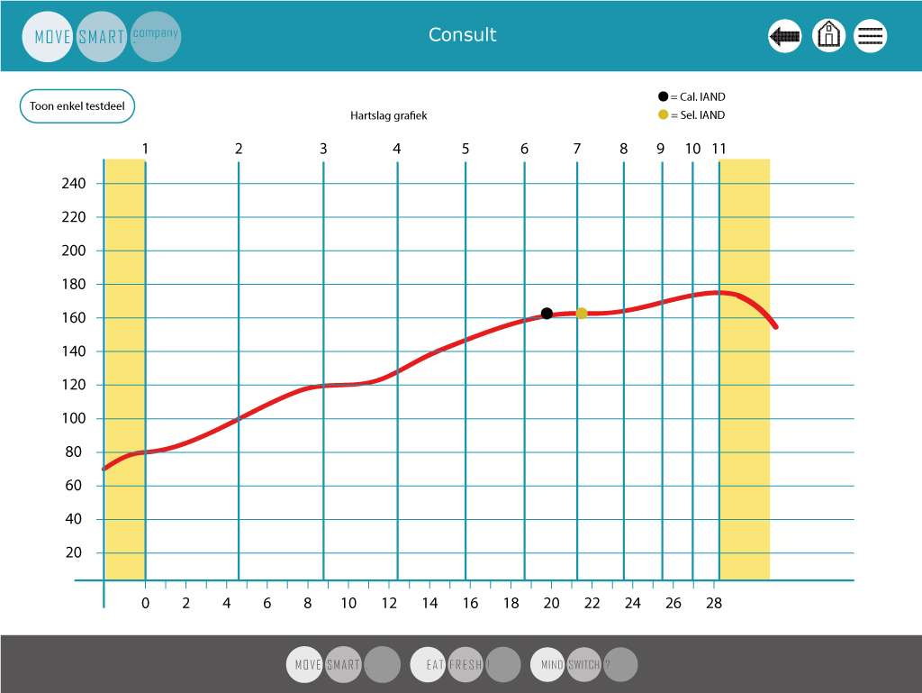
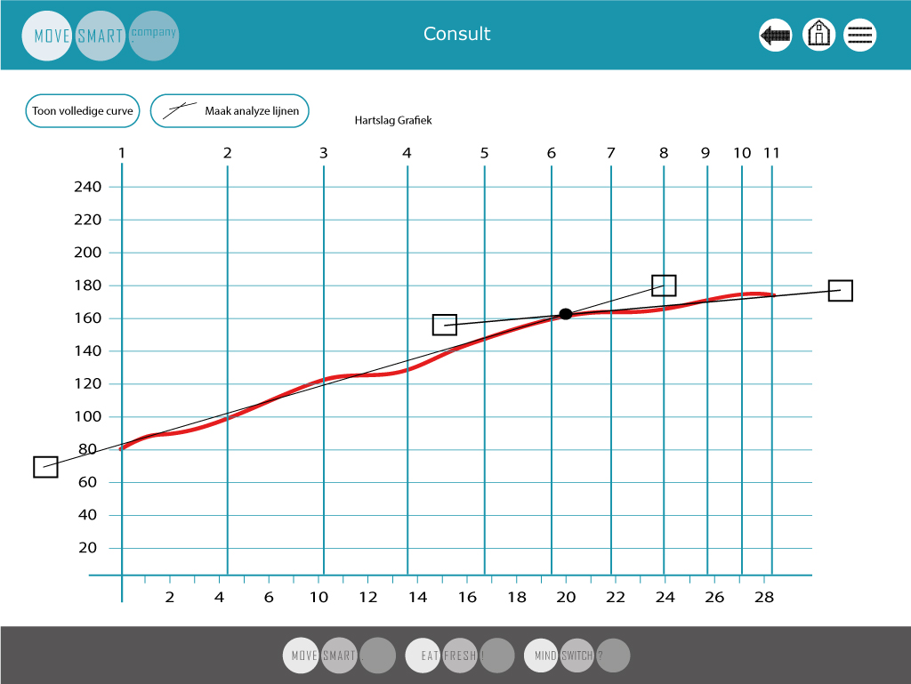

- The button ‘Make analyses lines’ will give immediately two lines on the screen with at the end of the lines pressure points so we can move them to the needed positions to have a better view of the AINT-point.
- Scrolling down will show the Fit-Graph and Device-Graph (is original like shown to client on device)
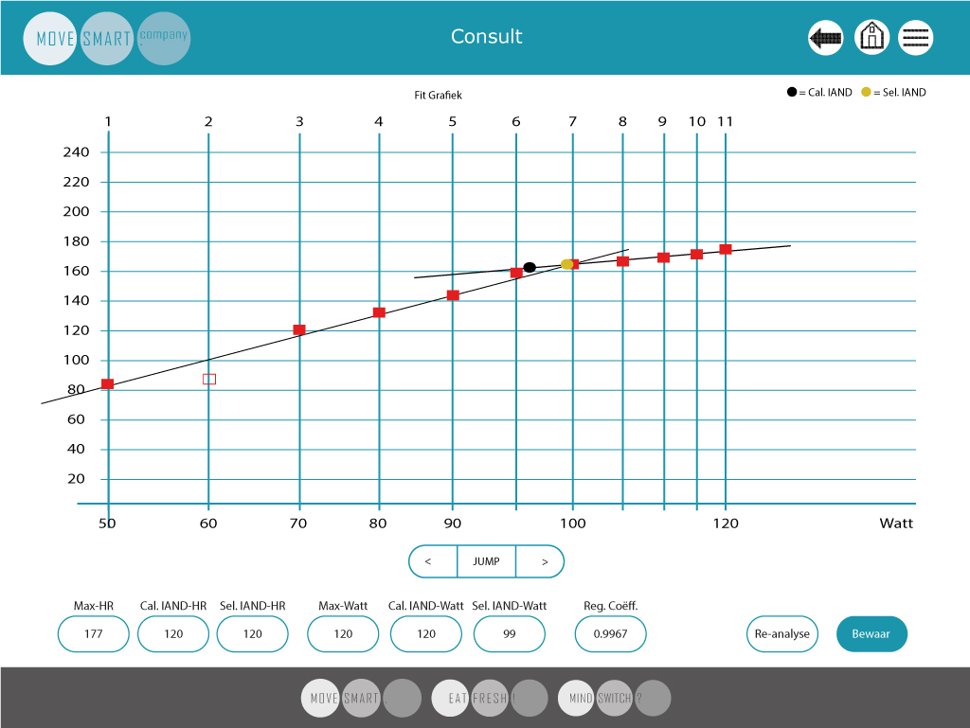
- In this part the analysis can be done by pressing the arrows in the ‘JUMP’- button or ‘TRIM’-button.
- When pressing IANT then this will change to the ‘TRIM’ modus and visa versa.
- In IANT mode, the arrows go one full line left or right. In the TRIM modus the IANT point will move in small steps along the horizontal analyse line left or right to move the IANT point a little bit.
- Pressing Save will write this analyse to the database.
- After pressing Save the button ‘Re-analyse’ will appear left of it (so this button is not visible during the first analysis, but for clarity it is shown in the screenshot above).
- After pressing this button, a new analysis can be done and saved again under the new date. After analysing again, the coach will be asked to continue with training in current week or to restart from week 1. Depending on the answer the program will react with the new analysis in the current week and with if needed adjusted credits (already earned credits will be kept) or the program will start again in week 1 (already earned credits will be kept) and the new credit calculation will continue with the new parameters.
- Keep in mind that the weeks always start on Monday. So, if credits done before the first Monday after the consult the credits will be added to that Monday.

- This screen is a print screen of the cardio test at the moment the test is stopped (‘STOP’), and not when pressed cooldown. All info is needed for analyses, so also the info for the cooldown.

Once this is done the coach can have a look at the Follow-up report to be opened by pressing the section ‘Follow-up report’ in the menu.

Follow-up report (260 points)

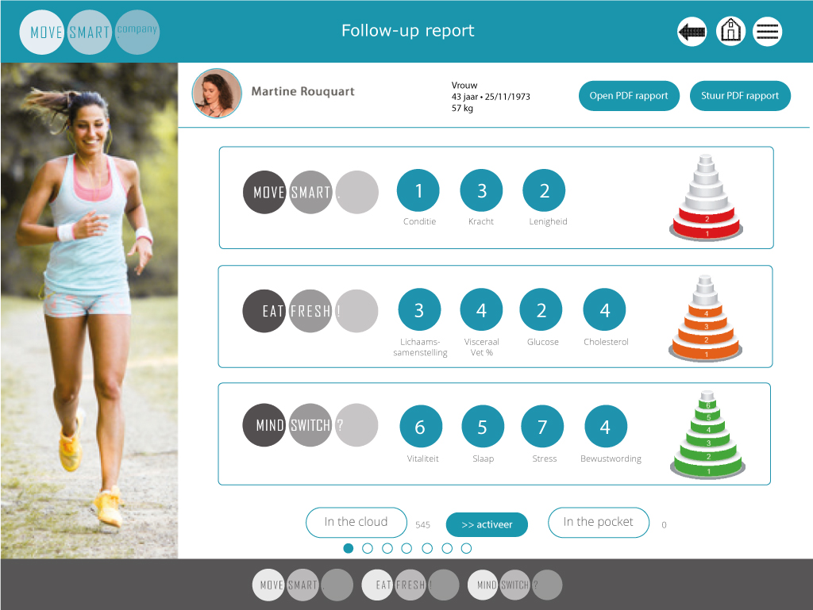

Extra buttons to set credits from “In the cloud” to “In the pocket”.
MOVE LEVELS
- Conditie
- Kracht
- Lenigheid

EAT LEVELS
- Lichaamssamenstelling
- Visceraal vet
- Glucose
- Cholesterol

MIND levels
- Vitaliteit
- Slaap
- Stress
- Bewustwording

Click on number to open pop-up with corresponding text from database.
These texts are also used in pdf export.

Or if the consult is a second/consecutive consult the page should look like below.
If more consults are done more pyramids and levels will be shown so, the coach can have an overview of all the consults and tests done.
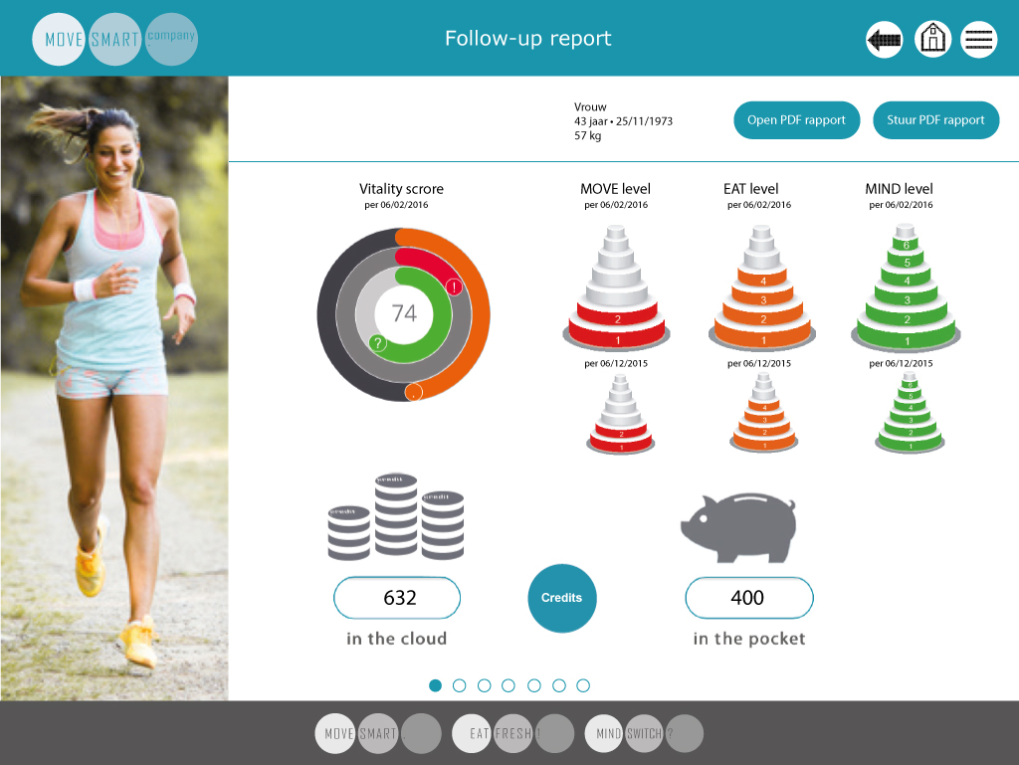

Program Activation (Phase 3 & 4) (260 Points)

Go to PAGE| Programma activeren

No design yet. Should contain:
- List of available programs
  - Ranked on “advised” and “Other”
  - With details shown when we press on the name of the activity.
    - # of Coach appointments
    - Devices necessary
    - Workshops
    - Location: Home, outside and/or in club
- Automatic advice based on
  - Preference (MOVE, EAT, MIND)
  - UPCC (support needed high/low)

Note: In the backend we should be able to add/edit the list of programs since this will be different for every club. Information that should be editable:
- Name of program
- Details
  - # of Coach appointments
  - Devices necessary
  - Workshops
  - Location: Home, outside and/or in club
- Picture of program
- Support high / low
- For preference MOVE, EAT of MIND

This means that a program generator should be created in the backoffice.
This we first have to discuss and write out in full. We need the input of the team for that.

MOVESMART CARDIO TRAINING (MOVE) - 12 Week Program

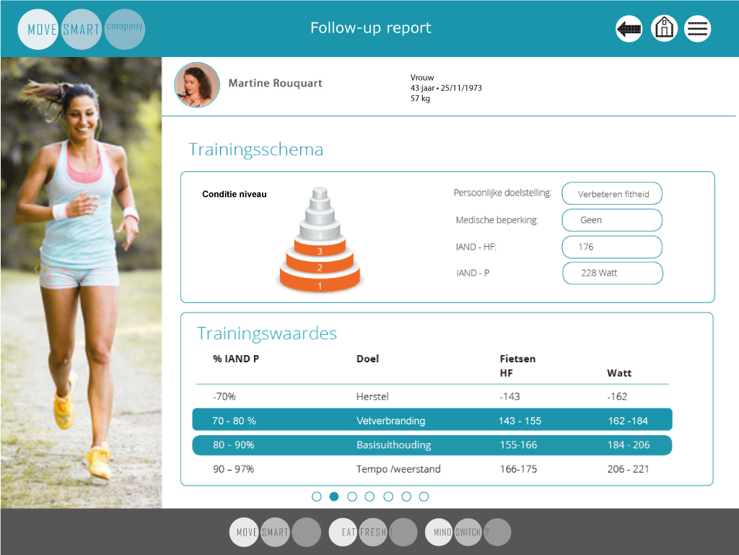
in this screen the value that is highlighted must be both 70-90% in bleu. The split-up that we see now should be removed, so only three lines will be visible:
-70%
70-90%
and 90-97%
Swipe to go to next page

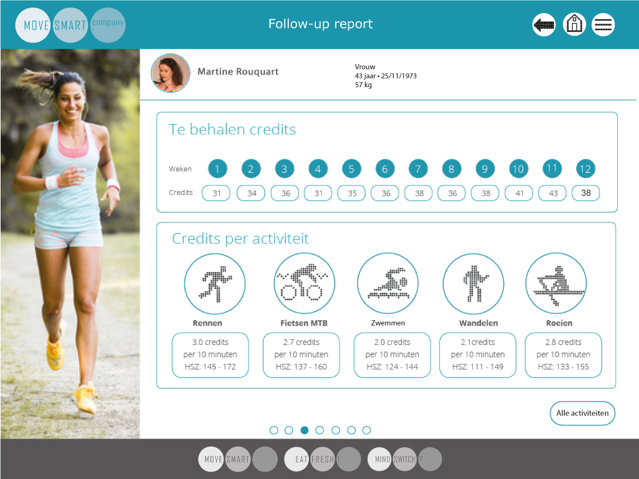
Also add button to get list of other cardio activities to collect credits, this list is available. In the main page only the 5 activities that the client frequently does are listed. Before selection by client the standard 5 activities are listed. Running, cycling, walking, swimming, circuit training.
Swipe to go to next page

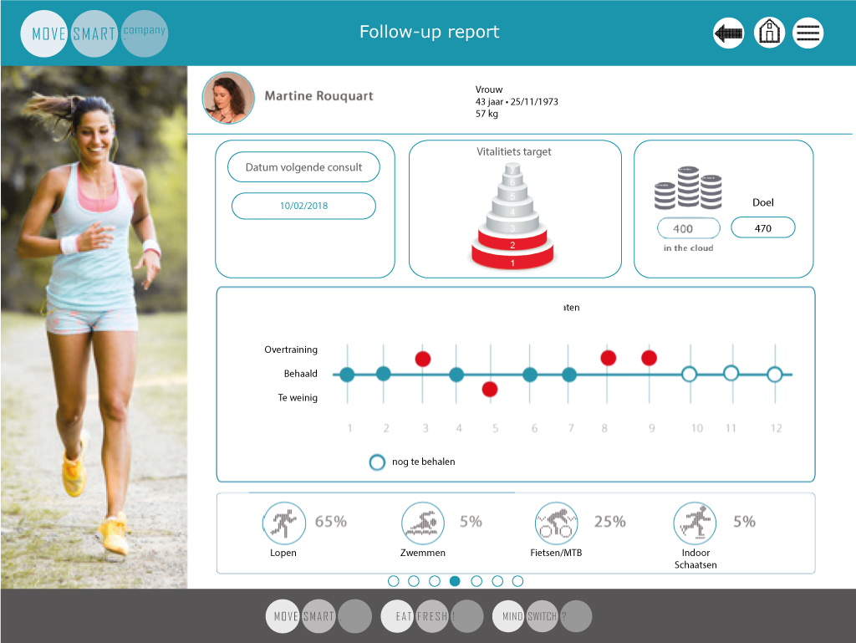

Extra credits (130 points)

When selecting this option in the menu, the coach can add bonus credits for this client. He can repeat this as many times as he wants.
But this possibility should be linked to the coach profile, so only coaches that are allowed to do this will see this button.

A popup will appear
