FAQ –
- More FAQ needs to be added to the list - Not done.
Sent the FAQ sheet with highlighted points

About us –
- We want a Clients section at the bottom of the page scrolling images like the login page. – The Mothercare logo has a grid in the background. Should be clear like the rest. Also, can we please make all the logo photo center as some are showing up higher and lower etc.
- Images on about us page needs changing. – The first 2 photos should have been the portrait that was sent and not landscape. Can we have it portrait like the one we sent and like the rest please?

Login page –
- Image needs changing at the bottom of the page. Can we please remove 1 photo on the login page? The highlighted one below please 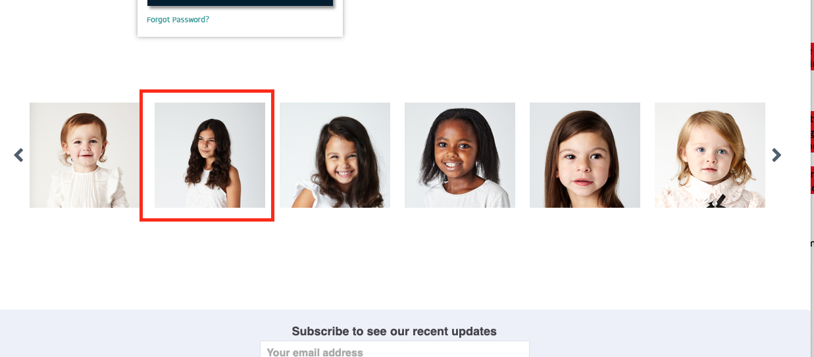

Contact us page –
- Images change – some photos are very blurry and does not fit in like it should.
