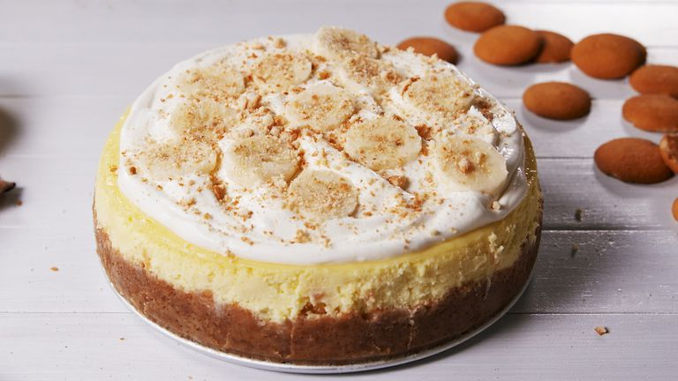
Banana Pudding Cheesecake
YIELDS: 12 SERVINGS
PREP TIME: 0HOURS 15MINS
TOTAL TIME: 7HOURS 45MINS

INGREDIENTS
FOR THE CRUST
2 c. finely crushed Nilla Wafers (from about 60 wafers)
6 tbsp. melted butter
Pinch kosher salt
FOR THE CHEESECAKE & TOPPING
4 (8-oz.) blocks cream cheese, softened
3/4 c. granulated sugar
1 (3.4-oz.) box banana cream pudding mix
3 large eggs
1 tsp. pure vanilla extract
1/4 c. sour cream
2 tbsp. all-purpose flour
1/4 tsp. kosher salt
2 c. Cool Whip, for garnish
1 banana, sliced, for garnish
1/4 c. crushed Nilla Wafers, for garnish

DIRECTIONS:
Preheat oven to 325° and grease an 8" or 9" springform pan with cooking spray. Make
crust: In a large bowl, mix together crushed wafers, butter, and salt. Press mixture into
bottom of prepared pan and up the sides.

Make cheesecake: In a large bowl using a hand mixer (or in the bowl of a stand mixer),
beat cream cheese, sugar, and pudding mix together until no lumps remain. Add eggs,
one at a time, then stir in vanilla and sour cream. Add flour and salt and beat until just
combined. Pour mixture over the crust. Wrap bottom of pan in aluminum foil and place in
a large roasting pan.

Pour in enough boiling water to come up halfway in the baking pan. Bake until center of
cheesecake only slightly jiggles, about 1 hour 30 minutes.

Turn off the heat, prop open oven door, and let cheesecake cool in oven, 1 hour. Remove
foil and refrigerate cheesecake for at least 5 hours and up to overnight.

Before serving, spread Cool Whip on top of cheesecake and garnish with banana slices
and crushed wafers.

