Abstract

This study aims to solve traffic congestion which is a severe problem in many modern cities in India. To solve this problem, we have a framework for a dynamic and automatic traffic light control system. Generally, each traffic light on an intersection is assigned a constant green signal time. It is possible to propose a dynamic time-based coordination scheme where the green signal time of the traffic lights is assigned based on the present conditions of the traffic. In this study, we adopt the approach to take data/input/image from object/subject/vehicle and to process the input data by Computer and Micro-controller and finally display it on the traffic light signal to control the Closed Loop System.

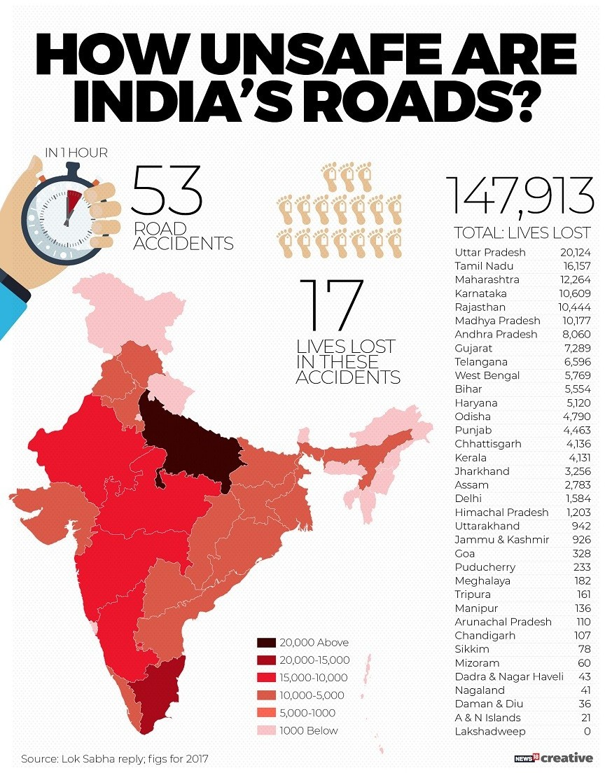

Table of Contents
- Abstract………………………………………………..
- Index…….,……………………………………………
- Introduction…………………………………………...
- Survey………………………………………………...
- Vision…………………………………………………
- Proposed Solution ……………………………………
        - Product Description……………………………..
        - How it works?......................................................
- Science Behind it’s Working………………………...
        - Flowchart of the Proposed sysem……………….
8) Advantages………………………………………….
(a)Economic Advantage……………………………..
- Future Applications………………………………….
- Conclusion……………………………………………

Introduction

An increase in population and urbanization in India is going hand in hand and as a result, many smaller cities in India have become a million cities. The increase in the number of million cities has created pressure on the exiting recourses in terms of infrastructure, traffic, roads, lights, housing, etc. This has led to an alarming increase in the number of vehicles plying on roads on each of these million cities. It has brought congestion and huge traffic jams resulting in increasing the commuters’ journey time and reduced speed. If it goes unabated we are sure to see choked roads, frail environment leading to health problems and in the long run, these cities will not be conducive for human living.
We have ignored the problems of traffic for quite some time and have been conservative in our preparedness to tackle it. The time has come when we need to bring in scientific technology and innovations to deal with traffic problems squarely. The significant problems leading to traffic congestion in Indian cities include Rising demand for travel due to increased population and other activities

Survey
Uttar Pradesh saw the maximum increase in number of road deaths which increased from 16,004 in 2013 to 22,256 in 2018, while there are lessons to be learnt from Tamil Nadu and Andhra Pradesh; wherein there have been a significant decrease in road fatalities.
2018 saw a total of 4.61 lakh road accidents across India as compared to 4.65 lakh in 2017. Though the number of road accidents have dropped marginally, the same cannot be said where road fatalities are concerned. This figure which stood at 1.51 lakh in 2016, dipped to 1.48 lakh in 2017, which went up to 1.49 lakh in the past.

Vision

We need IISs(Integrated Traffic Systems ) in order to bring abut a change in -
- the current way of enforcement of traffic laws
- reduce rash and negligent driving by adopting quality measures
- to avoid conflicts between people and police
- to keep a record of the vehicle density
- and, to increase the quality of traffic management in cities

Some technical reasons include-
- To evaluate the performance of thermal video sensors under varying lighting and temperature conditions compared to visible light cameras. Performance is evaluated with respect to road user detection, classification, and vehicle speed measurements. Lighting and temperature conditions where each camera outperformed the other are identified to provide practical recommendations for the implementation of video-based sensors.
- To integrate existing tracking and classification computer- vision methods for automated thermal-video data collection under low visibility conditions, night-time and shadows.

Proposed Solution

Our proposed solution is the use of F.L.I.R. systems in Traffic management.
- Product Description- F.L.I.R. Systems is the world leader
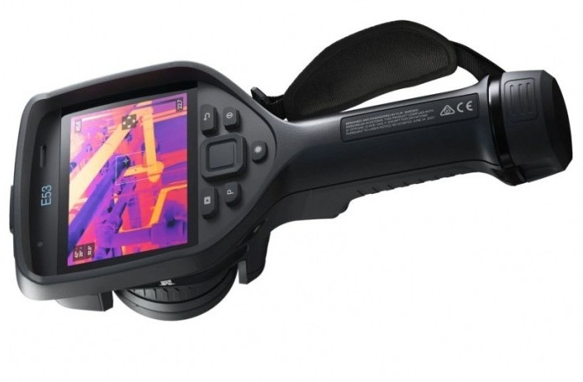
in the design, manufacturing and marketing of thermal imaging systems for a wide variety of
commercial, industrial and government applications.

- How it works?
FLIR cameras use a thermographic sensor that senses infrared radiations. The sensors installed in forward-looking infrared cameras, as well as those of other thermal imaging cameras, use detection of infrared radiation, typically emitted from a heat source (thermal radiation), to create an image assembled for video output. They can be used to help pilots and drivers steer their vehicles at night and in fog, or to detect warm objects against a cooler background. The wavelength of infrared that thermal imaging cameras detect is 3 to 12 μm and differs significantly from that of night vision, which operates in the visible light and near-infrared ranges (0.4 to 1.0 μm).

The Science behind it’s working

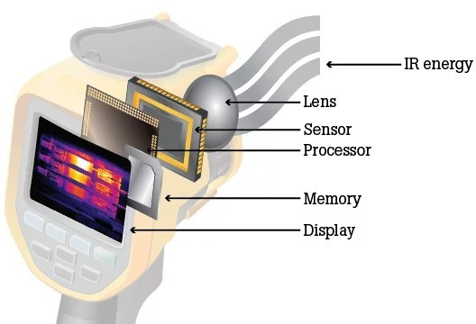
Human eyes can see objects that are illuminated by either the sun or other form of light at specific wavelengths in the visual spectrum. In contrast, thermal
cameras ‘see’ heat, or electromagnetic radiation within the infrared spectrum, emitted by the objects. Infrared light is electromagnetic
radiation of small particles named photons. All objects at temperatures above absolute zero (-273.16°C) emit infrared radiation, and this is how heat is transferred and detected by the IR (thermal) cameras. This is why a thermal camera can work even in complete darkness. Though it is not visible to the human eye, radiation of infrared energy can be felt. Thermal cameras can see this radiation and convert it into an image that we can see with our eyes.

Capture image every 5 seconds.

Process each thermal image
Synchronize information with M.C.U.
Maintain a default switching sequencing until flagged for a change.
Clear memory every 30 minutes

Synchronize data with each Control Unit.

Reprogram Switching of lights based on traffic density.

Pass1: Break the sequence but maintain waiting times.
Pass2: Reducing waiting time until traffic density is subthreshold.

Flowchart of the proposed system

Advantages

FLIR ITS not only offers you the hardware but also the software that is needed for your demanding traffic monitoring applications. Flux - Video detection management software Flux is an intelligent software platform for use with a FLIR video detection system. Flux collects traffic data, events, alarms and video images generated by the video detectors. Key benefits:
  - Fast, reliable and stable system
  - Easy installation, Windows and Linux compatible 3.User-friendly configuration and operation 4.Browser-based Graphical User Interface 5.Expandable, scalable system
6.Open architecture for easy integration with larger traffic management systems.
The main goal of Flux is to manage and control all traffic information generated by various detectors and to make it useful, meaningful and relevant to the user. Flux provides a user-friendly interface composed of a monitoring and a reporting application and enables real-time monitoring of events and alarms. All event info is automatically documented and visualized straightforwardly, allowing the operator to manage each traffic situation efficiently.

Economic Advantage

The average installation cost per intersection of an Adaptive Taffic Control System (ATCS) is 46,20,882 .
It costs the taxpayer 1,78,00,000 to purchase and install a traffic signal. Electric bills and routine maintenance amount to about 56000, a year. Drivers also have increased costs for fuel, time delay, and accident.

Future Applications

F.L.I.R. can also be used in various other fields. These include-

- Security- These cameras help to secure facilities like ports, airports, nuclear facilities, warehouses, estates and many more against intruders.
- Mechanical- In industrial environments, thermal imaging is used to find hot-spots that can lead to failures in electrical and mechanical installations. By detecting anomalies at an early stage production breakdowns can be avoided and money can be saved.
- Data collection & flow monitoring- FLIR Systems accurately monitors traffic flow speed to help keep highways safe by differentiating levels of service: fluid, dense, congested or stop & go. Queues during road-works can be monitored and travel time can be calculated based on information flows from Video Image Processors (VIPs).
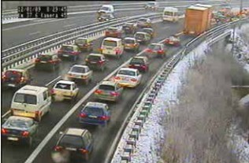

Conclusion
Using the method discussed in this paper, the amount of traffic on a particular road can be estimated to a very high degree of accuracy. Besides, since thermal cameras can function even in complete darkness, the limitations of using the conventional CCTV cameras for monitoring (which are of no use in the absence of ambient light or in low visibility) are also overcome. As we have seen, this technique not only serves the purpose of traffic monitoring, but also helps in manipulating and managing it automatically with the help of dynamic traffic signaling. This reduces a lot of human effort in countries where intelligent traffic systems are not developed. Moreover, its low cost and potential to detect security threats (like presence of explosives or fire accidents) make it a very efficient and

